VCST Internal Memo
Title: Saturation Temperature Determination from JPSS J1 VIIRS RC-05 Part 1 Test
Memo Number: 2015_014
Revision: 01
Date: July 6, 2015
Author: Jeff McIntire
To: Xiaoxiong Xiong and James Butler
Cc: Hassan Oudrari, Kwo-Fu (Vincent) Chiang, Jon Fulbright and Aisheng Wu

References

[1] TP154640-2233 Rev 1, ‘Emissive Band Radiometric Response and Sensitivity, RC-5 Test Procedure – VIIRS,’ Raytheon.
[2] VIIRS PRD Rev C, ‘Joint Polar-orbiting Satellite System (JPSS) Visible Infrared Imaging Radiometer Suite (VIIRS) Performance Requirements Document (PRD),’ Raytheon.
[3] VCST_TECH_REPORT_14_080, ‘Preliminary Analysis of J1 VIIRS Thermal Band Radiometry from RC-5 Part 1,’ Jeff McIntire, November 11, 2014.
[4] ‘Performance Verification Report – VIIRS J1 Emissive Band Calibration,’ Mark Bilton and Eslim Monroy, Raytheon, January 8, 2015.
[5] VCST_TECH_MEMO_2015_010, ‘Analysis of the Radiometric Calibration from JPSS J1 VIIRS RC-05 Part 1 Test,’ Jeff McIntire, May 1, 2015.
[6] VCST_TECH_MEMO_2014_020, ‘Analysis of Ambient Level RC-1 Part 1 Thermal Band Radiometric Characterization,’ Jeff McIntire, September 15, 2014.

- Introduction

The scene temperatures at which the JPSS J1 VIIRS thermal bands saturate were determined from the thermal vacuum test RC-05 Part 1 using the high temperature source (TMCBB) [1]. This work will also compare the measured saturation temperatures to the specified dynamic range [2]. A preliminary investigation of this test was reported in [3]. Raytheon analysis was reported in [4].

Tables 1 – 5 list the relevant UAIDs and collects as well as the TMCBB temperatures. The TMCBB source was viewed in the middle collect window (or a scan angle of ~-1 degrees). In addition, the Space View Source (SVS) was viewed through the Space View (SV) port (at ~ -65.7 degrees scan angle) and was controlled at ~90 K.

The VIIRS sensor was operated in diagnostic mode and each collect contains 100 scans. The sensor was set to fixed high gain. Testing was performed on both electronics sides A and B.

2. Data Processing

The external source data analyzed here is restricted to a subset of the Earth View (EV) samples in a given collect for which the TMCBB source yielded a stable response. The following sample ranges were used in this work: samples 550 – 799 for M bands and samples 1100 – 1599 for I bands. All the samples for the SV were analyzed. The DN for the EV sector is truncated to 12 bits while the calibration sectors report DN in 14 bits. This leads to a bias in the dn. As a result, all calibration view data used in this work was truncated to 12 bits.

First, the DN_{SV} was averaged over all samples in a given scan. Then, the sample averaged DN_{SV} was subtracted from each sample of the DN_{EV} in the corresponding scan to produce the dn. Next, the dn was averaged over scans and the standard deviation of all scans for a specific sample was calculated. Note that the Half Angle Mirror (HAM) sides alternate from scan to scan such that there are 50 scans for each HAM side. Additionally, the I band data is divided into two subsamples; the larger for SV is always matched to the larger for the EV, to ensure the proper background subtraction.

The temperatures (T_{xxx}) of the following were extracted: TMCBB, SVS, HAM, Rotating Telescope Assembly (RTA), and scan CAVity (CAV). The HAM and CAV temperatures were acquired using the LRV telemetry extractor while the TMCBB and SVS temperatures were obtained from the Ground Support Equipment (GSE) files. The RTA temperature is the CAV temperature minus 4 degrees K.

3. Saturation Determination

The saturation temperature is determined by scanning the TMCBB and evaluating the full and partial views of the source. As the partial views contain larger portions of the source, the detector response will ramp up. When the view is fully within the extended source, the detector response becomes level. An example is shown in Figure 1. For the TMCBB, because the source is collimated, the ramp up and down from the plateau is steep in terms of number of samples. The saturation point is taken to be the sample on either side of the middle of the TMCBB profile at which the response is a maximum. The response is then converted into a scene radiance using equations detailed in [5], and then converted in to a scene temperature by the Planck equation. The average of the two sides of the profile is taken, and the maximum over all the measured collects is reported.

Note that the detector saturation can occur in the digital or analog domain. Digital saturation occurs when the Analog to Digital Converter (ADC) saturates, and is observed when the raw digital response equals its upper limit (in the case of VIIRS detectors, DN=4095). Increasing the input radiation will not change the detector response. Analog saturation occurs when the amplifier (CTIA) saturates. When this occurs the measured response decreases with increasing input radiation. Digital saturation was observed in Figure 1 and analog saturation was observed in Figure 2.

The specified dynamic ranges for the thermal bands are specified by V_PRD-12624 [2]. This work will assess whether the thermal bands saturate above the upper specified limit (T_{MAX}).

4. Analysis

Figures 3 – 10 show the saturation temperatures for each thermal band versus detector. All bands are shown to saturate above the specified limits. All bands digitally saturate first; two bands (I4 and M12) exhibit analog saturation at some higher radiance. For these two bands, the digital response decreases to or close to zero at the highest measured radiance levels. On-orbit this results in two possible values for a given digital response; fortunately, scenes with temperatures above saturation for these bands are rare, and can be correlated to M13. The LWIR saturation temperatures are generally consistent between different instrument plateaus to within ~1 K and between electronics sides to within 2 – 3 K; for the MWIR, the separation between electronics sides is less clear, but all instrument conditions are consistent to within 2 – 3 K. The detector dependence is largely the reflection of the detector gain dependence. Bands I4, M12, and M14 saturate between 4 and 10 K above the specified limit; all other bands saturate more than 10 K above their limits.

Note that only M13 high gain is shown; the source temperature was not high enough to saturate M13 low gain. M13 low gain was observed to digitally saturate in ambient testing [6]. Assuming that the M13 low gain behavior is unchanged, it is estimated to saturate at ~670 K.

5. Summary

Thermal band saturation was characterized under TVAC conditions for the J1 VIIRS sensor during RC-5 Part 1 testing. Analysis showed the following:
- Saturation occurs for all thermal bands above their specified maximum scene temperatures.
- All thermal bands digitally saturate first. Bands I4 and M12 are observed to undergo analog saturation as well at higher scene radiances.
- M13 low gain was not observed to saturate during thermal vacuum testing; it was observed to saturate in ambient testing, above the specified limit (634 K).

Acknowledgement

The sensor test data used in this document was provided by the Raytheon El Segundo testing team. Approaches for data acquisition and data reductions, as well as data extraction tools were also provided by the Raytheon El Segundo team. We would like to thank the Raytheon El Segundo team for their support. The data analysis tools were developed by the VCST team.
Table 1: RC-01 Part 1 TMCBB test data used in the saturation determination taken during Cold Plateau.

Eside A |  |  | Eside B
UAID | Collect | TMCBB T [K] | UAID | Collect | TMCBB T [K]
U4303058 | 1 | 295 | U4303111 | 1 | 295
U4303059 | 1 | 294 | U4303111 | 3 | 294
U4303060 | 1 | 294 | U4303111 | 5 | 294
U4303061 | 1 | 294 | U4303111 | 7 | 294
U4303062 | 1 | 294 | U4303111 | 9 | 294
U4303063 | 1 | 294 | U4303111 | 11 | 294
U4303064 | 1 | 305 | U4303111 | 15 | 305
U4303066 | 1 | 325 | U4303111 | 17 | 325
U4303067 | 1 | 344 | U4303111 | 19 | 344
U4303069 | 1 | 358 | U4303111 | 21 | 358
U4303070 | 1 | 369 | U4303111 | 23 | 369
U4303071 | 1 | 375 | U4303111 | 25 | 375
U4303073 | 4 | 388 | U4303112 | 4 | 388
U4303074 | 2 | 413 | U4303112 | 8 | 413
U4303075 | 2 | 448 | U4303112 | 12 | 448
U4303076 | 2 | 599 | U4303112 | 16 | 599
U4303076 | 6 | 677 | U4303112 | 20 | 677
U4303076 | 10 | 730 | U4303112 | 24 | 730
U4303076 | 14 | 763 | U4303112 | 28 | 763

Table 2: RC-01 Part 1 TMCBB test data used in the saturation determination taken during Nominal Plateau.

Eside A |  |  | Eside B
UAID | Collect | TMCBB T [K] | UAID | Collect | TMCBB T [K]
U4303367 | 1 | 295 | U4303632 | 1 | 295
U4303367 | 3 | 294 | U4303632 | 3 | 294
U4303367 | 5 | 294 | U4303632 | 5 | 294
U4303367 | 7 | 294 | U4303632 | 7 | 294
U4303367 | 9 | 294 | U4303632 | 9 | 294
U4303367 | 11 | 294 | U4303632 | 11 | 294
U4303367 | 13 | 305 | U4303632 | 13 | 305
U4303367 | 15 | 325 | U4303632 | 15 | 325
U4303367 | 17 | 344 | U4303632 | 17 | 344
U4303367 | 19 | 358 | U4303632 | 19 | 358
U4303367 | 21 | 369 | U4303632 | 21 | 369
U4303367 | 23 | 375 | U4303632 | 23 | 375
U4303368 | 4 | 388 | U4303633 | 4 | 388
U4303368 | 8 | 413 | U4303633 | 8 | 413
U4303368 | 12 | 448 | U4303633 | 12 | 448
U4303368 | 16 | 599 | U4303633 | 16 | 599
U4303368 | 20 | 677 | U4303633 | 20 | 677
U4303368 | 24 | 730 | U4303633 | 24 | 730
U4303368 | 28 | 763 | U4303633 | 28 | 763

Table 3: RC-01 Part 1 TMCBB test data used in the saturation determination taken during Hot Plateau.

Eside A |  |  | Eside B
UAID | Collect | TMCBB T [K] | UAID | Collect | TMCBB T [K]
U4304199 | 1 | 295 | U4304341 | 1 | 295
U4304199 | 3 | 294 | U4304341 | 3 | 294
U4304199 | 5 | 294 | U4304341 | 5 | 294
U4304199 | 9 | 294 | U4304341 | 7 | 294
U4304199 | 11 | 294 | U4304341 | 9 | 294
U4304199 | 13 | 294 | U4304341 | 11 | 294
U4304199 | 15 | 305 | U4304341 | 13 | 305
U4304199 | 17 | 325 | U4304341 | 15 | 325
U4304199 | 19 | 344 | U4304341 | 17 | 344
U4304199 | 21 | 358 | U4304341 | 19 | 358
U4304199 | 23 | 369 | U4304341 | 21 | 369
U4304199 | 25 | 375 | U4304341 | 23 | 375
U4304200 | 4 | 388 | U4304342 | 10 | 388
U4304200 | 8 | 413 | U4304342 | 14 | 413
U4304200 | 12 | 448 | U4304342 | 18 | 448
U4304200 | 16 | 599 | U4304342 | 22 | 599
U4304200 | 20 | 677 | U4304342 | 26 | 677
U4304200 | 24 | 730 | U4304342 | 30 | 730
U4304200 | 28 | 763 | U4304342 | 34 | 763

Table 4: Specifications addressed by this work [2].

V_PRD-12624 | The VIIRS sensor shall be able to measure scene temperature for the single gain emissive bands between the minimum temperature (T_{MIN}) and the maximum temperature (T_{MAX}) and for the dual gain emissive bands between the high gain T_{MIN} and the low gain T_{MAX} temperature shown in Table 7.

Table 5: Specified and optimized dynamic range for all emissive bands [2].

Band | T_{MIN} [K] | T_{MAX} [K]
I4 | 210 | 353
I5 | 190 | 340
M12 | 230 | 353
M13 HG | 230 | 343
M13 LG | 343 | 634
M14 | 190 | 336
M15 | 190 | 343
M16 | 190 | 340

Figure 1: Earth view data from Nominal plateau (Eside A) for band M16B, showing the TMCBB source profile.

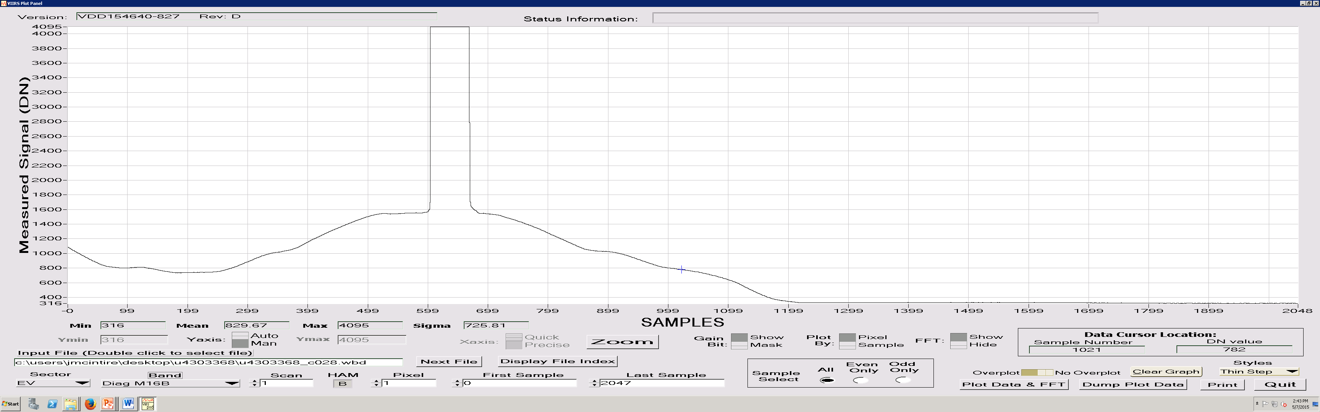

Figure 2: Earth view data from Nominal plateau (Eside A) for band M12, showing the TMCBB source profile.

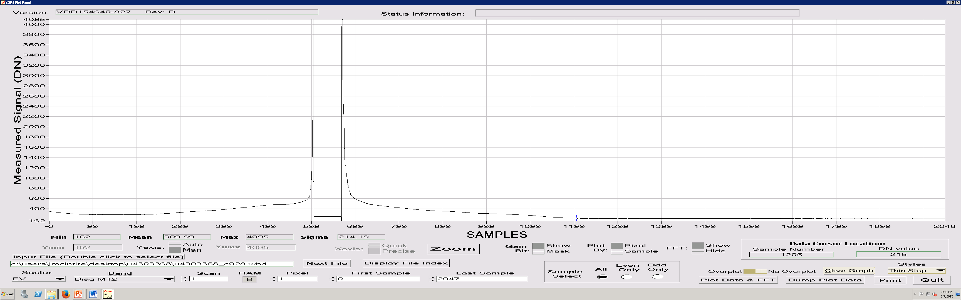

Figure 3: Measured I4 saturation temperatures [K] for all instrument plateaus and electronics sides.

Figure 4: Measured I5 saturation temperatures [K] for all instrument plateaus and electronics sides.

Figure 5: Measured M12 saturation temperatures [K] for all instrument plateaus and electronics sides.

Figure 6: Measured M13 HG saturation temperatures [K] for all instrument plateaus and electronics sides.

Figure 7: Measured M14 saturation temperatures [K] for all instrument plateaus and electronics sides.

Figure 8: Measured M15 saturation temperatures [K] for all instrument plateaus and electronics sides.

Figure 9: Measured M16A saturation temperatures [K] for all instrument plateaus and electronics sides.

Figure 10: Measured M16B saturation temperatures [K] for all instrument plateaus and electronics sides.

