NICST_MEMO_10_007

NICST Internal Memo

Date: April 14, 2010
From: J. McIntire, T. Schwarting, N. Che, C. Pan, and A. Wu
To: Bruce Guenther, Jim Butler, and Jack Xiong
Subject: Analysis of VIIRS F1 Relative Spectral Response for the SMWIR FPA
---------------------------------------------------------------------------------------------------------

References:

[1] TP154640-265, ’Relative Spectral Response, In Band (FP-15) Test Procedure for – VIIRS.’
[2] TP154640-266, ’Relative Spectral Response, Out Of Band and Band-Point Crosstalk (FP-16) Test Procedure for – VIIRS.’
[3] PVP154640-101, ‘Sensor Performance Verification Plan.’
[4] ps154640-101, ‘Performance Specification Sensor Specification.’
[5] NICST_REPORT_09_065, ‘Emissive Band Spectral Response: Preliminary Analysis (A Side),’ J. McIntire, July 6, 2009.
[6] NICST_REPORT_09_067, ‘Emissive Band Spectral Response: Preliminary Analysis (B Side),’ J. McIntire, July 7, 2009.
[7] NICST_REPORT_09_090, ‘Emissive Band RSR: Preliminary Analysis,’ J. McIntire and N. Che, July 22, 2009.
[8] NICST_MEMO_10_002, ’Analysis of VIIRS F1 Relative Spectral Response for the LWIR FPA,’ J. McIntire, T. Schwarting, N. Che, and C. Pan, February 22, 2010.
[9] MODTRAN (3.7/4.0)
[10] NICST_MEMO_06_031,’VIIRS EDU Preliminary In-band RSR for the Cold Focal Planes,’ D. Moyer, N. Che, and J. Xiong, August 24, 2006.

1. Introduction

FP-15 Part 2 and FP-16 Part 2 were performed during VIIRS TV testing (Nominal plateau) in order to determine the spectral characteristics of VIIRS cold focal planes [1-3]. This work will focus on the SMWIR In-Band (IB) and Out-Of-Band (OOB) sections of the Relative Spectral Response (RSR) as well as assess compliance with the associated specifications [4]. Preliminary results were reported in [5-7].

The test configuration for both FP-15 and FP-16 was described in [8]. In addition, the data analysis methodology used in this work was also detailed in [8]. As a result neither the bulk of the test configuration details nor the data analysis methodology will be repeated here.

For FP-16, the SMWIR focal plane was sampled over a wavelength range of approximately 1 – 7 µm. An example of RSO used in this work over the OOB region measured for SMWIR bands is shown in Figure 1. Figure 2 shows a schematic of the IB metrics. Tables 1 – 4 list the UAID, number of collects, band, detector row, order filter number, grating number, ND filter (used only for FP-16 IB measurements), and wavelength range.
The spectral smile of the source (SpMA) was measured for all bands in the SMWIR FPA (except for I4 odd). This correction is applied using the following formula

$λ_{\text{COR}}\left(C,B,D,T\right)=λ\left(C,B,D,T\right)+λ_{\text{SMILE}}\left(B,D\right)$ (1)

to all FP-15 and FP-16 data sets. Here C, B, D, and T represent the collect, detector, and test (FP-15, FP-16 IB, or FP-16 OOB).

2. Analysis Results

The IB RSR for band M8 is graphed in Figure 3 as a function of wavelength. The main peak is on the short side of the bandpass; the response is relatively flat at around 95 % of peak response over the remainder of the bandpass. The M8 IB metrics are listed in Tables 5 – 7. All IB metrics for this band are within the specified limits for all detectors, except for the bandwidth. The M8 bandwidth is about 6 nm longer than the specified bandwidth (20 nm) and 2 nm outside the specified tolerance (±4 nm). The ND filter transmission results are listed in Table 6. The detector averaged derived ND transmission is 0.0160 for the odd detectors and 0.0154 for the even detectors with an average standard deviation of 0.0002 (odd) and 0.0002 (even). A 1.9 ND filter was used for the odd detectors and a 1.8 ND filter was used for the even detectors; this corresponds to theoretical transmissions of 0.0126 (odd) and 0.0158 (even). The full RSR curve including the OOB is shown in Figure 4. There is some OOB structure between 1400 and 2300 nm including two prominent spikes (one around 2000 nm with a response of just below 10⁻² and another close to 2300 nm with a response around 10⁻⁴). Elsewhere the response is at or near the noise floor (around 10⁻⁷). The IOOB results are listed in Table 7. For M8, all detectors are well within the specified limit of 0.8 % (the average value is 0.59 %).

Figure 5 plots the IB RSR for band M9 as a function of wavelength. There are a number of jagged peaks within the bandpass; this is the result of strong water vapor absorption within the M9 bandpass. Tables 8 – 10 list the IB metrics for M9. All detectors for this band are within the specified limits for all the IB metrics. Table 9 contains the ND filter transmission results for M9. A 2.6 ND filter was used for all detectors; the corresponding theoretical transmission of 0.0025. The measured transmission (averaged over detectors) is 0.0033 with an average standard deviation of 0.0003. Table 10 contains the results of the IOOB calculation for M9. All detectors are well within the specified limit of 1.0 % (the average value is 0.55 %). The full OOB RSR curve is shown in Figure 6. Some OOB structure is observed in the 1600 – 2600 nm region (generally around 10⁻⁵ of peak response); there is a prominent spike at roughly 2500 nm with a response of around 10⁻³. All other wavelength regions are at or near the noise floor (around 10⁻⁷).

The M9 bandpass covers a region of strong water absorption. To estimate the impact of this effect, MODTRAN data was used to estimate the percent change in radiance due to a shift in center wavelength that might result from atmospheric effects [9]. The simulation is run for a standard (1976) atmospheric profile over ocean. The results are listed in Table 11. For a shift of ±2 nm, the maximum radiance shift is 0.02 %. Comparable MODIS bands (band 26) shifts by up to 4.77 % for Terra.

A plot of the IB RSR as a function of wavelength is shown in Figure 7 for band M10. The main peak is on the long side of the bandpass; on the short side of the bandpass there is a smaller peak in which some detector variation is observed. The IB metrics for M10 are shown in Tables 12 – 14. All detectors for this band are within the specified limits for all the IB metrics. The ND filter transmission results for M10 are listed in Table 13. The mean measured transmission is 0.0186 with a mean standard deviation of 0.0010. A 1.8 ND filter was used, which corresponds to a theoretical transmission of 0.016. The IOOB results are listed in Table 14. The average IOOB over detectors is 0.47 %, which is within the specified limit of 0.7 %. Figure 8 displays the full OOB RSR curve. Aside from the main peak inside the M10 bandpass, there is a small peak (with about 10⁻⁴ RSR) in the region of 2100 nm that is about 200 nm wide. All other features are at around 10⁻⁶ of the peak response or lower.

The M11 IB RSR is plotted as a function of wavelength in Figure 9. There are two peaks within the bandpass of about the same magnitude with a 10 % dip between them. The peak on the long end of the bandpass is broader and more uniform over detectors; the peak on the short end of the bandpass is narrower and higher number detectors exhibit a slightly lower response. Tables 15 – 17 list the IB metrics for M11. All detectors for this band are within the specified limits for all the IB metrics. Table 16 displays the ND filter transmission results. The M11 testing used different filters for odd and even detector arrays (1.3 and 1.2, respectively); the corresponding theoretical transmissions are 0.050 and 0.063. The odd detectors had an average ND filter transmission of 0.0436 with an average standard deviation of 0.0020 and the even detectors had a mean ND filter transmission of 0.0553 with an mean standard deviation of 0.0014. Table 17 lists the IOOB results; the average IOOB for M11 is 0.43 % (the specified limit is 1.0 %). The full OOB RSR curve is shown in Figure 10. All OOB features are on the 10⁻⁶ level for M11.

Figure 11 shows the IB RSR for band M12 as a function of wavelength. There is a small side peak on the long side of the bandpass for lower number odd detectors and there is some detector difference on the short side of the peak also in lower number odd detectors. Tables 18 – 20 contain the IB RSR metrics for M12. All detectors for this band are within the specified limits for all the IB metrics. The ND filter transmission results are listed in Table 19. A 1.6 ND filter was used for M12, which corresponds to a transmission of 0.025. The measured average transmission of the ND filter was 0.0275 with an average standard deviation of 0.0020. The IOOB for M12 was 0.37 % (averaged over detectors), which is well below the specified limit of 1.1 %. The IOOB results are listed in Table 20. Figure 12 shows the full OOB RSR curve. All OOB features are on the 10⁻⁶ level for M12.

The M13 IB RSR is graphed in Figure 13 as a function of wavelength. The peak of the IB RSR is relatively flat to within 5 % of the peak response over the range of 4020 to 4120 nm. The IB RSR metrics for band M13 are listed in Tables 21 – 23. All detectors for this band are within the specified limits for all the IB metrics. The measured ND filter transmission per detector is listed in Table 22. The average transmission is 0.0576 and the average standard deviation is 0.0037. The theoretical transmission for a 1.3 ND filter is 0.05. The IOOB results for M13 are listed in Table 23. The average IOOB of 0.42 % is well below the specified limit of 1.3 %. The full M13 OOB RSR curve is shown in Figure 14. There is a small feature on the long side of the bandpass (around 4250 nm) with a peak at about 10⁻²; the gap between this feature and the main peak results from atmospheric absorption (CO₂). No other features are evident above the noise floor (10⁻⁶ of peak response).

Figure 15 shows the I3 SS1 IB RSR as a function of wavelength. The peak is on the long side of the bandpass; on the short side of the bandpass, there is a smaller peak at about 90 % of the peak response with a gap between the two peaks at about 80 %. Tables 24 – 29 display the IB metrics for I3 SS1. All detectors for this band are within the specified limits for all the IB metrics. For I3, different ND filters were used during the measurements of the odd (1.7) and even (2.0) detectors; this translates into theoretical transmissions of 0.02 and 0.01, respectively. The measured ND transmissions are listed in Table 26 and 27. The average transmission for the odd detectors is 0.0211 with an average standard deviation of 0.0007; the mean transmission for the even detectors is 0.0121 with a mean standard deviation of 0.0005. The results of the IOOB calculation are listed in Tables 28 and 29. The average IOOB is 0.50% which is within the specified limit of 0.7 %. Figure 16 graphs the full OOB RSR curve for I3 SS1. The I3 RSR curve is similar to that of M10; the only feature is a small OOB peak (below 10⁻⁴ of peak response) in the region of 2100 nm.

The I4 SS1 IB RSR is plotted in Figure 17 as a function of wavelength. The peak is on the long side of the bandpass. There are four successively smaller peaks (including the main one) as the wavelength decreases over the bandpass; these peaks are about 100 nm apart and the lowest (on the short side of the bandpass) is approximately 80 % of the peak response. The IB metrics for I4 SS1 are listed in Tables 30 – 35. All detectors for this band are within the specified limits for all the IB metrics. As with I3, the odd and even detectors were measured with different ND filters; the 1.3 (odd) and 1.0 (even) ND filters correspond to theoretical transmissions of 0.05 and 0.1, respectively. Tables 32 and 33 list the ND filter transmission results. The average transmissions for the odd and even detectors are 0.0574 and 0.0869 with mean standard deviations of 0.0013 and 0.0050, respectively. The average IOOB for I4 SS1 is 0.24 % (the specified limit is 0.5 %); the IOOB results are listed in Tables 34 and 35. The full OOB RSR curve for I4 SS1 is shown in Figure 18. There are no OOB features evident above the noise floor (10⁻⁶ peak response).

Figure 19 shows the deviation of the center wavelength from the average for all SMWIR bands. In general, the center wavelengths for the SMWIR bands trend downward with decreasing detector number. There is strong odd – even detector dependence in the center wavelength for I4. The total variation for all bands does not exceed 5 nm over all detectors in a given band. Note that for the SMWIR bands, a SpMA spectral smile correction was applied for all bands except even detectors in I4.

The spectral characteristics listed in this work (particularly the non-compliances) need to be evaluated in terms of their impact on the Environmental Data Record (EDR). The driving EDRs for the SMWIR bands are Cloud Imagery (I4), SST (M12 and M13), Fire (M13), Clouds (M11), Snow Fraction (M10), Binary Snow Map (I3), Cirrus/Cloud Cover (M9), and Cloud Particle Size (M8).

In general, the EDU RSR measurements are comparable to F1 in terms of the IB metrics (see [10]). The one exception in the SMWIR focal plane is M8. For EDU, M8 had a bandwidth of 13 nm; in contrast, F1 M8 has a bandwidth of 26 nm. Figure 20 shows the odd EDU IB RSR (minus edge detectors). Note that no SpMA spectral smile correction was made for EDU SMWIR bands (there is a small shift in wavelength for the entire profile from detector to detector).

3. Summary

- VIIRS F1 SMWIR spectral characteristics are largely within the specifications. All non-compliances are well characterized by the measurements. The following metrics are non-compliant:
  - Bandwidth: M8 (all detectors).
- VIIRS F1 SMWIR spectral characteristics are generally consistent with VIIRS EDU measurements. The exception is M8; the bandwidth was approximately 13 nm for EDU and 26 nm for F1. In both sensors the bandwidth was non-compliant.
- Atmospheric effect on radiance of band M9 estimated from MODTRAN data to be less than 0.02 % for a shift in center wavelength of ±2 nm.

Acknowledgement
The sensor test data used in this document was provided by the Raytheon El Segundo testing team. Approaches for data acquisition and data reductions, as well as data extraction tools were also provided by the Raytheon. We would like to thank the Raytheon El Segundo team for their support. The data analysis tools were developed by the NICST team, and we would like to extend our gratitude for their valued assistance.

Table 1: VIIRS F1 FP-15 and FP-16 SMWIR IB RSR data

Table 2: VIIRS F1 FP-16 SMWIR OOB RSR data

Table 3: VIIRS F1 FP-16 SMWIR OOB RSR data

Table 4: VIIRS F1 FP-16 SMWIR OOB RSR data

Table 5: Center wavelength and bandwidth for M8

Table 6: ND filter transmission for M8

Table 7: 1 % limits and IOOB for M8

Table 8: Center wavelength and bandwidth for M9

Table 9: ND filter transmission for M9

Table 10: 1 % limits and IOOB for M9

Table 11: MODTRAN results for M9 and Terra MODIS band 26

Table 12: Center wavelength and bandwidth for M10

Table 13: ND filter transmission for M10

Table 14: 1 % limits and IOOB for M10

Table 15: Center wavelength and bandwidth for M11

Table 16: ND filter transmission for M11

Table 17: 1 % limits and IOOB for M11

Table 18: Center wavelength and bandwidth for M12

Table 19: ND filter transmission for M12

Table 20: 1 % limits and IOOB for M12

Table 21: Center wavelength and bandwidth for M13

Table 22: ND filter transmission for M13

Table 23: 1 % limits and IOOB for M13

Table 24: Center wavelength and bandwidth for I3 SS1

Table 25: Center wavelength and bandwidth for I3 SS1

Table 26: ND filter transmission for I3 SS1

Table 27: ND filter transmission for I3 SS1

Table 28 1 % limits and IOOB for I3 SS1

Table 29: 1 % limits and IOOB for I3 SS1

Table 30: Center wavelength and bandwidth for I4 SS1

Table 31: Center wavelength and bandwidth for I4 SS1

Table 32: ND filter transmission for I4 SS1

Table 33: ND filter transmission for I4 SS1

Table 34: 1 % limits and IOOB for I4 SS1

Table 35: 1 % limits and IOOB for I4 SS1

Figure 1: Example of SpMA RSO used for M12

Figure 2: Spectral Characteristics

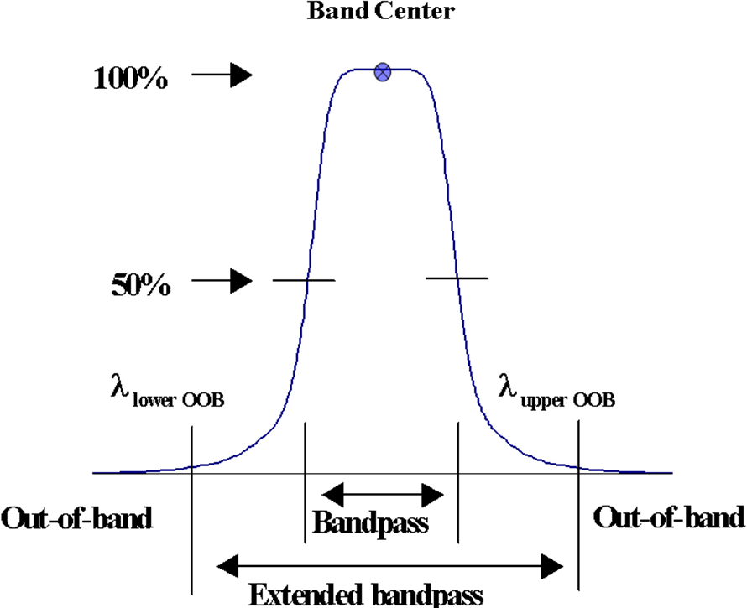

Figure 3: IB RSR for M8

Figure 4: RSR for M8

Figure 5: IB RSR for M9

Figure 6: RSR for M9

Figure 7: IB RSR for M10

Figure 8: RSR for M10

Figure 9: IB RSR for M11

Figure 10: RSR for M11

Figure 11: IB RSR for M12

Figure 12: RSR for M12

Figure 13: IB RSR for M13

Figure 14: RSR for M13

Figure 15: IB RSR for I3 SS1

Figure 16: RSR for I3 SS1

Figure 17: IB RSR for I4 SS1

Figure 18: RSR for I4 SS1

Figure 19: Deviation of center wavelength for average for all SMWIR

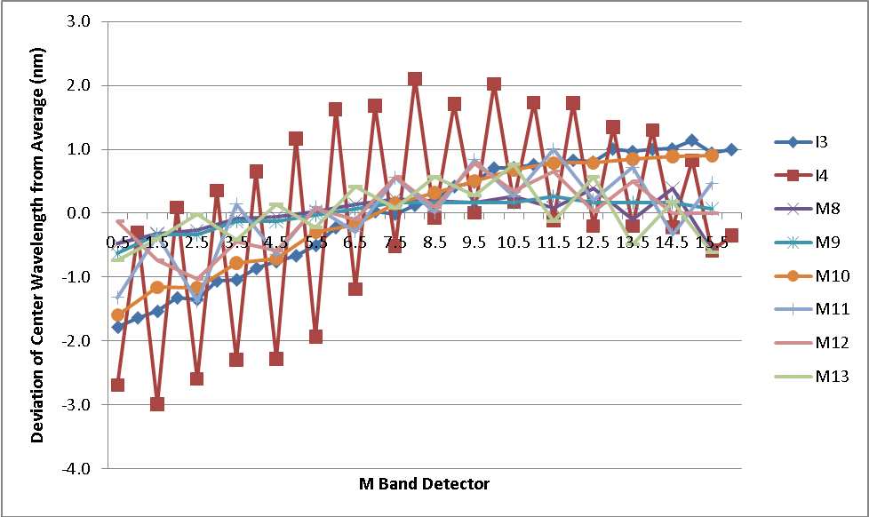

Figure 20: EDU M8 IB RSR for odd detectors (minus edge detectors)

