NICST_MEMO_10_002

NICST Internal Memo

Date: February 22, 2010
From: J. McIntire, T. Schwarting, N. Che, and C. Pan
To: Bruce Guenther, Jim Butler, and Jack Xiong
Subject: Analysis of VIIRS F1 Relative Spectral Response for the LWIR FPA
---------------------------------------------------------------------------------------------------------

References:

[1] TP154640-265, ’Relative Spectral Response, In Band (FP-15) Test Procedure for – VIIRS.’
[2] TP154640-266, ’Relative Spectral Response, Out Of Band and Band-Point Crosstalk (FP-16) Test Procedure for – VIIRS.’
[3] PVP154640-101, ‘Sensor Performance Verification Plan.’
[4] ps154640-101, ‘Performance Specification Sensor Specification.’
[5] NICST_REPORT_09_065, ‘Emissive Band Spectral Response: Preliminary Analysis (A Side),’ J. McIntire, July 6, 2009.
[6] NICST_REPORT_09_067, ‘Emissive Band Spectral Response: Preliminary Analysis (B Side),’ J. McIntire, July 7, 2009.
[7] NICST_REPORT_09_090, ‘Emissive Band RSR: Preliminary Analysis,’ J. McIntire and N. Che, July 22, 2009.
[8] NICST_MEMO_08_031, ‘Shutter Map Investigation for VIIRS EDU FP-15 and FP-16,’ J. McIntire, T. Schwarting, and C. Pan, September 10, 2008.
[9] NICST_MEMO_06_031, ‘VIIRS EDU Preliminary In-band RSR for the Cold Focal Planes,’ D. Moyer, N. Che, J. Xiong, August 24, 2006.
[10] NICST_MEMO_08_042, ‘SMWIR and LWIR Crosstalk Analysis Using VIIRS EDU FP-16 Part 2,’ J. McIntire, T. Schwarting, and C. Pan, December 16, 2008.
[11] 07.0_Sensor Performance, ‘Sensor Performance,’ Eric Johnson and Brendan Robinson, November 2, 2009.

1. Introduction

FP-15 Part 2 and FP-16 Part 2 were performed during VIIRS TV testing (Nominal plateau) in order to determine the spectral characteristics of VIIRS cold focal planes [1-3]. This work will focus on the LWIR In-Band (IB) and Out-Of-Band (OOB) sections of the Relative Spectral Response (RSR) as well as assess compliance with the associated specifications [4]. The data used in this work is listed in Tables 1 – 3. Preliminary results were reported in [5-7].

2. Test Configuration

The source for both FP-15 and FP-16 was the Spectral Measurement Assembly (SpMA) which uses a ceramic source for wavelengths above about 3 µm and a tungsten lamp below 3 µm. The SpMA is a double monochromator operating in subtractive mode and a narrow wavelength output. In FP-15, the SpMA spectral output is relatively narrow and a fine wavelength sampling covering roughly the range between the 1 % response points is used. For FP-16, a larger SpMA spectral output is used (relative to FP-15) and a coarser wavelength sampling is used from approximately 2 – 16 µm. The range is divided into sweeps, each with a different order filter number and grating number; each sweep is contained in a single UAID, listed in Tables 2 and 3. In addition, a higher source radiance is utilized for FP-16 to increase the SNR of OOB measurements. This higher radiance causes saturation during FP-16 for some IB wavelengths (in the LWIR, this occurs only for M14). When saturation of the FP-16 IB wavelengths occurs, an additional IB measurement was conducted using a Neutral Density (ND) filter.

VIIRS cold focal plane detector arrays are staggered into even and odd numbered detector columns; for spectral testing, each detector column is separately tested.

Both FP-15 and FP-16 were conducted in Diagnostic mode with the telescope locked. As both FP-15 and FP-16 are staring tests, the background subtraction was obtained by use of a shutter on the SPMA; the details of the shutter mapping used in this work are contained in [8]. Note that as this test is staring, measurements are conducted using only one HAM side A.

The SpMA output is not constant over wavelength. In addition, different order filters and gratings are used for different wavelength ranges. Each combination of order filter and grating used in LWIR spectral testing was characterized by use of a pyro-electric reference detector located near the SpMA exit slit outside of the thermal vacuum chamber. This Relative Spectral Output (RSO) of the SpMA is used in conjunction with characterization of other optical components in the beam path to correct the measured response in order to simulate a source whose output is uniform with wavelength. This RSO must be characterized for each source (they are liable to failure at which time they are replaced) and are corrected for the optical path from the SpMA to inside the thermal vacuum chamber (including the effects of the fold mirrors and the vacuum chamber window transmission). The different order filters and gratings used are listed in Tables 1 – 3; an example of RSO used in this work over the OOB region measured for LWIR bands (2 – 16 µm) is shown in Figure 1.

3. Data Analysis

This section describes the data processing. First, the EV DN is averaged over all samples (2048 or 4096 for M and I bands respectively). For each collect, there are eight scans. The background subtraction is provided by the use of a shutter on the SpMA which follows a pattern of two scans open followed by two scans closed. The shutter state is determined by the use of the shutter map described in [8]. Then, the shutter closed states are subtracted from the shutter open states and then averaged to determine the EV dn (see also [8]). The dn at each wavelength is corrected by the RSO of the SpMA, or

${\text{dn}}_{\text{COR}}\left(B,D,S,λ\right)=\text{dn}\left(B,D,S,g,f,λ\right)/\text{RSO}\left(g,f,λ\right)$ (1)

where B, D, S, g, f, and λ represent band, detector, subsample, grating, order filter, and wavelength, respectively. Note that this RSO correction was only applied when the SNR was above 3; for a low signal, the RSO correction will exaggerate the noise. For the LWIR, the spectral smile of the SpMA was not measured and therefore no correction was applied. In addition, some overlap in wavelength between gratings and/or filters exists in FP-16; the overlap data from the longer wavelength sweep was discarded. The Relative Spectral Response (RSR) was determined by normalizing the response curve as a function of wavelength to the peak response for each detector individually, or

$\text{RSR}\left(B,D,S,λ\right)={\text{dn}}_{\text{COR}}\left(B,D,S,λ\right)/{\text{dn}}_{\text{COR}}\left(B,D,S,λ_{\text{peak}}\right)$. (2)

Separate RSR curves were constructed for FP-15, FP-16 IB with the ND filter, and FP-16 OOB without the ND filter. This data was combined to form a full RSR curve as described below.

The IB metrics considered here are the center wavelength, the bandwidth, and the 1 % response points (see Figure 2). Both the center wavelength and the bandwidth uncertainties are also characterized. First, the 50 % response points are determined as the wavelengths at which the response falls to 50 % of the peak value. The center wavelength is defined as the point midway between the 50 % response points and the bandwidth is defined as the interval between the 50 % points. Then, the 1 % points are determined in the same manner as the 50 % points. These metrics are compared with the specified limits in [4]. The IB metrics presented in this work are derived from the FP-15 data only. The uncertainties will be addressed in a later work.

In addition, the centroid wavelength is calculated using the following equation,

$λ_{\text{centroid}}\left(B,D,S\right)=\frac{\int{\text{RSR}\left(B,D,S\right)λdλ}}{\int{\text{RSR}\left(B,D,S\right)dλ}}$. (3)

Note that the centroid is not compared to any specification in this work.

The FP-15 IB data is combined with the FP-16 OOB data to form a full RSR curve. First, for those bands that required the additional FP-16 IB measurement with the ND filter, the ND filter transmission τ is determined. The τ is determined by taking the ratio of the response of the unsaturated measurements (with the ND filter) to the same wavelength measurements without the ND filter. These ratios are then averaged to obtain a wavelength independent estimate of τ, or

$τ\left(B,D,S\right)={\left\langle \frac{{\text{dn}}_{\text{COR}−\text{ND}}\left(B,D,S,λ\right)}{{\text{dn}}_{\text{COR}}\left(B,D,S,λ\right)}\right\rangle }_{\text{unsat}}$. (4)

In addition, the standard deviation of the ND filter transmission over all unsaturated wavelengths is determined in order to estimate the stability of the measurement. The derived ND filter transmission average is also compared to the theoretical transmission determined by

$τ_{\text{THEORY}}={\text{10}}^{−\text{ND}}$. (5)

The FP-16 IB measurements with the ND filter are then divided by the ND filter transmission average to obtain the response corrected for ND filter effects, or

${\text{dn}}_{\text{COR}−τ}\left(B,D,S,λ\right)={\text{dn}}_{\text{COR}}\left(B,D,S,λ\right)/τ\left(B,D,S\right)$. (6)

The peak response from Equation (6) may be larger than 4095. The dn_{COR-τ} is used to replace the saturated FP-16 OOB dn (without ND filter) to form a new FP-16 response curve (IB + OOB) which is then normalized to the peak response as in Eq. (2).

The new FP-16 RSR curve is now combined with the FP-15 RSR curve. A peak to peak replacement is used; in other words, the peak response of the FP-15 RSR is matched to the peak response of the FP-16 RSR, with the FP-15 RSR replacing the FP-16 RSR for all wavelengths where the Signal-to-Noise Ratio is greater than or equal 3. The RSR value at this SNR is typically below 0.1 %. The result of this replacement is the final RSR curve.

Lastly, the Integrated Out-Of-Band (IOOB) is calculated. The IOOB is defined as the ratio of the integrated OOB response (i.e. outside the 1 % response points) to the integrated IB response (i.e. between the 1 % response points) when viewing the sum of a diffuse 5800 K blackbody (to simulate an Earth albedo of 1.0) and a 300 K blackbody, or

$\text{IOOB}=\frac{\int{{\text{RSR}}_{\text{OOB}}\left(λ\right)\left[ΩL_{\text{5800}}\left(λ\right)+L_{\text{300}}\left(λ\right)\right]dλ}}{\int{{\text{RSR}}_{\text{IB}}\left(λ\right)\left[ΩL_{\text{5800}}\left(λ\right)+L_{\text{300}}\left(λ\right)\right]dλ}}$. (7)

Where L₅₈₀₀ and L₃₀₀ are the Planck radiances of the 5800 K and 300 K blackbodies and Ω=0.0000217588 is the solid angle centered on the sun that is subtended by the solar diffuser. This factor is meant to simulate the solar reflectance entering the Earth view for a 1.0 albedo earth scene with a 300 K emission temperature.

4. Analysis Results

The IB RSR for band M14 is graphed in Figure 3 as a function of wavelength. Notice that the M14 RSR has two nearly identical peaks (at about 8500 and 8675 nm) and a 25 % dip between these two peaks. For comparison, the EDU RSR for detectors 5 and 9 is shown in Figure 4; for EDU, the M14 IB RSR had only a single peak. The M14 IB metrics are listed in Tables 4 – 5. The center wavelength, and the upper and lower 1 % limits are all within the specified limits. The bandwidth for M14 is slightly non-compliant for all detectors (see Table 5) by less then 1.5 nm. Note that the M14 bandwidth for EDU was well within specification for detectors 5 and 9 (the only detectors measured with a signal over 1000 dn) [9].

M14 is the only LWIR band for which the FP-16 measurement with the ND filter was necessary. The ND filter transmission results are listed in Table 6. The detector averaged derived ND transmission is 0.1543 with an average standard deviation of 0.0070. A 0.9 ND filter was used; this corresponds to a theoretical transmission of 0.125. The full RSR curve including the OOB is shown in Figure 5; no major OOB features were observed. In Table 5, the IOOB results are listed. For M14, all detectors are well within the specified limit of 0.9 % (the average value is 0.3 %).

M15 IB RSR is shown in Figure 6 as a function of wavelength. There is some small detector variation on the short and long sides of the RSR peak. Tables 7 – 8 list the IB metrics for M15. The center wavelength, the bandwidth, and the upper and lower 1 % limits are all within the specified limits. Table 7 shows that the center wavelength is Out Of Family (OOF) for this detector 1.

In Figure 7, the full RSR curve is plotted for M15. Notice that there are three small peaks in the 8.5 µm region; this is well outside the bandpass of M15. Table 8 lists the IOOB. All detectors are slightly non-compliant; the average IOOB for M15 is 0.44 % while the specification is 0.4 %. These non-compliances are driven by the 8.5 µm leak. This OOB leak was also observed in EDU [10].

Figure 8 graphs the IB RSR for band M16A as a function of wavelength. On the short side of the peak, detectors 1 and 2 show a slightly higher RSR; on the long side of the peak, detectors 10 – 16 exhibit a slightly larger response. In Tables 9 – 10, the IB RSR metrics are listed for band M16A. For M16A, the upper and lower 1 % limits are within the specified limits. The center wavelength for M16A is below the specified center by about 155 nm (which is outside the tolerance by approximately 65 nm). The variation in center wavelengths over detector is about 24 nm. Detectors 5 – 7 do not meet the bandwidth specification; these three detectors have bandwidths that are 54 – 58 nm too short (the tolerance is 50 nm). There is strong detector dependence in the bandwidth; detectors 1 and 2 as well as 10 – 16 have bandwidths around 920 nm while detectors 3 – 9 have bandwidths closer to 900 nm.

The full RSR curve is graphed in Figure 9 for M16A. The most prominent features are a couple small peaks in the 8.5 µm region (the largest of which is nearly 1 % of the peak response). The IOOB results are shown in Table 10. The IOOB is above the specified limit (0.4 %) for all detectors (the average value is 0.62 %). As with M15, the 8.5 µm leak causes these non-compliances. This OOB leak was also observed in EDU [10].

The IB RSR for band M16B is graphed in Figure 10 as a function of wavelength. On the long side of the peak detectors 10 – 16 exhibit a slightly larger response (similar to M16A); in addition, on the short side of the peak, detector 1 shows a slightly higher RSR. The IB RSR metrics are listed in Tables 11 – 12 for band M16B. The bandwidth, as well as the upper and lower 1 % limits, are all within the specified tolerances. As with M16A, the M16B center wavelength is about 150 nm below the specified center, which is about 60 nm outside the allowed tolerance. In addition, there is approximately a 25 nm spread in the center wavelengths for M16B. There is also strong detector dependence in the bandwidth, although the variation is smaller then in M16A.

In Figure 11, the full RSR curve for M16B is shown. Similar to M16A, there are a couple small peaks in the 8.5 µm region (the largest of which is nearly 1 % of the peak response). Table 12 lists the IOOB results. All detectors are outside the specified limit (0.4 %); the average IOOB for M16B is 0.59 %. As with both M15 and M16A, the 8.5 µm leak drives these non-compliances. This OOB leak was also observed in EDU [10].

Figure 12 shows the IB RSR for I5 subsample 1 (SS1) as a function of wavelength. The main peak is at the short edge of the bandpass and there are four progressively smaller peaks as the wavelength gets longer within the bandpass. In addition, detectors 1 and 2 exhibit OOF behavior on the long side of the I5 bandpass. Tables 13 – 16 list the IB RSR metrics for I5 SS1. The center wavelength, bandwidth, and lower 1 % limit are all within the specified limits. The center wavelength is OOF for detectors 1 and 2; for both of these detectors, the bandpass is short on the long wavelength side, which causes their center wavelength to be shorter than other detectors. There is strong odd – even dependence in the bandwidth; the odd and even detectors cluster in two separate groups about 50 – 60 nm apart. In addition, the upper 1 % limit is non-compliant with the specification by a margin of 100 – 200 nm.

The full RSR for I5 SS1 is plotted in Figure 13. I5 has a much higher noise floor for the OOB response (just below 1 % of peak response). The IOOB results are listed in Tables 15 and 16. All even detectors as well as detectors 1 and 31 are non-compliant with the specification (0.4 %); the average value is 0.63 %. Detector 1 is just above the specified limit and detector 31 is known to be OOF. The even detectors had a low SNR due to an incorrect SpMA setting [11].

Figure 14 shows the deviation of center wavelength from the average for all the LWIR bands. Note that no SpMA smile correction was made for the LWIR. All LWIR bands except M14 show a general downward trend from high number detectors to low number detectors (from about 5 – 10 nm above average to 10 nm below average). The decrease is more pronounced for I5 detectors 1 and 2 (as mentioned previously). In addition, there is strong odd – even dependence in I5. M14 detector variation in center wavelength is relatively constant to within about 5 nm.

The spectral characteristics listed in this work (particularly the non-compliances) need to be evaluated in terms of their impact on the Environmental Data Record (EDR). The driving EDRs for the LWIR bands are Cloud Imagery (I5), SST (M15 and M16), and Cloud Top Properties (M14, M15, M16).

5. Summary

- VIIRS F1 LWIR spectral characteristics are largely within the specifications. All non-compliances are well characterized by the measurements. The following metrics are non-compliant:
  - Center wavelength: M16A and M16B (all detectors)
  - Bandwidth: M14 (all detectors) and M16A (D5-7)
  - Upper 1 % limit: I5 (all detectors)
  - IOOB: M15, M16A, and M16B (all detectors), as well as I5 (all even detectors, D1, and D31)
- VIIRS F1 LWIR spectral characteristics are generally consistent with VIIRS EDU measurements. The exception is M14; the bandwidth was well within the specifications for EDU, but non-compliant for F1.

Acknowledgement
The sensor test data used in this document was provided by the Raytheon El Segundo testing team. Approaches for data acquisition and data reductions, as well as data extraction tools were also provided by Raytheon. We would like to thank the Raytheon El Segundo team for their support. The data analysis tools were developed by the NICST team, and we would like to extend our gratitude for their valued assistance.

Table 1: VIIRS F1 FP-15 and FP-16 LWIR IB RSR data

Table 2: VIIRS F1 FP-16 LWIR OOB RSR data

Table 3: VIIRS F1 FP-16 LWIR OOB RSR data
Table 4: Center wavelength and bandwidth for M14

Table 5: 1 % limits and IOOB for M14

Table 6: ND filter transmission for M14

Table 7: Center wavelength and bandwidth for M15

Table 8: 1 % limits and IOOB for M15

Table 9: Center wavelength and bandwidth for M16A

Table 10: 1 % limits and IOOB for M16A

Table 11: Center wavelength and bandwidth for M16B

Table 12: 1 % limits and IOOB for M16B

Table 13: Center wavelength and bandwidth for I5 SS1

Table 14: Center wavelength and bandwidth for I5 SS1

Table 15: 1 % limits and IOOB for I5 SS1

Table 16: 1 % limits and IOOB for I5 SS1

Figure 1: SpMA RSO

Figure 2: Spectral Characteristics

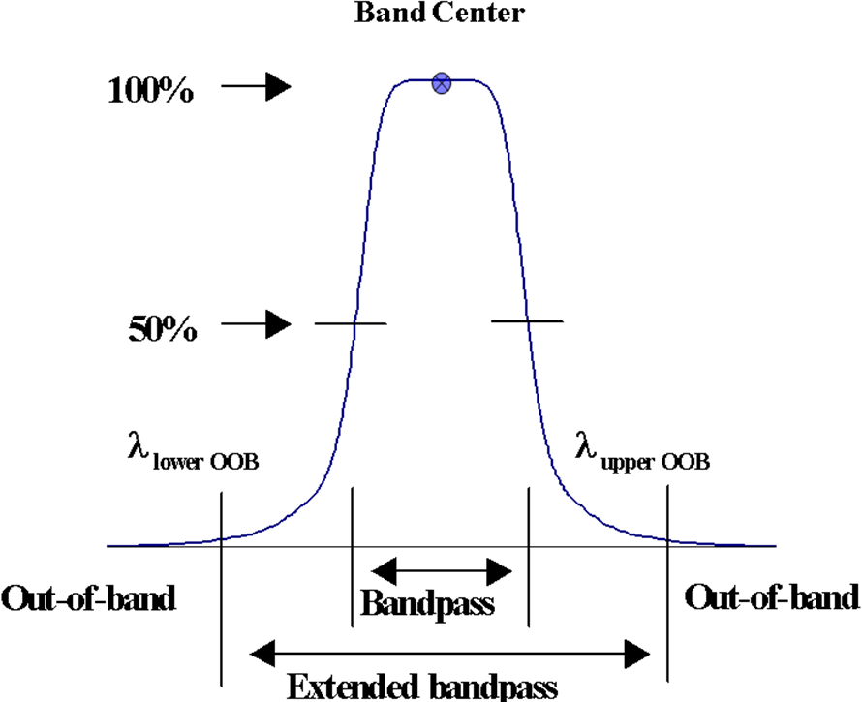

Figure 3: IB RSR for M14

Figure 4: EDU RSR for M14

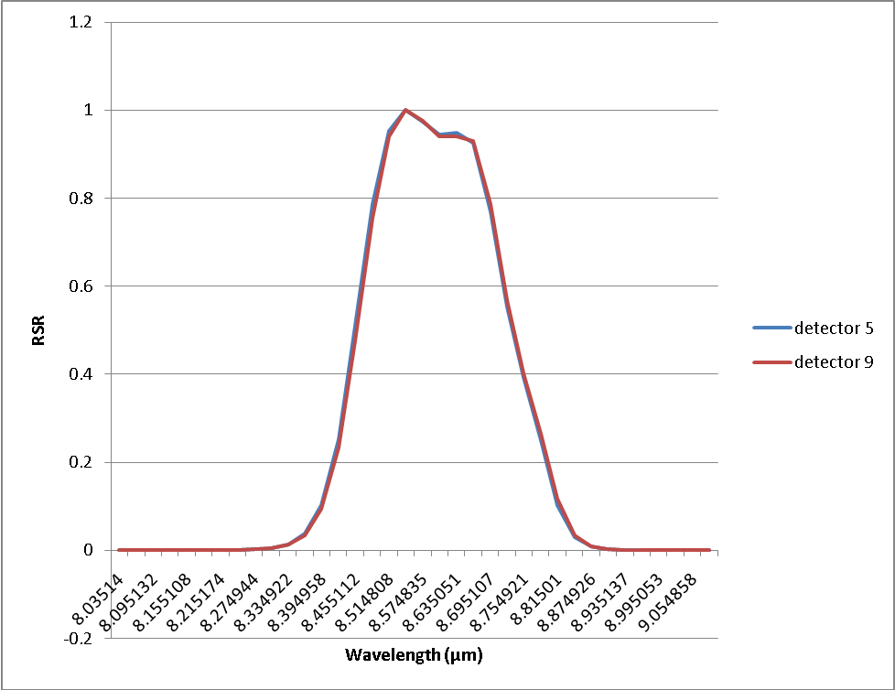

Figure 5: RSR for M14

Figure 6: IB RSR for M15

Figure 7: RSR for M15

Figure 8: IB RSR for M16A

Figure 9: RSR for M16A

Figure 10: IB RSR for M16B

Figure 11: RSR for M16B

Figure 12: IB RSR for I5

Figure 13: RSR for I5

Figure 14: Deviation of center wavelength from average for all LWIR bands

