NICST_MEMO_08_035

NICST Internal Memo

Date: October 14, 2008
From: J McIntire, C. Pan, and S. Xiong
To: Bruce Guenther, Jim Butler, Jack Xiong
Subject: Analysis Results for VIIRS EDU RC-05 Parts 1 and 2, Cold Plateau
---------------------------------------------------------------------------------------------------------

References:

[1] NICST_REPORT_06_003, ‘Preliminary analysis report of EDU TV cold plateau RC-05 Part 1 (22V) radiometric characterization for Thermal Emissive Bands (TEB),’ July 12, 2006.
[2] NICST_REPORT_06_005, ‘Preliminary analysis report of VIIRS EDU RC-05 Part 1 in TV at Cold Plateau for all Three Voltage Levels,’ July 14, 2006.
[3] NICST_REPORT_06_025, ‘Radiometric Characterization Report of EDU RC-05 Part 1 Using BCS at Hot Plateau (28V) and Comparison with Cold & Nominal,’ December 13, 2006.
[4] ‘Performance Specification Sensor Specification,’ ps154640-101c.
[5] Y18352, ‘Performance Verification Review: Thermal Emissive Band Radiometric response Characterization (RC-3 and RC-5 Tests),’ Eric Johnson and Jim Young, January 18, 2006.
[6] ‘Sensor Performance Verification Plan,’ PVP154640-101.
[7] NICST_MEMO_08_024, ‘Updated Analysis Results for VIIRS EDU RC-05 Part 1, Nominal Plateau at 28V,’ J. McIntire, C. Pan, and S. Xiong, July 1, 2008.
[8] NICST_MEMO_08_026, ‘Updated Analysis of the Radiometric Calibration from the VIIRS EDU RC-05 Part 2 Test (Nominal Plateau at 28V),’ J. McIntire, C. Pan, and S. Xiong, August 19, 2008.

1. Introduction

This memo documents the analysis results of Parts 1 and 2 of VIIRS EDU RC-05 conducted during the Cold Plateau of the Thermal Vacuum (TVAC) test. The purpose of RC-05 was to characterize the Thermal Emissive Bands (TEB) radiometric behavior at three different temperature plateaus. There are two parts to this test at each temperature plateau. The first part assesses the response to external sources: the Blackbody Calibration Source (BCS) and the Three Mirror Collimator (TMC) blackbody. The second portion characterizes the response to an internal source, the On-board Blackbody Calibrator (OBC). The current work focuses on the radiometric response (as an expansion on preliminary work [1-3]) and, in addition, assesses the sensor performance against a number of specifications [4] (nonlinearity, characterization uncertainty, radiance difference, response uncertainty, and OBC temperature sensitivity and stability).

Table 1 lists the BCS and TMC temperatures for each UAID in RC-05 Part 1 for 22V, 28V, and 34V, respectively. The BCS and TMC data is contained in separate collects. Table 2 lists the OBC temperature for each UAID in RC-05 Part 2. Each collect contains 100 scans. The BCS source was located in the last collect window and the TMC source was located in the middle collect window. In addition, the Space View Source (SVS) was positioned in the Space View (SV) port. The TMC source was used to access band M13 low gain (lg); M13 high gain (hg) was accessed using the BCS. The VIIRS sensor was operated in diagnostic mode. The general outline of the methodology used in this work follows from [5-6] with some modifications. The specifications considered in this memo are listed in Table 3 – 4 [4].

2. Data processing

The data processing and algorithms used here were described in detail in [7,8], and as a result, are not repeated here. However, the following modifications have been made:

- The background subtracted source radiances are converted from f9 to f6 by
${ΔL}_{f6}={ΔL}_{f9}{\left(\frac{6}{9}\right)}^{2}$. (1)
Thus, all the calculations and results presented here are for f6. In addition, the specifications compared to in this work were written for f6.
- The subsamples for the I bands are now labeled as follows: the first subsample is labeled 1 and the second subsample is labeled 2.
- For the TMC portion, the emissivity of the TMC is now initially assumed to be one. In addition, only the high temperature collects are used. The background subtracted radiance is calculated and the quadratic fitting is conducted as in [7]. The retrieved radiance for the high temperature collects is then calculated using the coefficients just determined. From this, we construct the emissivity of the TMC via the equation
$ε_{\text{TMC}}\left(B,D,C\right)=\frac{{\left\langle L_{\text{TMC}}\left(B,D,C\right)\right\rangle }_{\text{retrieved}}−\left\langle L_{\text{Bkg}}\left(B,D,C\right)\right\rangle }{\left\langle L_{\text{TMC}}\left(B,D,C\right)\right\rangle −\left\langle L_{\text{Bkg}}\left(B,D,C\right)\right\rangle }$. (2)
The background radiance is defined in [7] and is averaged over Half Angle Mirror (HAM) sides. Now, the process is repeated with the new emissivity. This process is iterated until the TMC emissivity converges.
- The Radiometric Response Characterization Uncertainty (RRCU) is now generated by the following:
$\text{RRCU}={\text{mean}}_{C}\left(Δ_{\text{fit}}\right)+σ_{C}\left(Δ_{\text{fit}}\right)$. (3)
Here $Δ_{\text{fit}}$ is the fractional radiance residual, defined in [8].
- All calculations include the Relative Spectral Response (RSR) correction.
- The retrieved radiance for the OBC in Part 2 is calculated using
${\left\langle L_{\text{OBC}}\left(B,D,j_{H},T_{\text{OBC}},N\right)\right\rangle }_{\text{ret}}=\sum_{i=0}^{N}{a_{i}{\text{dn}}_{\text{OBC}}^{i}\left(B,D,j_{H},T_{\text{OBC}}\right)}+\left\langle L_{\text{Bkg}}\left(B,D,j_{H},T_{\text{OBC}}\right)\right\rangle$. (4)
where the background radiance is defined in [8].

3. Analysis

3.1 Radiometric Gains (Part 1)

The radiometric gains for each individual detector determined for Part 1 of the Cold Plateau at 22V, 28V, and 34V are listed in Tables 5 – 7, respectively. These gains were evaluated using a quadratic fit. Note that all the gains given here are f6 and that only HAM side A is presented. HAM sides A and B agree to within 0.7% for all bands and detectors. Furthermore, the gains vary over detectors by as much as 16% (band I5). Figure 1 shows this variation in gain over detectors for each band (except M13 lg) for BUS voltages of 22V, 28V, and 34V. Notice that odd – even difference in the detector gains is particularly clear in the MWIR.

Table 8 lists the detector averaged radiometric gains (HAM side A) for all bands and subsamples over the three BUS voltages. As detector 1 for band M14 is Out Of Family (OOF), it is not included in these or any subsequent averages. Here the results of quadratic fitting are shown along with the maximum radiance fitting residual (within the dynamic range). The gains are stable across BUS voltages to within 1%. Note that the residual for band I4 at 28V is much larger then for the other BUS voltages; the lowest data point inside the I4 dynamic range is not consistent with this model, as will be seen below.

An increase in fitting level from quadratic to cubic yields less than a 2% change in the average gain. The fitting residual exhibits improvement from quadratic to cubic for bands M12 and M13 hg (as seen in Table 9), but little or no change for the LWIR bands. We stress that it is undetermined whether a cubic fit is an appropriate model here. Higher order polynomials are more unstable and the fitting residual may result from test artifacts, especially at the low end of the dynamic range.

Figure 2 shows for each band (except M13 lg) plots of quadratic fits to dn versus ${ΔL}_{\text{BCS}}$ for 28V and Figure 3 compares the quadratic fits to dn versus ${ΔL}_{\text{BCS}}$ for the middle detector of each band for all three voltages. In Figure 2, it is clear that detector 1 for band M14 is OOF. It is clear from Figure 3 that there is little variation in the fitting across voltages. The dynamic range requirement was not fully tested as no band was close to L_{MAX} in the range of measured values (note that this is a result of the data being recorded in f9). Note that the dynamic range is marked: L_{MIN} in green, L_{TYP} in blue, and L_{MAX} in red.

Figure 4 is a plot of the quadratic (upper graph) and cubic (lower graph) fractional radiance fitting residuals in the dynamic range for band M12 at 28V. Again, note that the vertical dashed lines represent L_{MIN} (green), L_{TYP} (blue), and L_{MAX} (red). The fitting residual improves at the low end of the dynamic range when the cubic fit is used instead of the quadratic fit. Figure 5 shows the same graph for band M13 hg. Again, the improvement in the fitting residual is observed for the cubic fit relative to the quadratic fit. The other bands show limited to no improvement when using a cubic polynomial fit. Again, we stress that whether a cubic polynomial is an appropriate model here is undetermined.

Graphs of band I4 at 28V for linear, quadratic and cubic fits to dn versus ${ΔL}_{\text{BCS}}$ are given in Figure 6, where only the low radiance portion is shown. The third data point (corresponding to a BCS temperature of 230 K and the first point inside the I4 dynamic range) is OOF; it has a much larger fitting residual. This point is shown clearly off the fitting lines for all detectors and polynomial fitting levels. In previous work [7], this point was discarded for the Nominal Plateau at 28V. However, as this anomaly occurs at multiple plateaus, always at a BCS temperature of 230 K, it is retained here.

The calculated TMC emissivity is 0.9405 and 0.9403 for 22V and 28V respectively.

3.2 Radiometric Gains (Part 2)

The radiometric gains for each detector as determined from the Part 2 analysis are listed in Tables 10 (warm-up) and 11 (cool-down). The detector averaged values are listed in Table 12. A quadratic fit was used for both the warm-up and cool-down cases. Note that all the results given here are f6, that only HAM side A is presented, and that M13 lg is not accessible using the OBC. HAM sides A and B agree to within 0.9% for all bands and detectors. Furthermore, the gain variation over detectors is as much as 18% (band I5). Figure 7 shows this gain variation over detectors and bands for both warm-up and cool-down. Again, notice that odd – even difference in the detector gains is particularly clear in the MWIR.

Figures 8 and 9 show, for each band (except M13 lg), plots of quadratic fits to dn versus ${ΔL}_{\text{BCS}}$ for the warm-up and cool-down, respectively.

3.3 Specifications (Part 1)

The RRCU for all three BUS voltages are shown in Tables 13 and 14 for the detector average and worst case detector (HAM side A), respectively. The calculations for both quadratic and cubic fits are shown. The specification (SRV0448 [4]) is meet if RRCU < 0.1%. Those bands that failed are marked in red. For 28V, band I5, detector 24 and band M15, detectors 6 and 13 fail the specification by a small amount. Detectors 7 and 10 for 22V, 7 and 16 for 28V, and 7 for 34V in band M14 also fail the requirement by a small amount. Band M14, detector 1 for all three BUS voltages is OOF and was not included in either Table 15 or 16. The MWIR bands (I4, M12, and M13 hg) all fail the specification for both detector averaged and worst case RRCU for all three voltages. There is marked improvement in bands M12 and M13 hg when a cubic fit is considered; however, I4 show little to no improvement when using a cubic fit. The OOF family data point in I4 for 28V causes the RRCU to be very large, on the order of 10%. Figures 10 – 12 show the RRCU for each MWIR band as a function of detector for the three voltages, respectively. The black line delineates the quadratic fit and the red line represents the cubic fit; the dashed red line indicates the requirement (0.1%).

The nonlinearity requirement (SRV0595 [4]) is addressed by the Relative Response Non-Linearity (RRNL), listed in Tables 15 and 16 for the detector averaged and worst case detector, respectively. The nonlinearity requirement is met if RRNL < 1%. All detectors and bands meet this requirement, except band M14, detector 1. Note that only the linear fit is used to determine the RRNL [4].

The Absolute Radiance Difference (ARD) for 22V, 28V, 34V is listed in Tables 17 – 19 for the worst case detector (excluding band M14, detector 1), respectively. The requirements for the ARD (SRV0545 and SRV0546 [4]) are listed in Table 4. The closest BCS temperature to the scene temperatures in Table 4 is compared to the specification; scenes that fail this requirement are highlighted in red and those that pass the requirement are highlighted in green. Scene temperatures that are outside the dynamic range are highlighted in blue. The ARD met the requirement for all bands and scene temperatures except for 28V, bands M12 and M13 hg at 230 K and band M15 at 190 K, as well as for 34V, bands M12 and M13 hg at 270 K. Figures 13 – 17 plot the ARD for those scene temperatures that fail to meet the requirement.

The Relative Response uniformity (RRU) addresses the requirement SRV0613 [4]. This specification is satisfied if RRU < 1. Tables 20 – 22 list the worst case detector RRU for 22V, 28V, and 34V (excluding band M14, detector 1), respectively. The RRU that failed the specification are marked in red; the RRU that are outside the dynamic range are highlighted in blue. Figures 18 – 20 show the RRU for band M12 that fail this specification.

3.4 Specifications (Part 2)

Figure 21 shows that the OBC is controllable over the temperature range from ambient to 315 K, in compliance with SRV0598 [4]. Figure 22 plots the OBC temperature vs scan for all the collects in the warm-up cycle. It is clear that, as the temperature is stable to within ±0.2 K, SRV0654 is satisfied [4]. The standard deviation of the OBC temperature (warm-up) for each of thermistor is plotted in Figure 23. For the warm-up collects the standard deviation is less than 0.03 K, in compliance with SRV0095 [4].

Table 23 lists the worst case detector ARD for both the OBC warm-up and cool-down. The ARD is compared to the closest scene temperature in Table 4; the ARD met the requirements for the scene temperatures accessed by the OBC. Again, green indicates compliance and red represents failure.

4. Summary

- All TEB Radiometric gains were determined for RC-05 Parts 1 and 2 of the Cold Plateau at 22V, 28V, and 34V.
- OOF data point observed for band I4 at BCS temperature of 230 K and BUS voltage of 28V.
- HAM side difference in gains is negligible for both Parts 1 and 2 (less than 0.9%).
- Use of cubic polynomial improves the fitting residual at the low temperature for bands M12 and M13 hg.
- Odd – even detector difference in MWIR detectors is evident (4 – 5 %).
- Gain variation of as much as 18% (band I5) over all detectors is observed.
- Band M14, detector 1 is OOF.
- RRCU does not meet the specification (SRV0448) for bands I4, M12, and M13 hg using a quadratic fit. M12 and M13 hg almost meet the specification when a cubic fit is employed.
- RRNL meets the specification for all bands (SRV0595), except detector 1 from band M14.
- ARD for Parts 1 and 2 meet specification for all bands (SRV0545 and SRV0546), except bands M12, M13 hg, and M15.
- RRU meet specification for all bands (SRV0613), except bands M12, M14, and M15.
- OBC requirements SRV0598, SRV0654, and SRV0095 are all met.

Acknowledgement
The sensor test data used in this document was provided by the SBRS testing team. Approaches for data acquisition and data reductions, as well as data extraction tools were also provided by the SBRS. We would like to thank the SBRS team for their support. The data analysis tools were developed by the NICST team, and we would like to extend our gratitude for their valued assistance.

Table 1: EDU RC-05 Part 1 UAIDs for the Cold Plateau with corresponding BCS and TMC temperatures.

Table 2: EDU RC-05 Part 2 UAIDs for the Cold Plateau at 28V with corresponding OBC temperatures.

Table 3: Specifications addressed by this work [4].

Table 4: Absolute radiometric calibration uncertainty of the spectral radiance for emissive bands [4].

Table 5: Radiometric gains (f6) for TEB bands calculated from Part 1 of the Cold Plateau at 22V (HAM side A).

Table 6: Radiometric gains (f6) for TEB bands calculated from Part 1 of the Cold Plateau at 28V (HAM side A).

Table 7: Radiometric gains (f6) for TEB bands calculated from Part 1 of the Cold Plateau at 34V (HAM side A).

Table 8: Detector averaged radiometric gains (f6) with corresponding maximum fitting residual from Part 1 of the Cold Plateau (HAM side A).

Table 9: Comparison of quadratic and cubic fits with corresponding maximum fitting residuals from Part 1 of the Cold Plateau (HAM side A).

Table 10: Radiometric gains (f6) for TEB bands calculated from the Part 2 warm-up, Cold Plateau at 28V (HAM side A).

Table 11: Radiometric gains (f6) for TEB bands calculated from the Part 2 cool-down, Cold Plateau at 28V (HAM side A).

Table 12: Detector averaged radiometric gains (f6) for Part 2, Cold Plateau at 28V (HAM side A).

Table 13: RRCU detector averaged for HAM side A.

Table 14: RRCU worst case detector for HAM side A.

Table 15: RRNL detector averaged for HAM side A.

Table 16: RRNL worst case detector for HAM side A.

Table 17: ARD worst case detector from Part 1 of the Cold Plateau (22V) and HAM A.

Table 18: ARD worst case detector from Part 1 of the Cold Plateau (28V) and HAM A.

Table 19: ARD worst case detector from Part 1 of the Cold Plateau (34V) and HAM A.

Table 20: RRU worst case detector from Part 1 of the Cold Plateau (22V) and HAM A.

Table 21: RRU worst case detector from Part 1 of the Cold Plateau (28V) and HAM A.

Table 22: RRU worst case detector from Part 1 of the Cold Plateau (34V) and HAM A.

Table 23: Cold Plateau (28V) ARD worst case detector for Part 2.

Figure 1: Radiometric gains from Part 1 of the Cold Plateau as a function of detector for all bands (except M13 lg), HAM side A, and subsample 1.

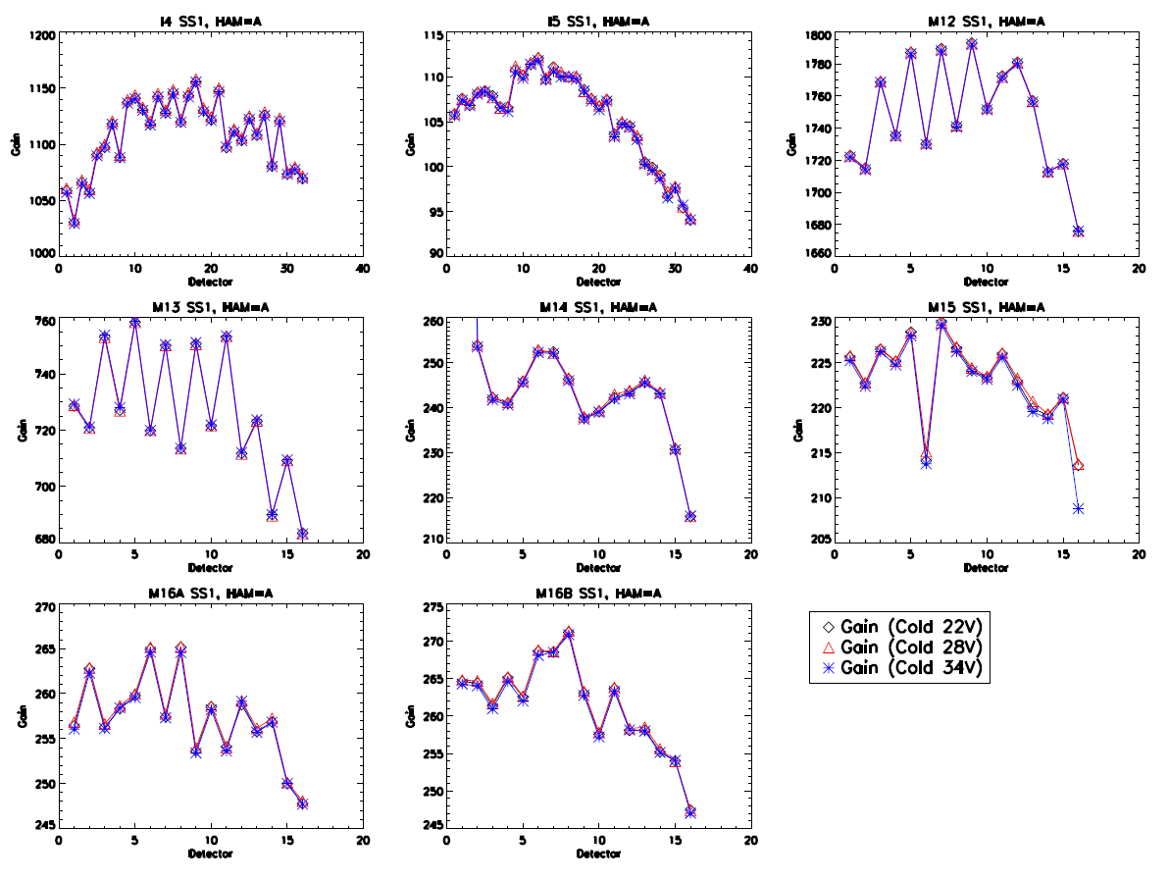

Figure 2: dn versus ΔL_{BCS} for all TEB from Part 1 of the Cold Plateau at 28V (subsample 1 and HAM side A).

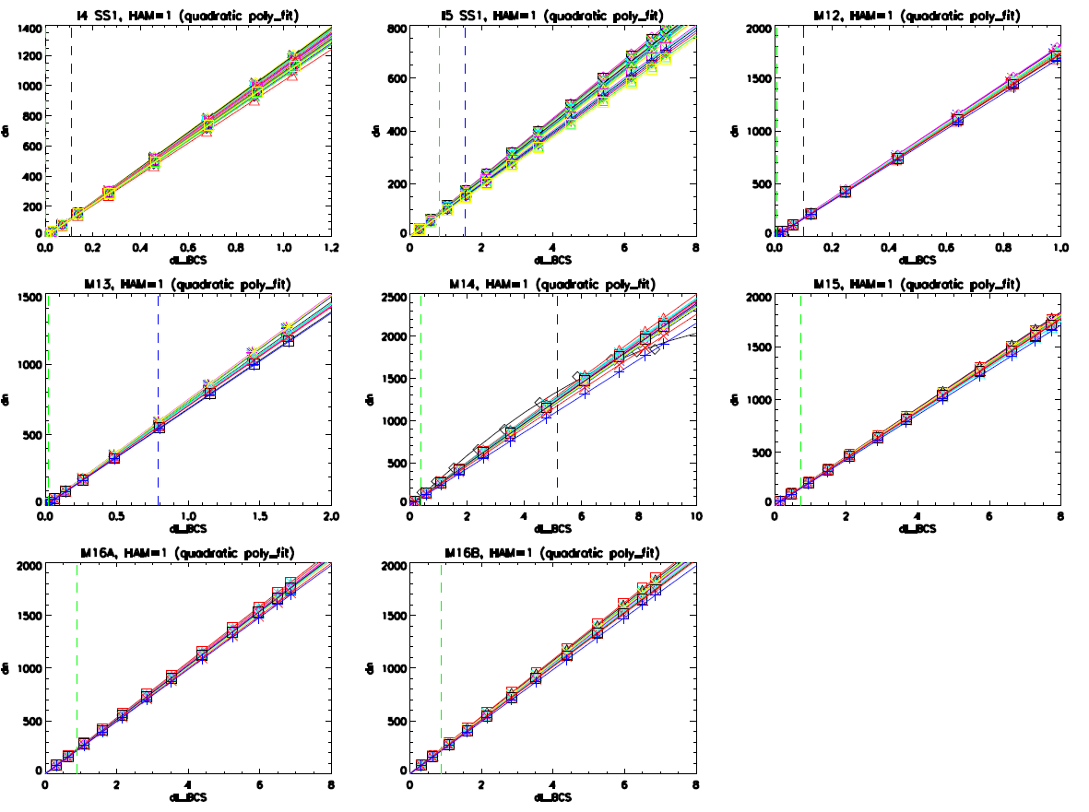
M14, detector 1 is OOF

Figure 3: dn versus ΔL_{BCS} for all TEB from Part 1 of the Cold Plateau for the middle detector at each voltage (subsample 1 and HAM side A).

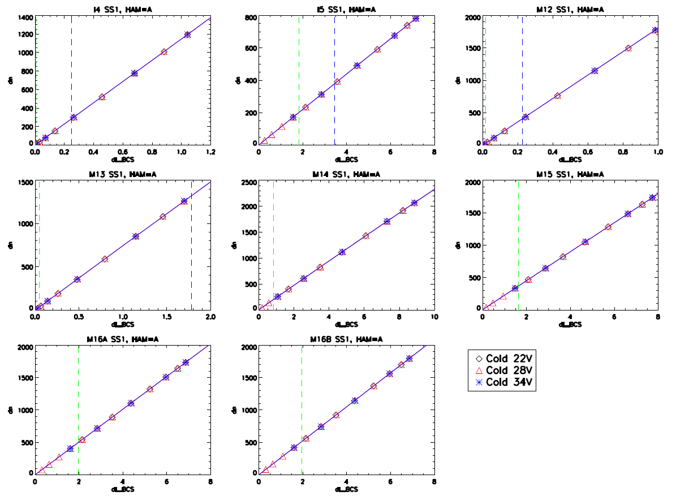

Figure 4: M12 fractional radiance residuals from Part 1 of the Cold Plateau at 28V (HAM side A).

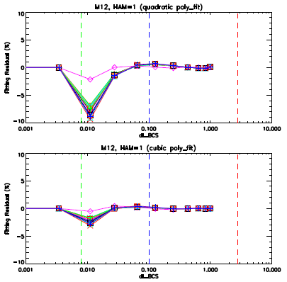

Figure 5: M13 hg fractional radiance residuals from Part 1 of the Cold Plateau at 28V (HAM side A).

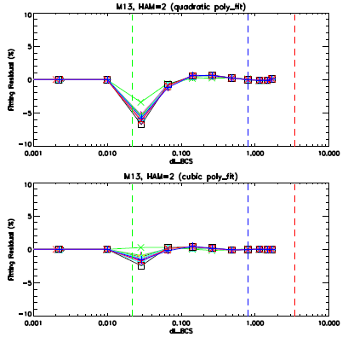

Figure 6: dn versus ΔL_{BCS} for I4 SS1 from Part 1 of the Cold Plateau at 28V (subsample 1 and HAM side A) for the low end of the dynamic range.

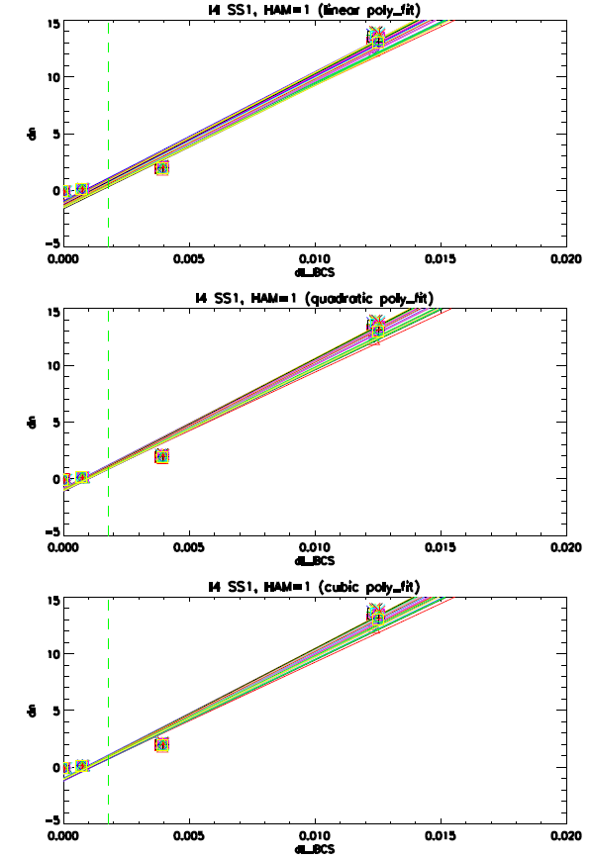
OOF data point

Figure 7: Part 2 warm-up and cool-down radiometric gains from the Cold Plateau (28V) as a function of detector for all bands (except M13 lg), HAM side A, and subsample 1.

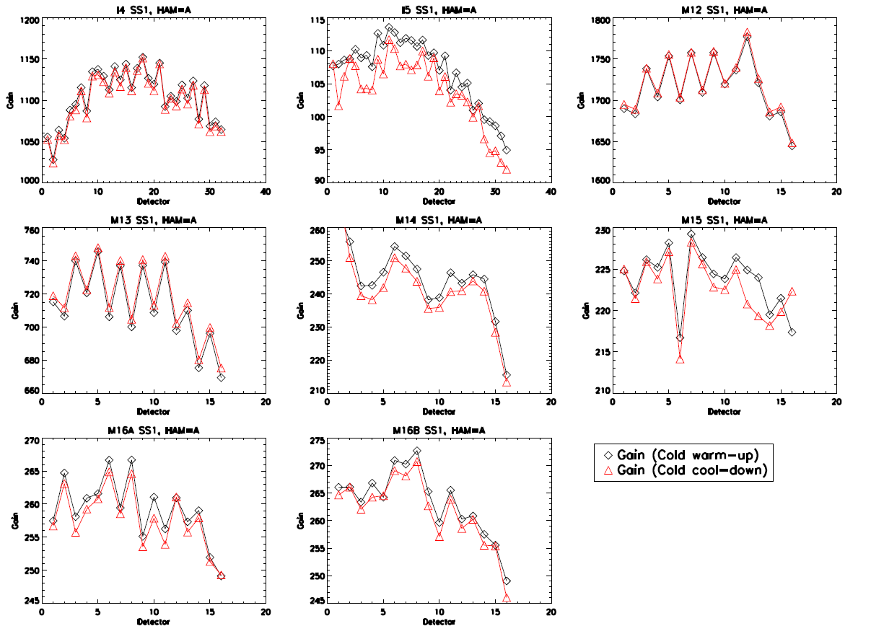

Figure 8: dn versus ΔL_{BCS} for all TEB from the Cold Plateau at 28V Part 2 warm-up (subsample 1 and HAM side A).

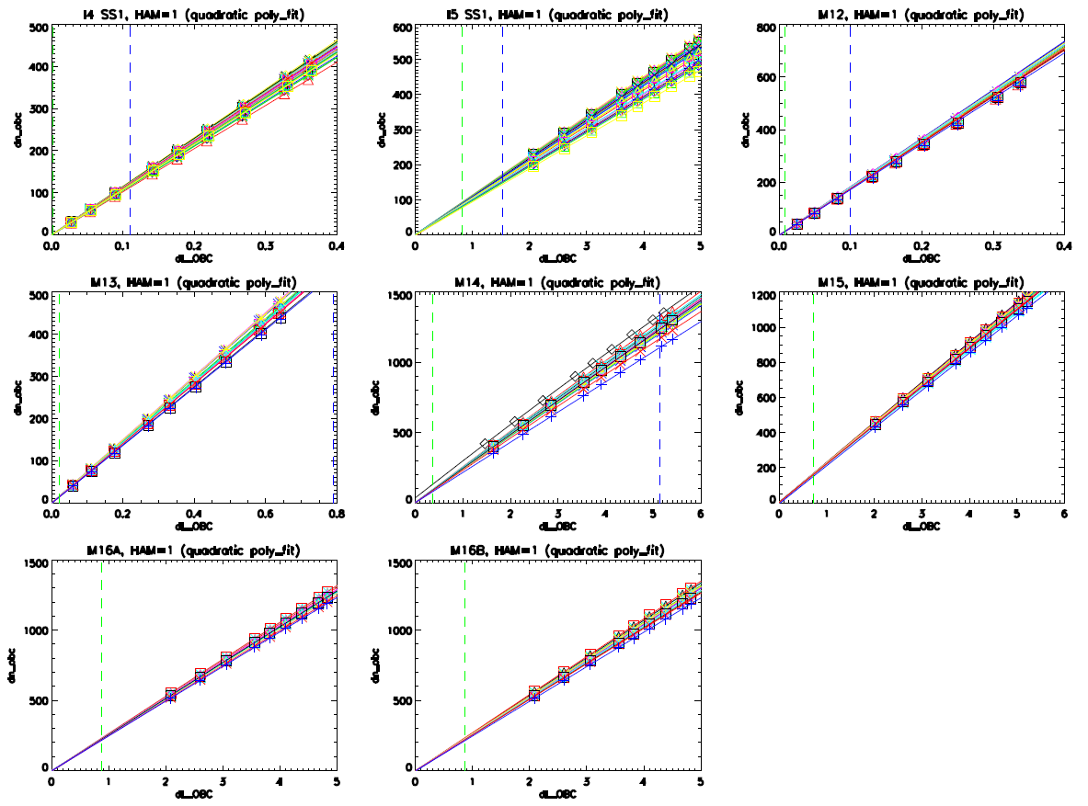

Figure 9: dn versus ΔL_{BCS} for all TEB from the Cold Plateau at 28V Part 2 cool-down (subsample 1 and HAM side A).

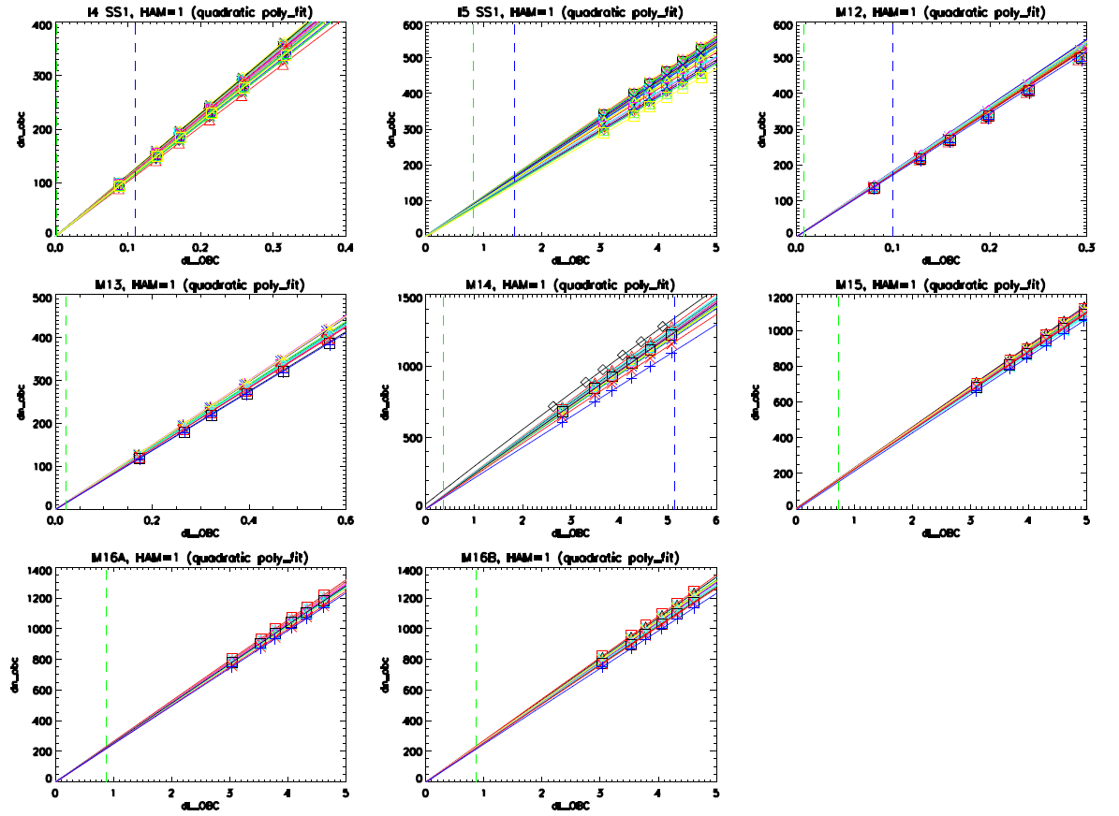

Figure 10: Part 1 of the Cold Plateau (22V) RRCU for both quadratic and cubic fits (black and red, respectively).

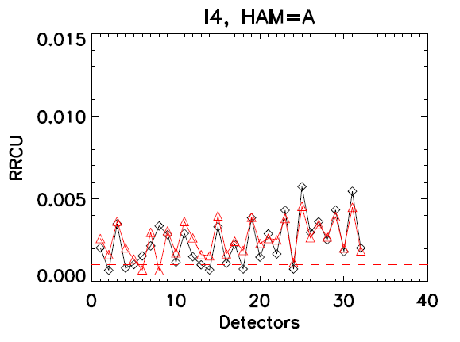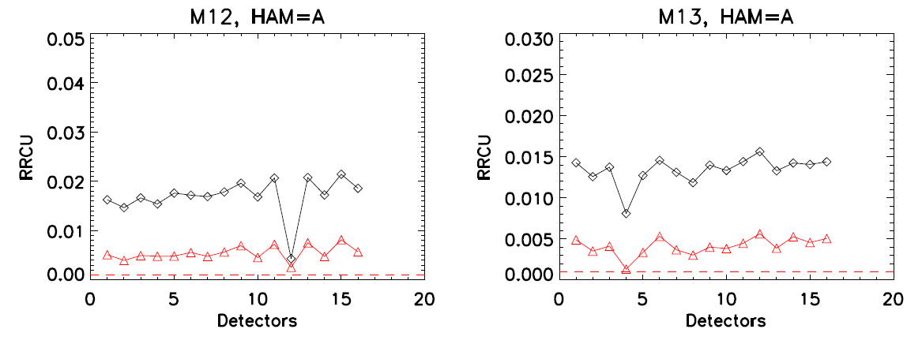

Figure 11: Part 1 of the Cold Plateau (28V) RRCU for both quadratic and cubic fits (black and red, respectively).

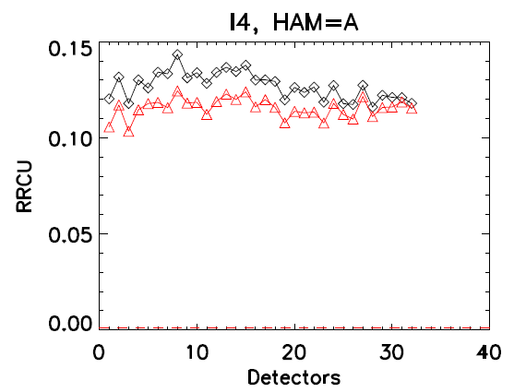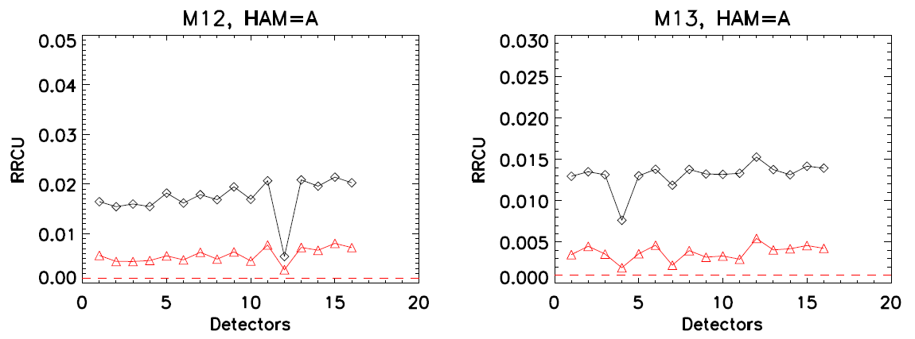
Figure 12: Part 1 of the Cold Plateau (34V) RRCU for both quadratic and cubic fits (black and red, respectively).

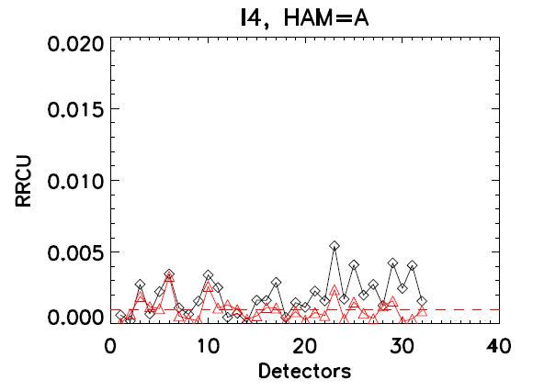
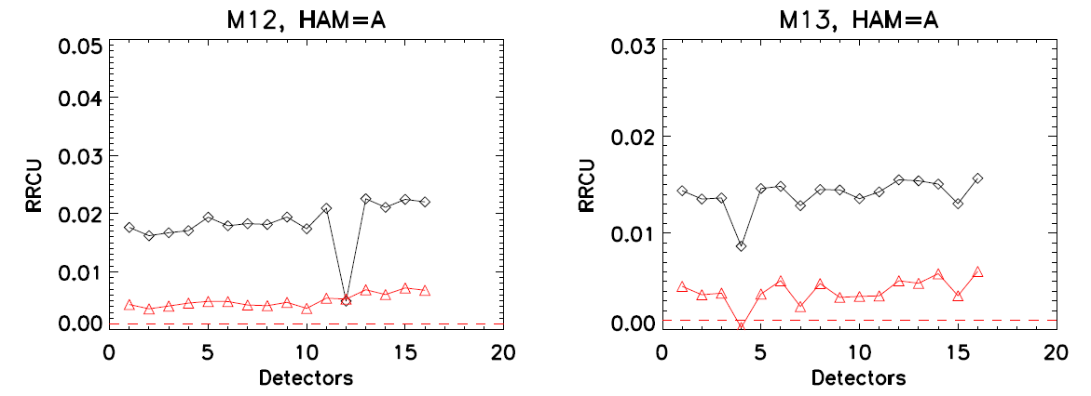

Figure 13: Part 1 of the Cold Plateau (28V) M12 ARD for HAM side A.

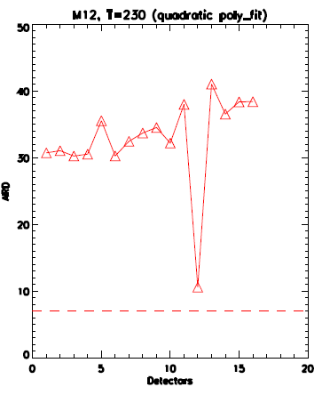

Figure 14: Part 1 of the Cold Plateau (34V) M12 ARD for HAM side A.

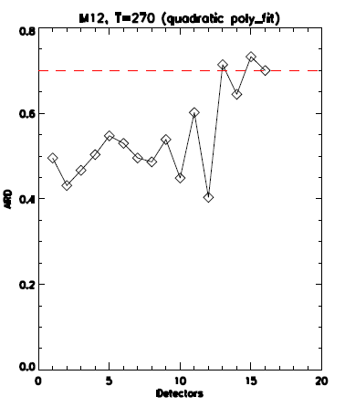

Figure 15: Part 1 of the Cold Plateau (28V) M13 hg ARD for HAM side A.

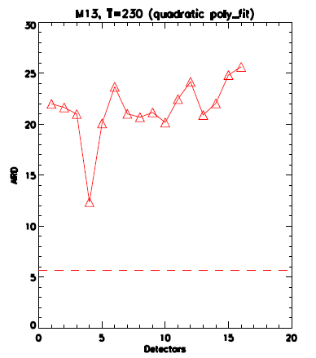
Figure 16: Part 1 of the Cold Plateau (34V) M13 hg ARD for HAM side A.

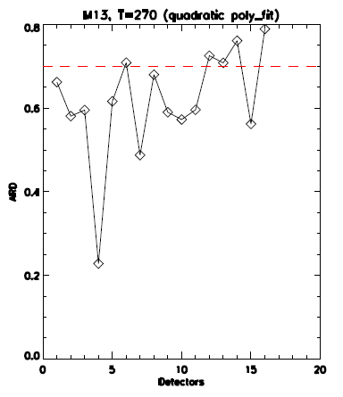

Figure 17: Part 1 of the Cold Plateau (28V) M15 ARD for HAM side A.

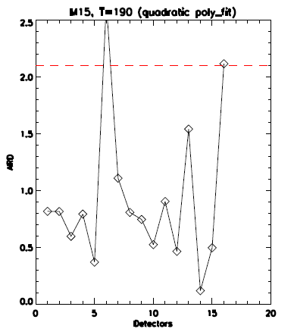

Figure 18: Part 1 of the Cold Plateau (22V) RRU for HAM side A (subsample 1 for I bands).

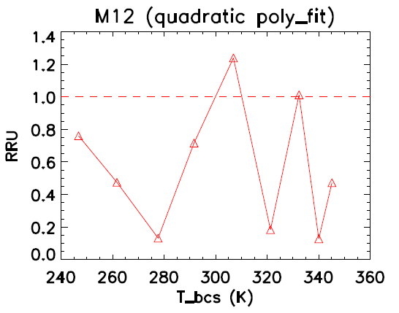

Figure 19: Part 1 of the Cold Plateau (28V) RRU for HAM side A (subsample 1 for I bands).

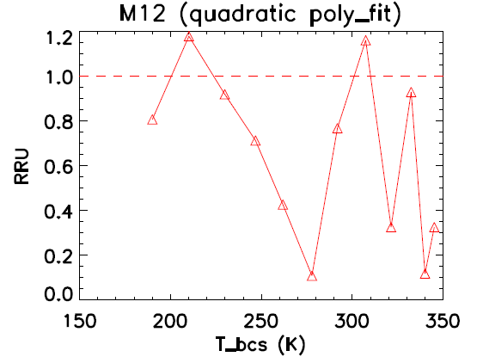

Figure 20: Part 1 of the Cold Plateau (34V) RRU for HAM side A (subsample 1 for I bands).

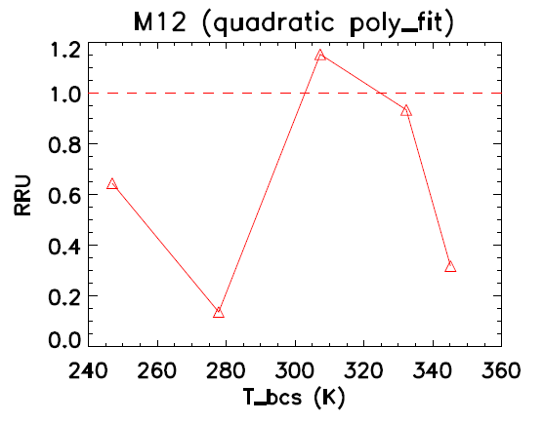

Figure 21: Cold Plateau (28V) Part 2 OBC temperature vs collect.

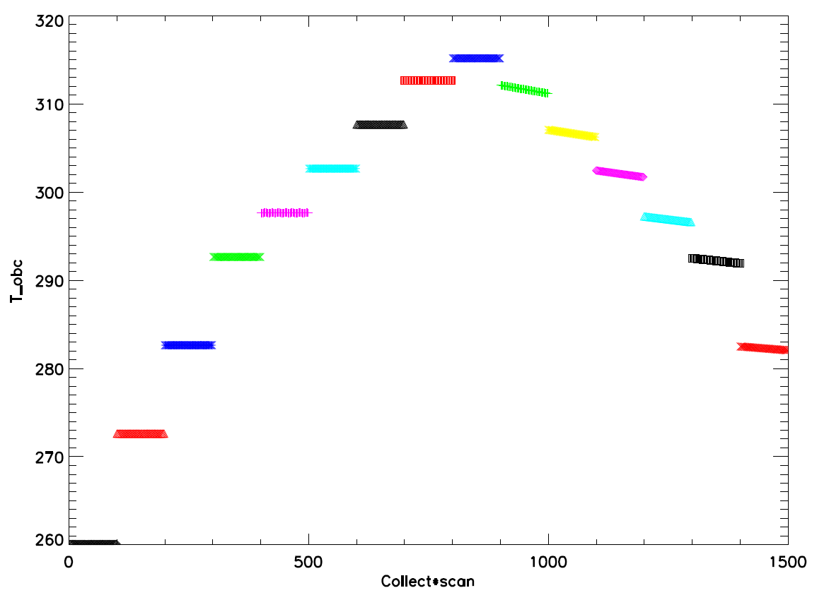
Warm-up
Cool-down

Figure 22: Cold Plateau (28V) Part 2 warm-up OBC temperature vs scan.

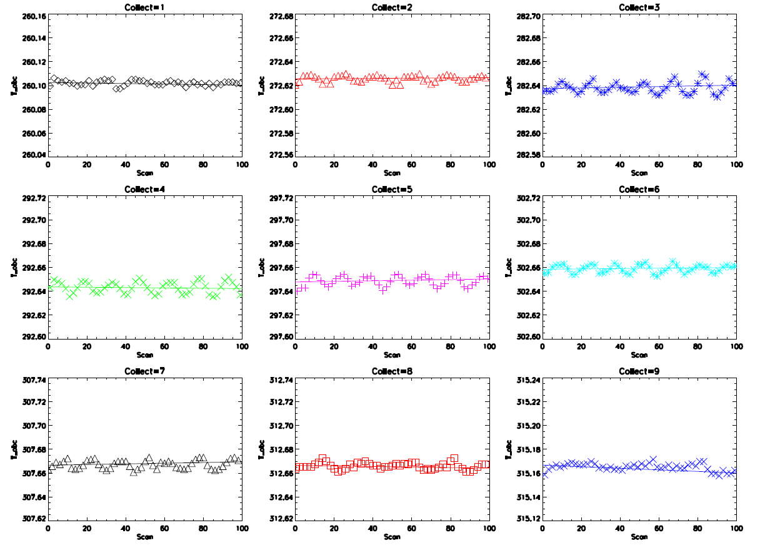

Figure 23: Cold Plateau (28V) Part 2 warm-up standard deviation of OBC temperature vs collect.

