NICST_MEMO_08_026

NICST Internal Memo

Date: June 19, 2008
From: J McIntire, C. Pan, and S. Xiong
To: Bruce Guenther, Jim Butler, Jack Xiong
Subject: Updated Analysis of the Radiometric Calibration from the VIIRS EDU RC-05 Part 2 Test (Nominal Plateau at 28V)
---------------------------------------------------------------------------------------------------------

References:

[1] NICST_MEMO_08_024, “Updated Analysis Results for VIIRS EDU RC-05 Part 1, Nominal Plateau at 28V,” J. McIntire, C. Pan, and S. Xiong, July 1, 2008.
[2] NICST_MEMO_08_025, “Sensitivity of the VIIRS Sensor Determined from the EDU RC-05 Part 1 test (Nominal Plateau at 28V),” J. McIntire, C. Pan, and S. Xiong, July 8, 2008.
[3] NICST_REPORT_06_009, ‘Preliminary test analysis report of VIIRS EDU RC-05 Parts 1 & 2 in TV at Nominal Plateau,’ August 4, 2006.
[4] NICST_REPORT_06_025, ‘Radiometric Characterization Report of EDU RC-05 Part1 Using BCS at Hot Plateau (28V) and Comparison with Cold & Nominal,’ December 13, 2006.
[5] Y18352, ‘Performance Verification Review: Thermal Emissive Band Radiometric response Characterization (RC-3 and RC-5 Tests),’ Eric Johnson and Jim Young, January 18, 2006.
[6] ‘Sensor Performance Verification Plan,’ PVP154640-101.
[7] ‘Performance Specification Sensor Specification,’ ps154640-101c.

1. Introduction

The VIIRS EDU thermal vacuum test RC-05 Part 2 was designed to examine the sensor response to the On-Board Calibration (OBC) blackbody in a near space-like environment. NICST analysis results for the nominal plateau portion of this test (both Parts 1 and 2) were reported for the radiometric gains and sensitivity as well as for compliance with a number of specifications [1-4]. This work will focus on the warm-up and cool-down (RC-05 Part 2) radiometric gains for the nominal plateau at 28V, as an update to previous work [3].

Table 1 lists the relevant UAIDs along with their corresponding OBC and Blackbody Calibration Source (BCS) temperatures (the collect label defines the order in which they were analyzed). Each collect contains 100 scans. This test consisted of two parts: warm-up and cool-down of the OBC temperature. The warm-up portion (UAIDs 2002542-3) was conducted with the OBC temperature controlled over all scans in each collect. For the cool-down (UAID 2002544) segment of this test, the OBC temperature was set at the beginning of each collect and then allowed to drift over scans. The BCS source was located in the last collect window. In addition, the Space View Source (SVS) was positioned in the Space View (SV) port. Band M13 in low gain mode was not considered. The VIIRS sensor was operated in diagnostic mode. The general outline of the methodology used in this work follows from [1,5,6] with some modifications.

2. Data Processing

The VIIRS EDU TV tests were conducted using the F9 apeture. However, all of the specifications for the VIIRS sensor assume a F6 apeture. In order to convert the radiance for comparison to the F9 specifications, the following factor was employed:
$L_{F6}=L_{F9}{\left(\frac{6}{9}\right)}^{2}$. (1)
Notice that it is the radiances, and not the temperatures, that are rescaled.

All the samples for both the OBC and SV were analyzed. The BCS data analyzed here is restricted to a subset of the Earth View (EV) samples in a given collect for which the BCS source yielded a stable response (the sweetspot). The following sample ranges were used in this work: samples 1650 – 1849 for M bands and samples 3300 – 3699 for I bands. Note that the BCS data was only used to calculate the retrieved OBC radiance.

The response was analyzed using the scan method. First, the DN_{SV} was averaged over all samples in a given scan. Then, <DN_{SV}>_{samples} was subtracted from each sample of the DN_{OBC}. Next, the dn was averaged over samples, or <dn>_{samples}. The standard deviation of all samples for a specific scan was calculated, or σ_{samples}. Note that the HAM sides alternate from scan to scan such that there are 50 scans for each HAM side. Additionally, for this memo the I band data is divided into two subsamples where the larger for both SV and OBC is always labeled subsample 1, to ensure the proper background subtraction. The same treatment was used for the EV data.

The temperatures (T_{xxx}) of the following were extracted: OBC, BCS, SVS, HAM, and Rotating Telescope Assembly (RTA). The OBC, HAM, and RTA temperatures were acquired using the LRV extractor and the BCS and SVS temperatures were obtained from the GSE files.

For each of these temperatures, a Planck radiation was calculated using the center wavelength (λ) of each band and the equation
$L_{\text{xxx}}\left(λ,T_{\text{xxx}}\right)=\frac{2\text{hc}}{λ^{5}}\frac{1}{e^{\text{hc}/λ{\text{kT}}_{\text{xxx}}}−1}$. (2)
Then, the in-band Relative Spectral Response (RSR) was applied as a correction to the Planck radiances; this was implemented by the following equation
$\left\langle L_{\text{xxx}}\left(B,D,j_{H},T_{\text{xxx}}\right)\right\rangle =\frac{\int{\text{RSR}\left(B,D,λ\right)L_{\text{xxx}}\left(B,j_{H},T_{\text{xxx}}\right)dλ}}{\int{\text{RSR}\left(B,D,λ\right)dλ}}$, (3)
where B, D, and j_{H} represent band, detector, and scan (HAM side dependent), respectively. The RSR data was available for only some detectors; therefore, the existing RSR was extrapolated to the missing detectors. The RSR used here was calculated by the NICST team.

The effective OBC radiance is
$\begin{aligned}{\left\langle L_{\text{OBC}}\left(B,D,j_{H},T_{\text{OBC}}\right)\right\rangle }_{\text{eff}}=ε_{\text{OBC}}\left\langle L_{\text{OBC}}\left(B,D,j_{H},T_{\text{OBC}}\right)\right\rangle \\ −\left(1−ε_{\text{OBC}}\right)[F_{\text{CAV}}\left\langle L_{\text{CAV}}\left(B,D,j_{H},T_{\text{OBC}}\right)\right\rangle \\ +F_{\text{SH}}\left\langle L_{\text{SH}}\left(B,D,j_{H},T_{\text{OBC}}\right)\right\rangle \\ +F_{\text{RTA}}\left\langle L_{\text{RTA}}\left(B,D,j_{H},T_{\text{OBC}}\right)\right\rangle ]\end{aligned}$ , (4)
where ε_{OBC} is the emissivity of the OBC and F_{CAV}, F_{SH}, and F_{RTA} are the fraction of the OBC reflectance attributable to the scan cavity (CAV), RTA, and OBC shield (SH), respectivily.

The PVP defines the background radiance as
$\begin{aligned}\left\langle L_{\text{Bkg}}\left(B,D,j_{H},T_{\text{OBC}}\right)\right\rangle =\text{rvs}\left(B,φ_{\text{SVS}},H\right)\left\langle L_{\text{SVS}}\left(B,D,T_{\text{OBC}}\right)\right\rangle \\ −\frac{\left[\text{rvs}\left(B,φ_{\text{SVS}},H\right)−\text{rvs}\left(B,φ_{\text{xxx}},H\right)\right]}{ρ_{\text{RTA}}\left(B\right)} \\ \left[\left\langle L_{\text{HAM}}\left(B,D,j_{H},T_{\text{OBC}}\right)\right\rangle −\left(1−ρ_{\text{RTA}}\left(B\right)\right)\left\langle L_{\text{RTA}}\left(B,D,j_{H},T_{\text{OBC}}\right)\right\rangle \right]\end{aligned}$.(5)
This includes contributions from not only the SVS, but from the RTA and HAM as well. In addition, the radiances are corrected for Response Versus Scan angle (RVS) and the reflectance factor (ρ_{RTA}) is included. Note that φ_{xxx} refers to the HAM angle of incidence for the OBC, SVS, or BCS source (the RVS for the OBC is normalized to 1). The RVS used here was calculated by the NICST team.

Now we calculate the scan dependent, background subtracted source radiances, or
${ΔL}_{\text{OBC}}\left(B,D,j_{H},T_{\text{OBC}}\right)={\left\langle L_{\text{OBC}}\left(B,D,j_{H},T_{\text{OBC}}\right)\right\rangle }_{\text{eff}}−\left\langle L_{\text{Bkg}}\left(B,D,j_{H},T_{\text{OBC}}\right)\right\rangle$, (6)
and
${ΔL}_{\text{BCS}}\left(B,D,j_{H},T_{\text{BCS}}\right)=\left\langle L_{\text{BCS}}\left(B,D,j_{H},T_{\text{BCS}}\right)\right\rangle −\left\langle L_{\text{Bkg}}\left(B,D,j_{H},T_{\text{BCS}}\right)\right\rangle$. (7)

In order to determine the radiometric gains, polynomial fits were conducted to the response versus the delta OBC radiance. Least-squares fits were performed over the dynamic range (F6) at the linear, quadratic, and cubic levels (or order N). These polynomials take the from
${ΔL}_{\text{OBC}}\left(B,D,j_{H},T_{\text{OBC}}\right)=\sum_{i=0}^{N}{a_{i}{\text{dn}}_{\text{OBC}}^{i}\left(B,D,j_{H},T_{\text{OBC}}\right)}$. (8)
This fitting is conducted on a scan by scan basis. The inverse of the linear term (1/a₁) is the radiometric gain.

Next, we need to calculate the retrieved calibration source radiance, or
$\begin{aligned}{\left\langle L_{\text{OBC}}\left(B,D,j_{H},T_{\text{OBC}},N\right)\right\rangle }_{\text{ret}}=\frac{{ΔL}_{\text{BCS}}\left(B,D,j_{H},T_{\text{BCS}}\right)\sum_{i=0}^{N}{a_{i}{\text{dn}}_{\text{OBC}}^{i}\left(B,D,j_{H},T_{\text{OBC}}\right)}}{\sum_{i=0}^{N}{a_{i}{\text{dn}}_{\text{BCS}}^{i}\left(B,D,j_{H},T_{\text{BCS}}\right)}} \\ +\left\langle L_{\text{Bkg}}\left(B,D,j_{H},T_{\text{OBC}}\right)\right\rangle \end{aligned}$. (9)
For the OBC source, we also determine the effective OBC emissivity. Here we use the following equation
$ε_{\text{OBC}}\left(B,D,T_{\text{OBC}}\right)=\frac{{\left\langle L_{\text{OBC}}\left(B,D,T_{\text{OBC}}\right)\right\rangle }_{\text{ret}}−\left\langle L_{\text{Bkg}}\left(B,D,T_{\text{OBC}}\right)\right\rangle }{\left\langle L_{\text{OBC}}\left(B,D,T_{\text{OBC}}\right)\right\rangle −\left\langle L_{\text{Bkg}}\left(B,D,T_{\text{OBC}}\right)\right\rangle }$, (11)
where the retrieved OBC radiance and the background radiance were both averaged over scans and HAM sides. The emissivity is then averaged over detectors.

Note that the emissivity calculated in Equation (11) is not a prediction. As an input in Equation (4), the emissivity calculated by Equation (11) is a verification of this methodology.

3. Analysis

Now the results of RC-05 Part 2 for the nominal plateau are discussed. HAM sides A and B yield similar results. In consequence, only HAM side A is presented here, unless otherwise noted. In addition, only the warm-up and cool-down (RC-05 Part 2) radiometric gains are discussed. The specifications addressed here are listed in Table 2 [7]. The collects are referred to here by their collect label (see Table 1). The radiometric gains given here are for the F6 aperture.

Figure 1 shows the OBC temperature as a function of scan for both warm-up and cool-down (note that SRV0598 is satisfied during the warm-up portion). Figures 2 and 3 display the OBC temperature for each individual collect along with a straight line fit for warm-up and cool-down, respectively. In compliance with SRV0654, the temperature variation for warm-up is less than ±0.2 K.

The standard deviations for each of the six thermistors are shown in Figure 4 for both warm-up and cool-down. The average value per collect is given in Table 3. Due to the fact that all the warm-up collects vary less than 0.03 K, the requirement SRV0095 is satisfied.

The radiometric gains for both the warm-up and cool-down are listed in Table 4. Here the gains have been averaged over scans, subsample, and detector. The radiometric gains calculated from RC-05 Part 1 by NICST [1] are shown for comparison. The Part 2 warm-up gains agree with the NICST Part 1 (quadratic fit) gains to within 0.7% for all bands, except M12 and M13 hg which agree to within 1.2%. The difference for bands M12 and M13 hg is only 0.6% when the cubic fit is used for Part 1. As shown in [1], the fitting residual is greatly improved using a cubic fit for these bands and that the improvement occurs at low temperature. For Part 2, this low temperature region is not accessible and a quadratic fit suffices. The cool-down gains show similar agreement, about 0.8% or less (using the quadratic fit for all bands). The warm-up gains are stable versus HAM side to approximately 0.8%; however, the cool-down gains are less stable, with a percent difference of 1.5% for all bands (except band I5 with 4%). Figure 5 plots of delta radiance vs dn for all bands and a middle detector (detector 8 for M bands and detector 16 for I bands) for both warm-up (black) and cool-down (red).

The coefficients from the quadratic fits (a₀, a₁, and a₂) are shown for both warm-up (black) and cool-down (red) in Figures 6, 7, and 8, respectively. There is a noticeable difference in the coefficients a₀ and a₂ between warm-up to cool-down whereas the coefficient a₁ is relatively stable (the exception is band I5). Here a₀ is the radiance offset, a₁ is the inverse of the gain, and a₂ is the nonlinear term.

Figure 9 plots of the percent difference between warm-up and cool-down for the coefficient a₁ for all bands and detectors. The percent difference between warm-up and cool-down a₁ is less than 3% (except for band I5 with 8%).

Detector 1 for band M14 was Out Of Family (OOF), as seen in Figure 5. The radiometric gains for this detector were computed using collects with OBC temperatures below 305 K. It was not included in the average show in Table 4.

Tables 5 and 6 list the individual detector gains for warm-up and cool-down, respectively. There is less than 14% variation as a function of detector for the warm-up and under 12% for the cool-down (expect for band I5 which has 17% and 20% variation, respectively). The variation between individual detectors from warm-up to cool-down is less than 7.0%. Figure 10 shows the radiometric gains as a function of detectors for warm-up (black) and cool-down (red).

The emissivity calculated using Equation (11) was 0.9966 and the input value in Equation (4) was 0.9983, a difference of about 0.2%. This gives us confidence that this methodology is accurate.

4. Summary

- The OBC temperature was controlled from ambient to 315 K (SRV0598).
- The OBC temperature was maintained at less than ±0.2 K of the programmed setpoint (SRV0654).
- The standard deviation of the OBC temperature over scans was less than 0.03 K for the warm-up (SRV0095).
- The radiometric gains for Part 2 (quadratic fit) are in good agreement with the results from Part 1 (quadratic fit, except for M12 and M13 hg with cubic fit).
- The warm-up gains were stable to less than 0.8% as a function of HAM side; the cool-down gains were stable to less than 1.5% as a function of HAM side (except band I5 with 4%).
- Noticeable difference between warm-up and cool-down for the radiance offset (a₀) and the nonlinear term (a₂).
- The inverse of the gain (a₁) is stable between warm-up and cool-down to within 3% (except band I5 with 8%).
- Large variation in individual detector gains within a given band.

Acknowledgement
The sensor test data used in this document was provided by the SBRS testing team. Approaches for data acquisition and data reductions, as well as data extraction tools were also provided by the SBRS. We would like to thank the SBRS team for their support. The data analysis tools were developed by the NICST team, and we would like to extend our gratitude for their valued assistance.

Table 1: EDU RC-05 Part 2 UAIDs with corresponding OBC and BCS temperatures.

Table 2: Specifications addressed by this work [7].

Table 3: Average standard deviations for all 6 OBC thermistors.

Table 4: Detector, scan, and subsample averaged radiometric gains (F6) for HAM side A.

Table 5: Radiometric gains (F6) from the warm-up for HAM side A.

Table 6: Radiometric gains (F6) from the cool-down for HAM side A.

Figure 1: OBC temperature (K) as a function of scan and collect.
Cool-down

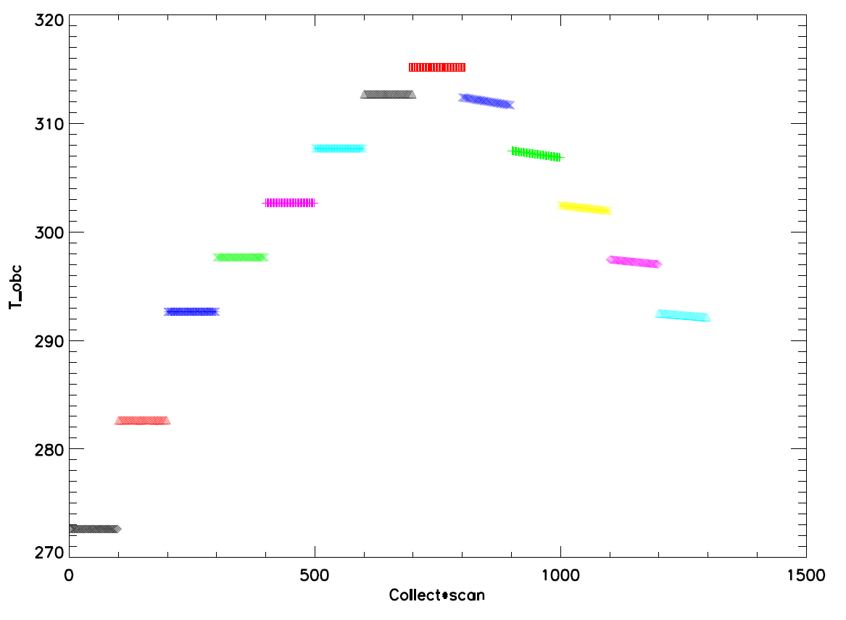
Warm-up

Figure 2: OBC temperature (K) as a function of scan for each warm-up collect.

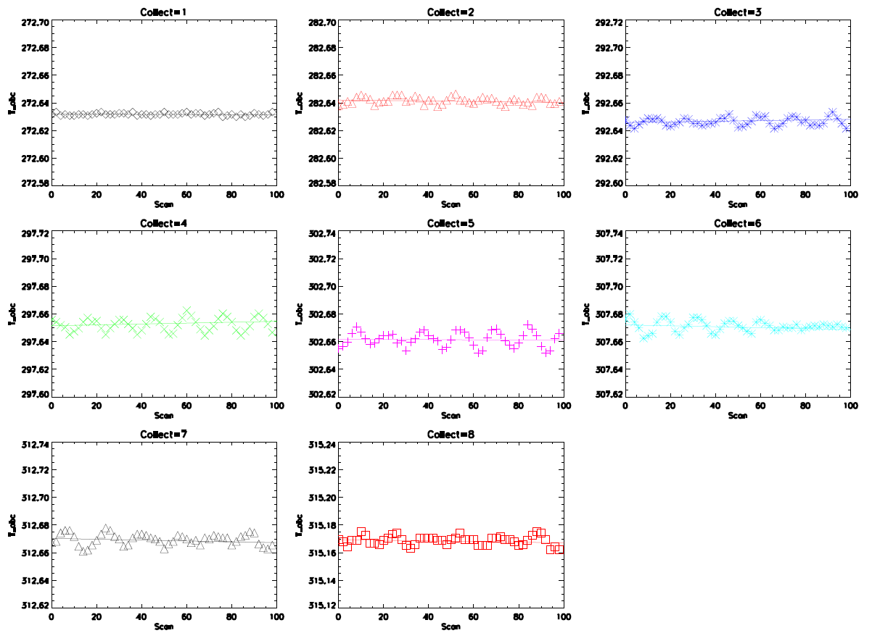

Figure 3: OBC temperature (K) as a function of scan for each cool-down collect.

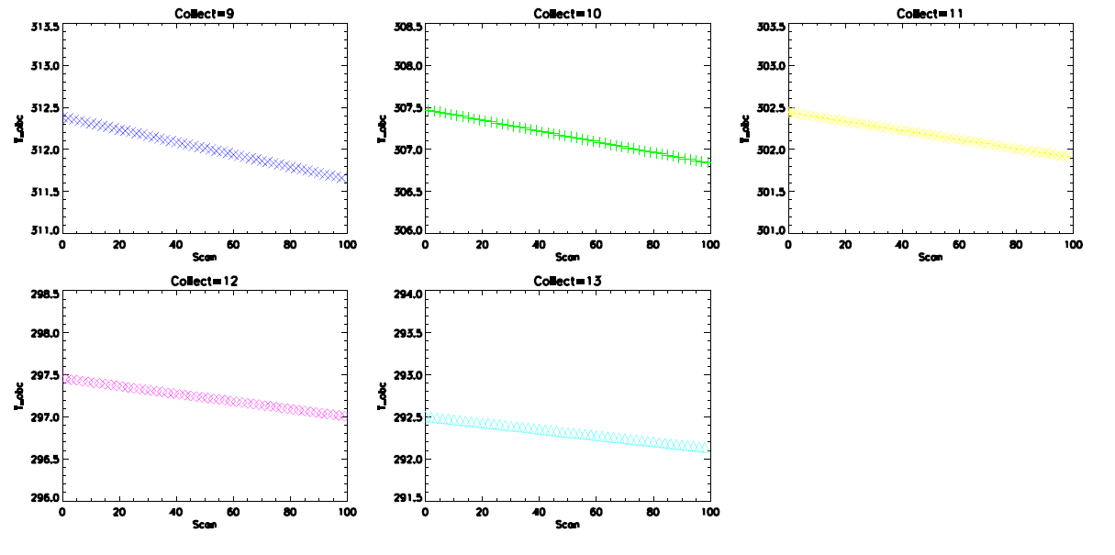

Figure 4: Standard deviation of OBC temperature for each thermistor as a function of collect.

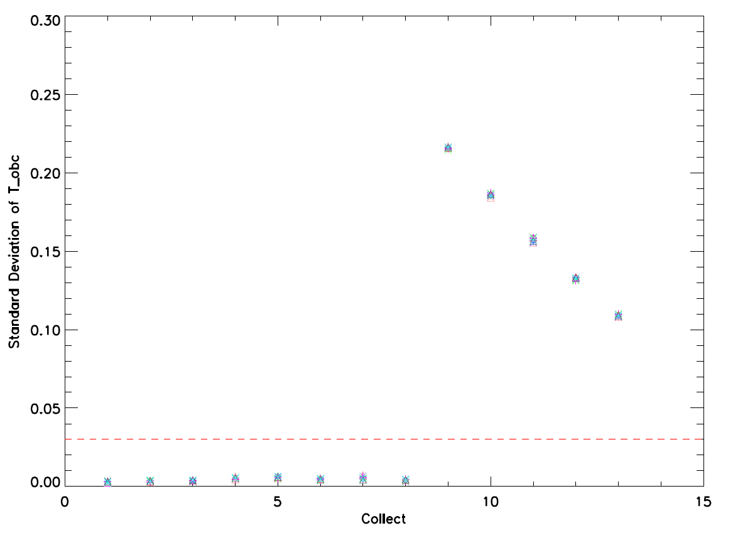
Cool-down
Warm-up

Figure 5: dn_{OBC} versus dL_{OBC} for the middle detectors (HAM side A and subsample 1). Detector 1 for band M14 is also included.

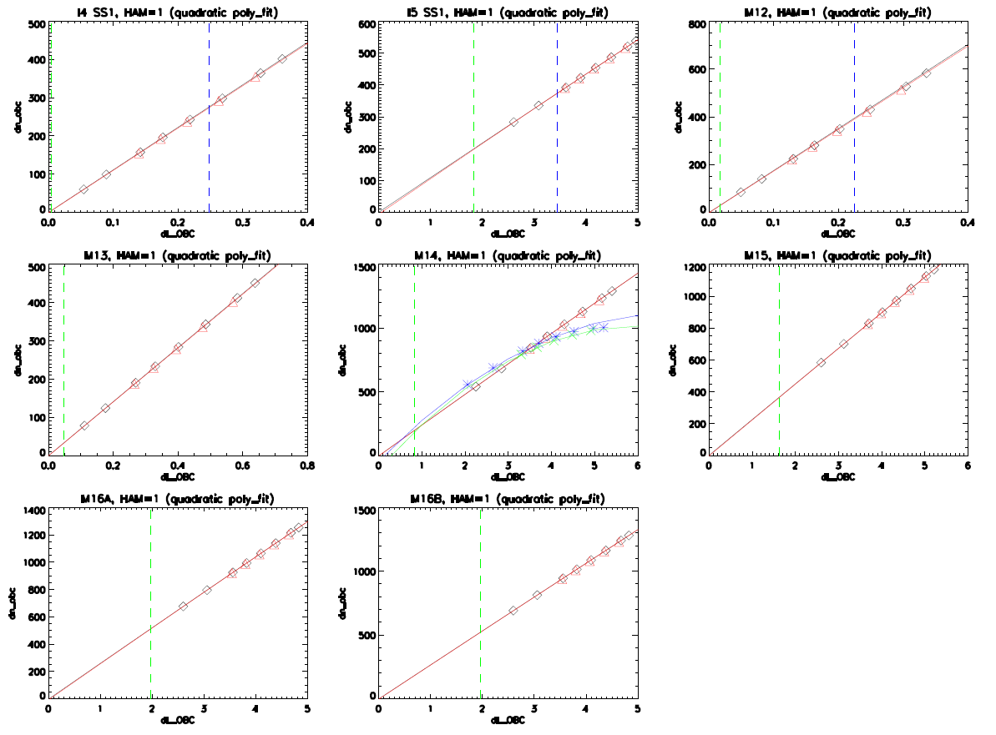
Detector 1 is OOF

Figure 6: Warm-up and cool-down coefficient a₀ (F6) for each individual detector and band (HAM side A and subsample 1).

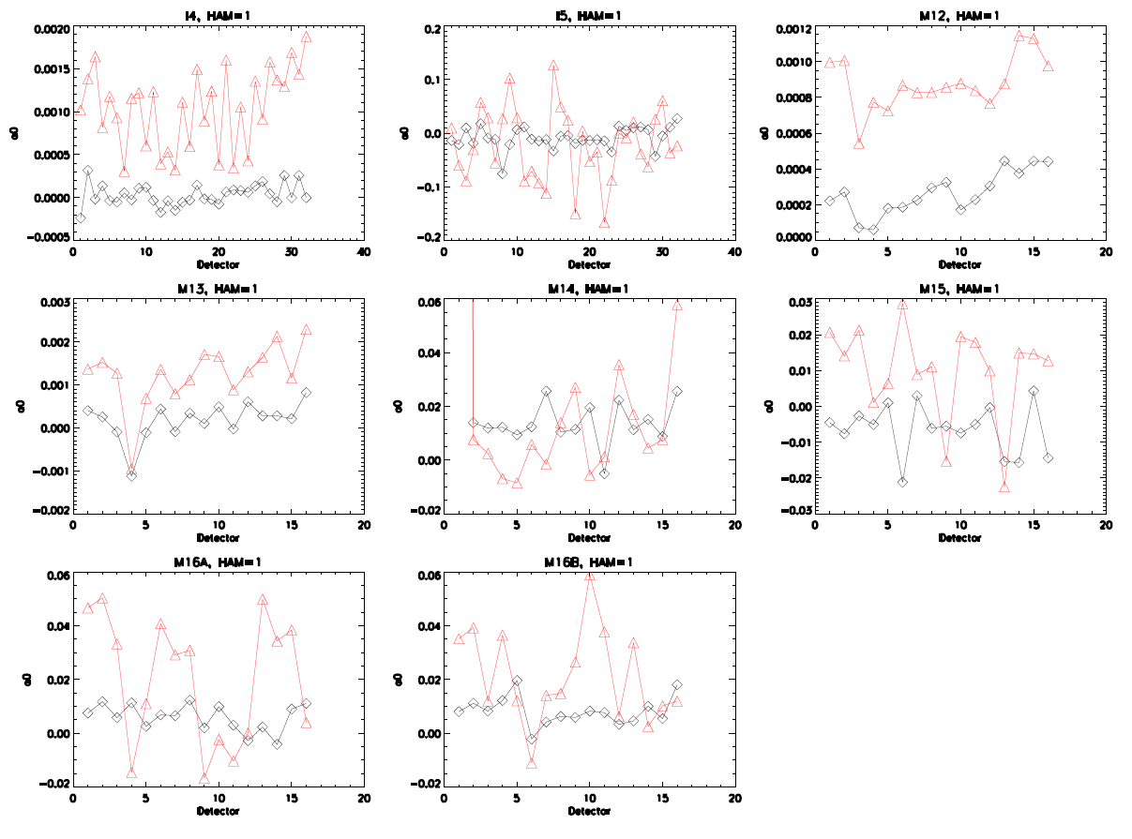

Figure 7: Warm-up and cool-down coefficient a₁ (F6) for each individual detector and band (HAM side A and subsample 1).

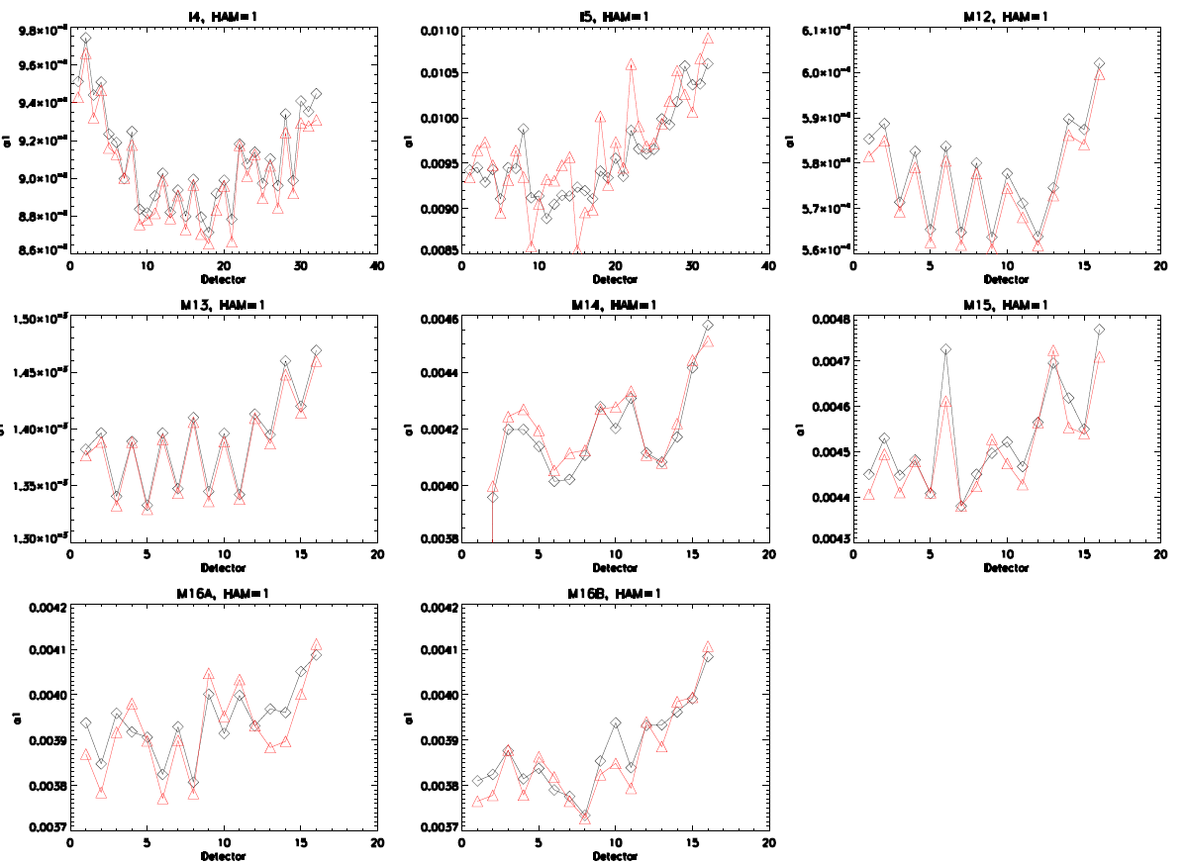

Figure 8: Warm-up and cool-down coefficient a₂ (F6) for each individual detector and band (HAM side A and subsample 1).

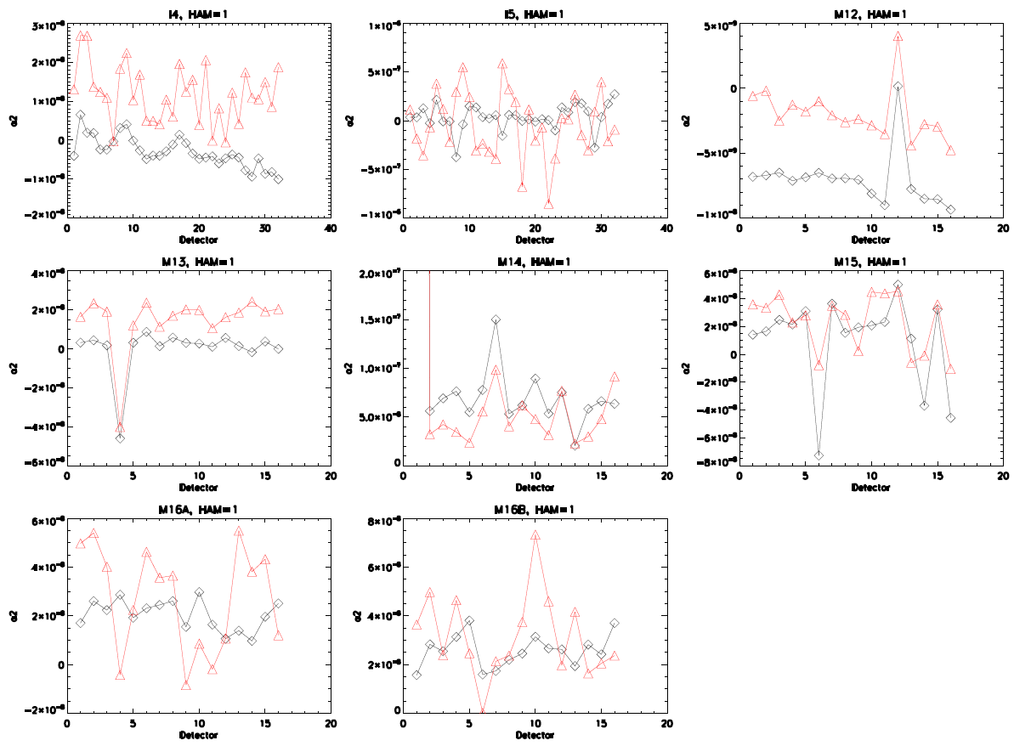

Figure 9: Percent difference in coefficient a₁ (F6) between warm-up and cool-down for each individual detector and band (HAM side A and subsample 1).

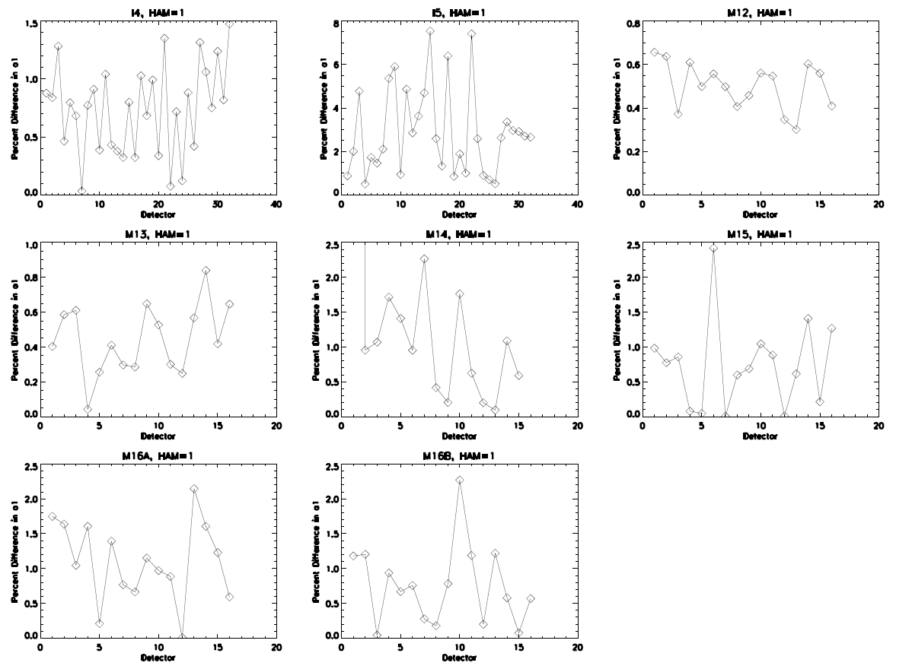

Figure 10: Radiometric gains (F6) for each individual detector and band (HAM side A and subsample 1).

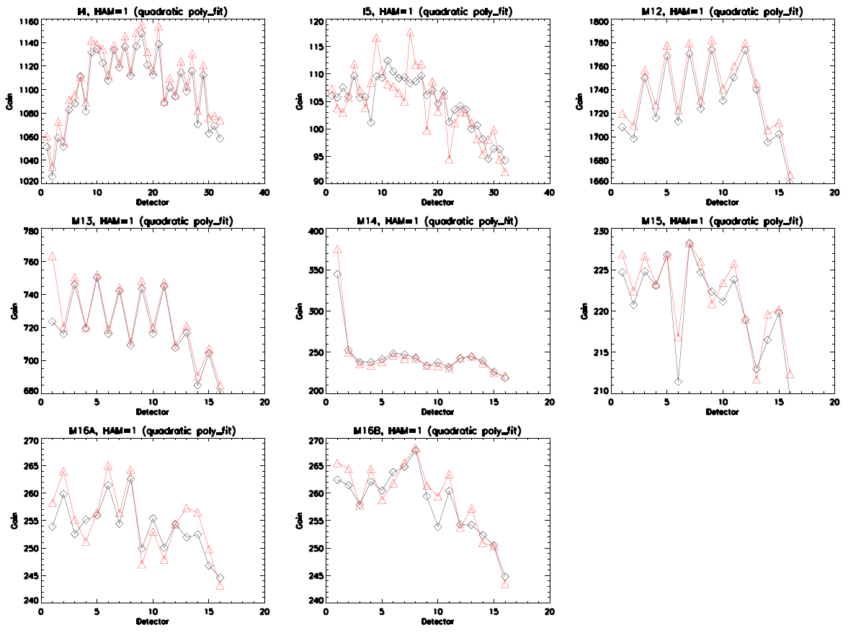
Detector 1 is OOF

