Global ocean phytoplankton —B. A. Franz, I. Cetinić, M. Gao, and T. K. Westberry
Marine phytoplankton play a crucial role in global ecosystems, contributing about 50% of the Earth's total net primary production. They meet the energy demands of oceanic food webs and provide a key mechanism for carbon sequestration, transporting carbon to the deep ocean (Field et al. 1998, Siegel et al. 2023). The diversity, abundance, and distribution of phytoplankton are influenced by both biotic factors—such as grazing by zooplankton and viruses—and abiotic factors like the availability of nutrients and light. These, in turn, depend on physical conditions like ocean temperature, stratification, and circulation (e.g., Behrenfeld et al. 2006). Observations from spaceborne ocean color sensors offer a global view of phytoplankton dynamics, tracking spatial and temporal variations by measuring near-surface concentrations of chlorophyll-a (Chla; mg m⁻³) and phytoplankton carbon (C_{phy}; mg m⁻³). While Chla levels reflect both phytoplankton biomass and physiological state, C_{phy} quantifies phytoplankton carbon biomass. Although Chla and C_{phy} often co-vary, differences in their distribution can reveal shifts in the physiological or compositional makeup of phytoplankton communities (Dierssen 2010; Geider et al. 1997; Cetinić et al. 2012; Siegel et al. 2013; Westberry et al. 2016).
In this report, we evaluate the global distribution of phytoplankton over the one-year period from October 2023 through September 2024 (the analysis year) using remotely sensed Chla and C_{phy} measurements from a continuous 27-year record (1997-2024) that combines observations of SeaWiFS (1997–2010), MODIS on Aqua (MODIS-A, 2002–present), and VIIRS on NOAA20 (VIIRS-N20, 2017-present). The MODIS-A daytime SST (°C) is also assessed over a consistent time-period to provide context on the physical state of the oceans. The ocean color data from VIIRS-N20, MODIS-A, and SeaWiFS correspond to NASA processing version R2022. The Chla product was derived using the Ocean Color Index algorithm of Hu et al. (2012), but with updated algorithm coefficients (Hu et al. 2019, O’Reilly and Werdell 2019, Werdell et al. 2023). C_{phy} was derived from the particle backscattering coefficient, b_{bp}, at 443 nm (Generalized Inherent Optical Properties algorithm; Werdell et al. 2013, McKinna et al. 2016, McKinna & Werdell 2024) and a linear relationship between b_{bp} and C_{phy} (Graff et al. 2015). In merging the time series of SeaWiFS and MODIS-A, differences between the sensors were assessed over the overlapping period from 2003 through 2008, and a mean bias correction (-0.0021 mg m⁻³ in Chla, and -6.7e-5 m⁻¹ in b_{bp} or -0.78 mg m⁻³ of C_{phy}) was derived and applied to the SeaWiFS time series. Similarly, the overlap period of 2018 to 2020 was used to assess the differences between MODIS-A and VIIRS-N20, and a bias correction (-0.0021 mg m⁻³ in Chla, and -3.1e-4 m⁻¹ in b_{bp} or -3.6 mg m⁻³ of C_{phy}) was applied to the VIIRS-N20 timeseries. The bias corrections between the VIIRS-N20 and MODIS-A b_{bp} time-series are relatively large, due to residual sensor radiometric calibration errors and sensitivity of the b_{bp} retrievals to spectral sampling differences between the sensors (i.e., Werdell and McKinna, 2019). While efforts are underway at NASA to reduce this retrieval bias, some additional caution is warranted here in the interpretation of C_{phy} anomalies from VIIRS-N20 relative to the climatological record that is dominated by MODIS-A. However, the VIIRS-N20 instrument is temporally stable (Twetd et al. 2022) and thus it provides the primary reference to assess changes over the current analysis year.
Changes in the global distribution of phytoplankton were assessed by subtracting monthly climatological means for MODIS-A Chla and C_{phy} (October 2002–September 2023) from the VIIRS-N20 bias-adjusted monthly mean values for the 2024 analysis year. These monthly anomalies were then averaged to produce the global Chla and C_{phy} annual mean anomaly maps (Figs. 3.25a,b). Similar calculations were performed on MODIS-A SST data to produce an equivalent SST annual mean anomaly for the same time period and climatological reference period (Fig. 3.25c). The permanently stratified ocean (PSO), which is used for the analyses depicted in Figs. 3.26 and 3.27, is defined as the region spanning the tropical and subtropical oceans where annual average SST is greater than 15°C and surface mixed layers are typically low in nutrients and shallower than the nutricline (black lines near 40°N and 40°S in Fig. 3.25; Behrenfeld et al. 2006).
For the 2024 analysis year, the distribution of SST anomalies (Fig. 3.25c) is consistent with strong to moderate El Niño conditions over much of the analysis year, including a pronounced tongue of anomalously warm waters extending across the equatorial Pacific with anomalously cool waters north and south of the feature. A similar but inverse feature is evident in the Chla anomalies, with concentrations depressed (< 20%) within the warm tongue and strongly elevated (> 40%) in the adjacent cooler waters (Fig. 3.25a). Negative SST anomalies within the PSO are typically associated with deeper surface mixed layers (Deser et al. 2010), which reduces phytoplankton light exposure rates leading to higher cellular Chla and a decoupling between Chla and C_{phy} variability (Behrenfeld et al. 2015). While C_{phy} and Chla anomalies appear to covary in the equatorial Pacific and the Indian Ocean south of the equator, C_{phy} is depressed where Chla is elevated in the North and South Atlantic, consistent with observations in 2023 (Franz et al. 2024). Similar decoupling between Chla and C_{phy} is also observed in the Arabian Sea (Chla depressed with C_{phy} elevated) and in the Indian Ocean east of Madagascar (Chla elevated with C_{phy} depressed). Patches of depressed Chla are visible throughout the subpolar and polar regions above and below the PSO (Fig. 3.25a), and the C_{phy} anomalies are generally elevated (Fig. 3.25b). Observed heterogeneity in biomass indicators outside of the PSO are a result of the ephemeral nature of phytoplankton blooms in these waters, as well as poor spatial and temporal sampling due to clouds and low-light conditions that limit our ability to interpret interannual variability in higher latitude regions.
Annual variability of Chla and C_{phy} within the PSO typically exhibits two distinct peaks (Fig. 3.26a,b), reflecting the springtime increases of biomass in Northern (Fig. 3.26c,d) and Southern Hemispheres (Fig. 3.26g,h). The timing of peaks in C_{phy} lags 2-3 months behind those of Chla, reflecting a reduction in phytoplankton chlorophyll-to-carbon ratios as the seasonal bloom progresses (e.g., Westberry et al. 2016), and the tight coupling between phytoplankton biomass and its losses (e.g., grazing). The timing of seasonal peaks and troughs observed in the 2024 analysis year are consistent with the monthly climatologies. The SH PSO anomalies for C_{phy} (Fig. 3.26h) are modestly low in the first half of the analysis year (Oct-Mar). A similar but stronger pattern was observed in 2023 (Franz et al. 2024) and was traced to error in the measurements due to continuing influence of stratospheric aerosols from the 2022 Hunga Tonga eruptions (Franz et al. 2024b, Khaykin et al. 2025). Low Chla and C_{phy} in the equatorial region over the first half of the year is consistent with expected response to the prevailing El Niño conditions over that time period, which leads to reduced upwelling and vertical transport of nutrients and thus reduced phytoplankton abundance and productivity (Behrenfeld et al. 2001, Chavez et al. 2011).
Over the 27-year time series of spatially averaged monthly mean Chla within the PSO, concentrations vary by 5.7% (0.008 mg m⁻³, standard deviation) around a long-term average of 0.136 mg m−3 (Fig. 3.27a). C_{phy} over the same 27-year period varies by 3.2% (0.69 mg m⁻³) around an average of 21.8 mg m⁻³ (Fig. 3.27c). Chla monthly anomalies within the PSO (Fig. 3.27b) vary by 4.5% (0.006 mg m−3) over the multi-mission time series, with the largest deviations generally associated with ENSO events (r=-0.39), as demonstrated by the correspondence of Chla anomaly variations with the Multivariate ENSO Index (MEI; Wolter and Timlin 1998; presented in the inverse to illustrate the covariation). C_{phy} anomalies (Fig. 3.27d), which vary by 2.0% (0.43 mg m⁻³), are less correlated with the MEI (r=-0.28) due to the inherent lag between environmental change, phytoplankton growth, and biomass accumulation. The mean anomalies in 2024 for Chla and C_{phy} within the PSO indicate modestly depressed concentrations in the early part of the analysis year, consistent with El Niño conditions that limited phytoplankton production, with concentrations returning to nominal state following relaxation of El Niño forcings.
Through continuous ocean color monitoring, we can track changes in the global distribution of phytoplankton, which are crucial for driving biogeochemical processes, influencing the oceans' role in the global carbon cycle, and exerting control over marine ecosystems, food webs, and fisheries. Small fluctuations in chlorophyll a (Chla) and carbon content (Cphy) help us differentiate between climate-driven changes in phytoplankton biomass and shifts in their physiology and community dynamics. The recently launched Plankton, Aerosol, Cloud, ocean Ecosystem (PACE) mission, equipped with the first global hyperspectral instrument for ocean color measurement, is expected to improve the identification of phytoplankton absorption features (Werdell et al., 2019). This instrument will also help separate these features from non-algal optical signals (e.g., Pahlevan et al., 2021; Siegel et al., 2005), enabling more accurate assessments of phytoplankton species and community composition changes (e.g., Cetinić et al., 2024). These advancements will enhance our capacity to understand the impacts of climate forces on global phytoplankton communities.

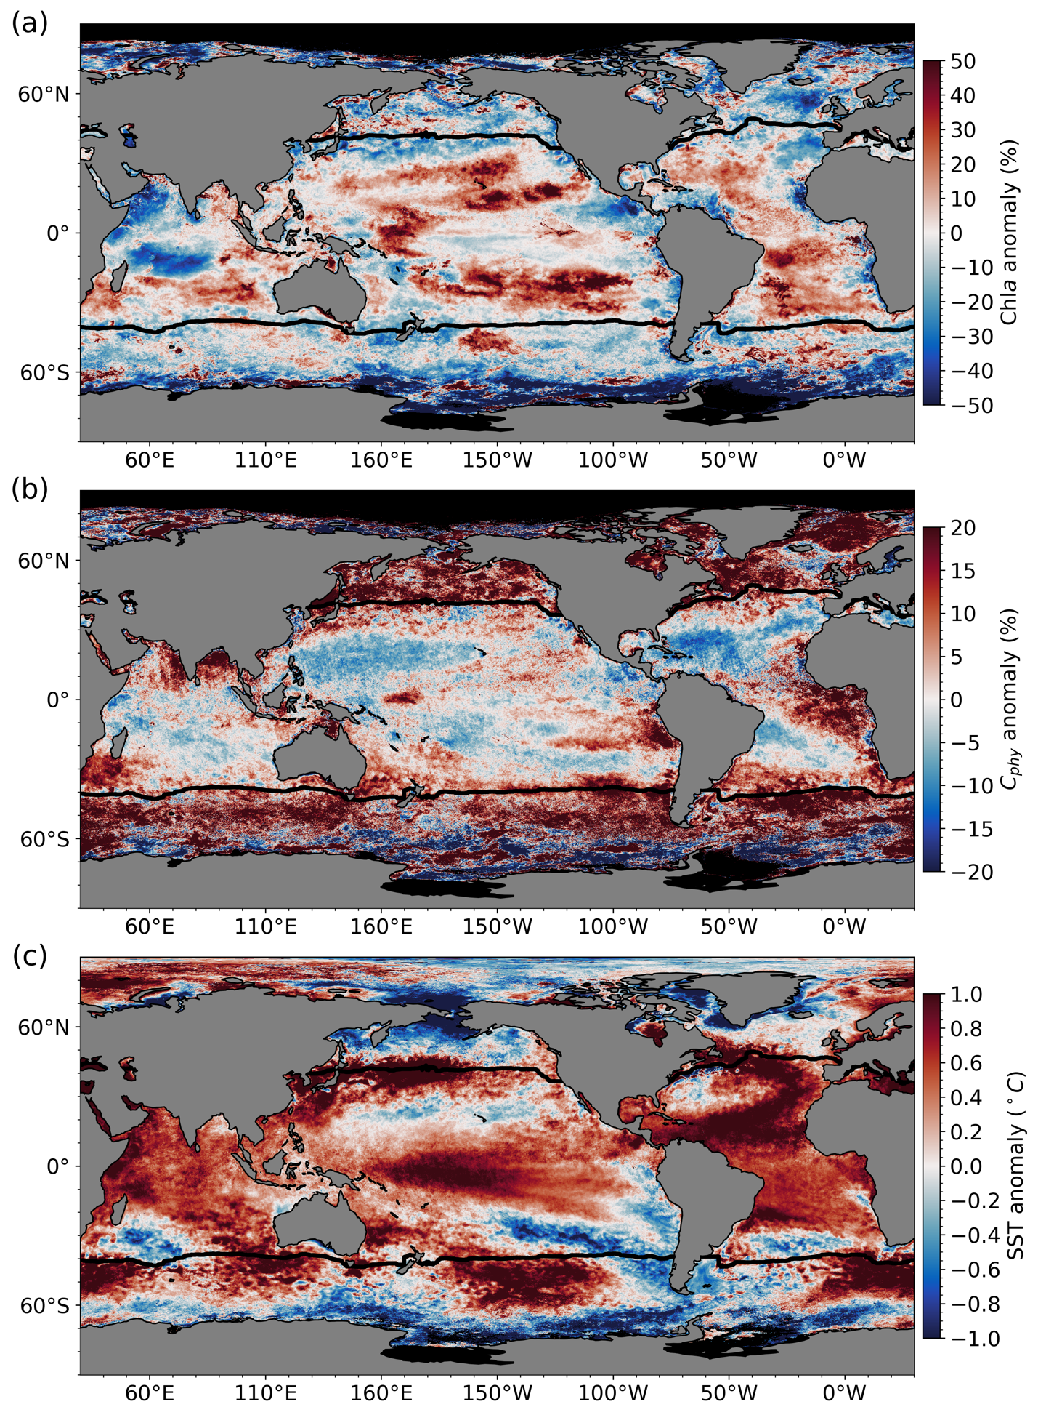

Fig. 3.25. Spatial distribution of average monthly (a) VIIRS-N20 Chla anomalies (%), (b) VIIRS-N20 C_{phy} anomalies (%), and (c) MODIS-A SST anomalies (°C) for Oct 2023–Sep 2024, where monthly differences were derived relative to the MODIS-A climatological record (Oct 2002–Sep 2023). Chla and C_{phy} are stated as % difference from climatology, while SST is shown as an absolute difference. Also shown in each panel is the location of the mean 15°C SST isotherm (black lines) delineating the permanently stratified ocean (PSO). Differences in the SST anomalies here versus in Fig. 3.1 are owing to differences in climatological periods, smoothing, and data sources.
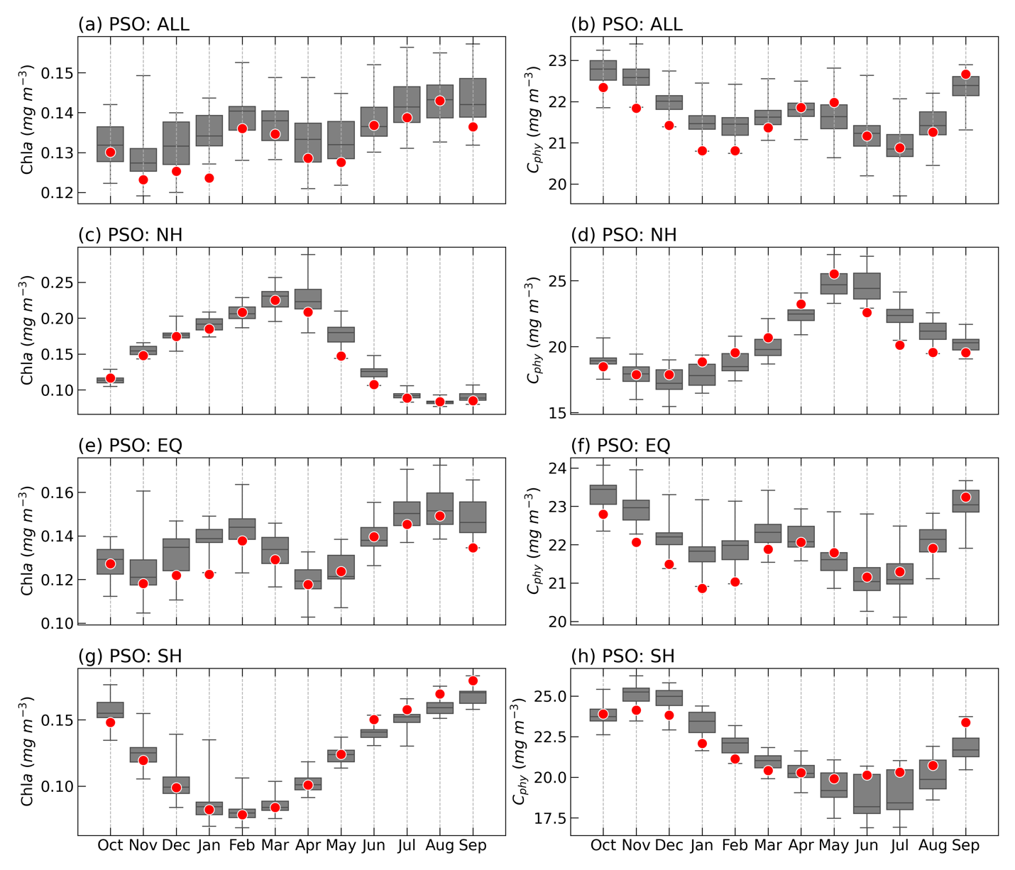

Fig. 3.26. Distribution of Oct 2023–Sep 2024 monthly means (red circles) for (a) VIIRS-N20 Chla and (b) VIIRS-N20 C_{phy} for the permanently stratified ocean (PSO) region (see Fig. 3.27), superimposed on the climatological values as derived from the combined time series of SeaWiFS, MODIS-A, and VIIRS-N20 over the period of Oct 1998–Sep 2023 Gray boxes show the interquartile range of the climatology, with a black line for the median value and whiskers extending to minimum and maximum values. Subsequent panels show latitudinally segregated subsets of the PSO for the Northern Hemisphere (above tropics), NH (c),(d), tropical ±23.5° latitude subregion, EQ (e),(f), and Southern Hemisphere (below tropics), SH (g),(h). Units for (a), (c), (e), and (g) are Chla (mg m⁻³) and (b), (d), (f), and (h) are C_{phy} (mg m⁻³).
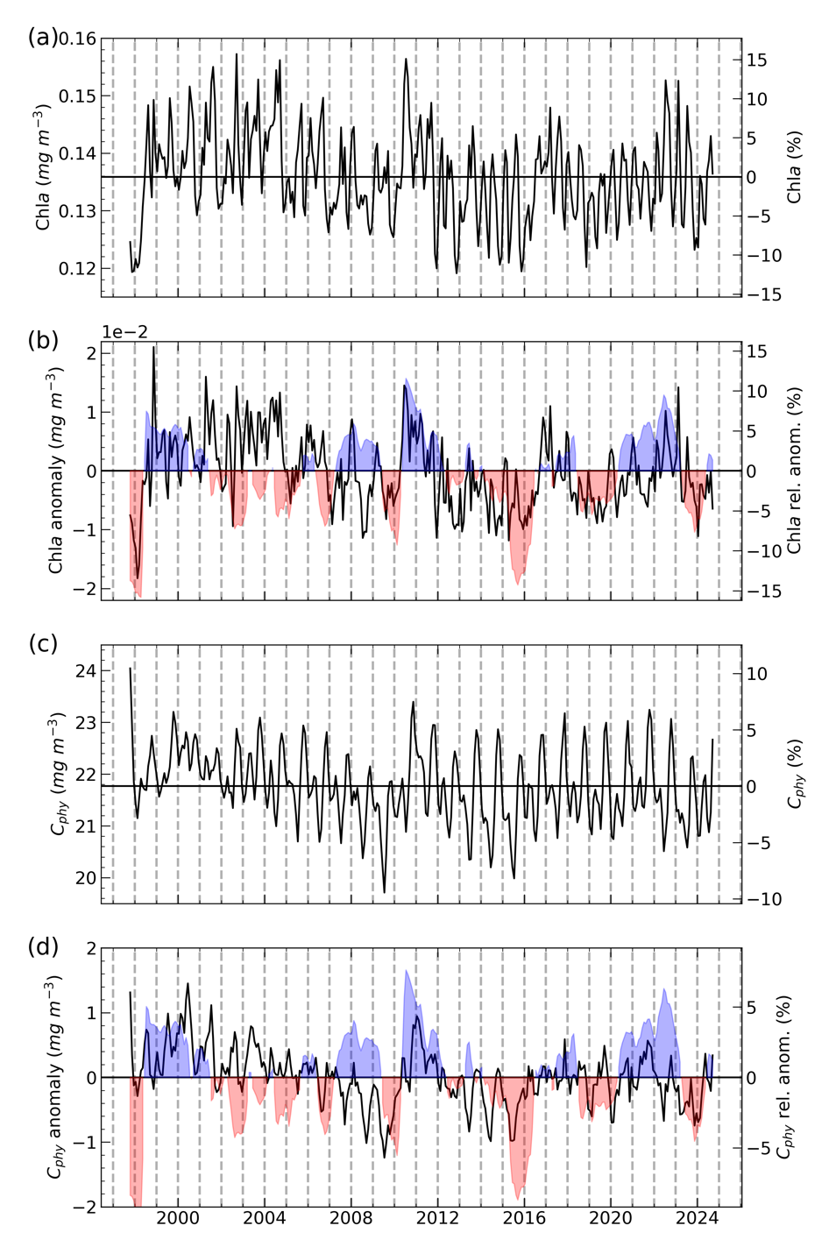

Fig. 3.27. 26-year, multi-mission record of Chla (mg m⁻³) and C_{phy} (mg m⁻³) averaged over the PSO (October 1997-Sep 2024). (a) Monthly Chla, with the horizontal line indicating the multi-mission mean Chla concentration for the entire PSO region. (b) Monthly Chla anomalies after subtraction of the multi-mission climatological mean (Fig. 3.26a). (c) Monthly C_{phy}, with the horizontal line indicating the multi-mission mean C_{phy} concentration for the entire PSO region. (d) Monthly C_{phy} anomalies after subtraction of the multi-mission climatological mean (Fig. 3.26b). Shaded blue and red colors show the Multivariate ENSO Index, inverted and scaled to match the range of the Chla and C_{phy} anomalies, where blue indicates La Niña and red indicate El Niño conditions.
References
Behrenfeld, M.J., Randerson, J.T., McClain, C.R., Feldman, G.C, et al., 2001: Biospheric Primary Production During an ENSO Transition. Science, 291,2594-2597. https://doi.org/10.1126/science.1055071
Behrenfeld, M. J., and Coauthors, 2015: Reevaluating ocean warming impacts on global phytoplankton. Nature Clim. Change, 6, 323–330.
Behrenfeld, M. J., and Coauthors, 2006: Climate-driven trends in contemporary ocean productivity. Nature, 444, 752-755.
Cetinić, I., M. J. Perry, N. T. Briggs, E. Kallin, E. A. D’Asaro, and C. M. Lee, 2012: Particulate organic carbon and inherent optical properties during 2008 North Atlantic Bloom Experiment, J. Geophys. Res., 117, C06028, https://doi.org/10.1029/2011JC007771.
Cetinić, I., Rousseaux, C., Carroll, I., Chase, A., Kramer, S., Werdell, P., Siegel, D., Dierssen, H., Catlett, D., Neeley, A., Soto Ramos, I., Wolny, J., Sadoff, N., Urquhart, E., Westberry, T., Stramski, D., Pahlevan, N., Seegers, B., Sirk, E., Lange, P., Vandermeulen, R., Graff, J., Allen, J., Gaube, P., McKinna, L., McKibben, S., Binding, C., Calzado, V., & Sayers, M., 2024: Phytoplankton composition from sPACE: Requirements, opportunities, and challenges. Remote Sensing of Environment, 302, 113964. https://doi.org/10.1016/j.rse.2023.113964
Chavez, F.P., M. Messié, J.T. Pennington, 2011. Marine primary production in relation to climate variability and change. Annual review of marine science, 3, 227-60. https://doi.org/10.1146/annurev.marine.010908.163917.
Deser, C., M. A. Alexander, S.-P. Xie, and A. S. Phillips, 2010: Sea surface temperature variability: Patterns and mechanisms. Annual review of marine science, 2, 115-143.
Dierssen, H. M., 2010: Perspectives on empirical approaches for ocean color remote sensing of chlorophyll in a changing climate. Proceedings of the National Academy of Sciences, 107, 17073-17078.
Field, C. B., Behrenfeld, M. J., Randerson, J. T., & Falkowski, P., 1998: Primary production of the biosphere: integrating terrestrial and oceanic components. Science, 281(5374), 237-240. doi:10.1126/science.281.5374.237
Franz, B. A., I. Cetinic, M. Gao, A. Siegel, and T. K. Westberry, 2024: Global ocean phytoplankton [in “State of the Climate in 2023”]. Bulletin of the American Meteorological Society, 105, S194 – S197.
Franz, B. A., I. Cetinic, A. Ibrahim, and A. M. Sayer, 2024b: Anomalous trends in global ocean carbon concentrations following the 2022 eruptions of Hunga Tonga-Hunga Ha'apa, Communications Earth & Environment, in review.
Geider, R. J., H. L. MacIntyre, and T. M. Kana, 1997: Dynamic model of phytoplankton growth and acclimation: responses of the balanced growth rate and the chlorophyll a:carbon ratio to light, nutrient limitation and temperature. Marine Ecology Progress Series, 148, 187-200.
Graff, J. R., and Coauthors, 2015: Analytical phytoplankton carbon measurements spanning diverse ecosystems. Deep Sea Res Part 1 Oceanogr Res Pap., 102, 16-25.
Hu, C., Z. Lee, and B. Franz, 2012: Chlorophyll algorithms for oligotrophic oceans: A novel approach based on three‐band reflectance difference. Journal of Geophysical Research: Oceans, 117.
Hu, C., L. Feng, Z. Lee, B.A. Franz, S.W. Bailey, P.J. Werdell, and C.W. Proctor, 2019: Improving satellite global chlorophyll a data products through algorithm refinement and data recovery. Journal of Geophysical Research: Oceans, 124(3), 1524-1543, doi: 10.1029/2019JC014941.
Khaykin, S., G. Taha, T. Leblanc, T. Sakai, I. Morino, B. Liley, and S. Godin-Beekmann, 2025: Sratospheric Aerosols [in “State of the Climate in 2024”]. Bulletin of the American Meteorological Society, in review.
Kramer, S. J., D. A. Siegel, S. Maritorena, and D. Catlett, 2022: Modeling surface ocean phytoplankton pigments from hyperspectral remote sensing reflectance on global scales. Remote Sensing of Environment, 270, 112879.
Lange, P. K., and Coauthors, 2020: Radiometric approach for the detection of picophytoplankton assemblages across oceanic fronts. Opt. Express, 28, 25682-25705.
McKinna, L.I.W., P.J. Werdell, and C.W. Proctor, 2016: Implementation of an analytical Raman scattering correction for satellite ocean-color processing, Opt. Express 24, A1123-A1137.
McKinna, L. and P.J. Werdell, 2023: Inherent Optical Properties. NASA Algorithm Publication Tool, v1.0, 10 April 2024. 10.5067/ZGBW3QECROJ2
O'Reilly, J.E., and P.J. Werdell, 2019: Chlorophyll algorithms for ocean color sensors - OC4, OC5 & OC6. Remote Sensing of Environment, 229, 32-47. doi: 10.1016/j.rse.2019.04.021
Pahlevan, N., B. Smith, C. Binding, D. Gurlin, L. Li, M. Bresciani, and C. Giardino, 2021: Hyperspectral retrievals of phytoplankton absorption and chlorophyll-a in inland and nearshore coastal waters. Remote Sensing of Environment, 253, 112200.
Siegel, D. A., S. Maritorena, N. B. Nelson, M. J. Behrenfeld, and C. R. McClain, 2005: Colored dissolved organic matter and its influence on the satellite-based characterization of the ocean biosphere. Geophys. Res. Lett., 32.
Siegel, D. A., and Coauthors, 2013: Regional to global assessments of phytoplankton dynamics from the SeaWiFS mission. Remote Sensing of Environment, 135, 77-91.
Siegel, D.A., T. DeVries, I. Cetinić, K.M. Bisson, 2023: Quantifying the Ocean's Biological Pump and Its Carbon Cycle Impacts on Global Scales. Annual Review of Marine Science, 15:1, 329-356.
Twedt, K., N. Lei , X. Xiong , A. Angal , S. Li, T. Chang , J. Sun, 2022: On-Orbit Calibration and Performance of NOAA-20 VIIRS Reflective Solar Bands. IEEE Transactions on Geoscience and Remote Sensing, 60.
Werdell, P. J., and Coauthors, 2013: Generalized ocean color inversion model for retrieving marine inherent optical properties. Appl. Opt., 52, 2019-2037.
Werdell, P. J., and L. I. Mckinna, 2019: Sensitivity of inherent optical properties from ocean reflectance inversion models to satellite instrument wavelength suites. Frontiers in Earth Science, 7 [10.3389/feart.2019.00054].
Werdell, P. J., and Coauthors, 2019: The Plankton, Aerosol, Cloud, Ocean Ecosystem Mission: Status, Science, Advances. Bulletin of the American Meteorological Society, 100, 1775-1794.
Werdell, P.J., J. O'Reilly, C. Hu, L. Feng, Z. Lee, B. Franz, S. Bailey, C. Proctor, 2023: Chlorophyll a. NASA Algorithm Publication Tool, v1.1, 6 November 2023. https://doi.org/10.5067/JCQB8QALDOYD
Westberry, T. K., and Coauthors, 2016: Annual cycles of phytoplankton biomass in the subarctic Atlantic and Pacific Ocean. Global Biogeochem. Cycles, 30, 175-190.
Wolter, K., and M. S. Timlin, 1998: Measuring the strength of ENSO events: How does 1997/98 rank?, 53, 315-324.
Zhu, Y., C.G. Bardeen, S. Tilmes, et al., 2022: Perturbations in stratospheric aerosol evolution due to the water-rich plume of the 2022 Hunga-Tonga eruption. Nature Communications Earth & Environment, 3, 248. https://doi.org/10.1038/s43247-022-00580-w

Datasets Used:

Variable | Dataset | Source
Phytoplankton Chlorophyll  Particle Backscattering Coefficient | SeaWiFS v R2022.0 | https://oceancolor.gsfc.nasa.gov/reprocessing/
 | MODIS-Aqua v R2022.0 | https://oceancolor.gsfc.nasa.gov/reprocessing/
 | VIIRS-NOAA20 v R2022.0 | https://oceancolor.gsfc.nasa.gov/reprocessing/
Daytime Sea Surface Temperature | MODIS-Aqua v R2019.0 | https://oceancolor.gsfc.nasa.gov/reprocessing/

