Analysis of a saline dust storm from the Aralkum Desert - Part 1: Consistency between multisensor satellite aerosol products
Xin Xi¹, Jun Wang², Zhendong Lu³, Andrew M. Sayer^{4,5}, Jaehwa Lee^{4,6}, Robert Levy⁴, Yujie Wang^{4,5}, Alexei Lyapustin⁴, Hongqing Liu^{7,8}, Istvan Laszlo^{7,9}, Changwoo Ahn^{4,10}, Omar Torres⁴,
Sabur Abdullaev¹¹, James Limbacher¹², and Ralph Kahn¹³
1Department of Geological and Mining Engineering and Sciences, Michigan Technological University, Houghton, MI, USA
2Department of Chemical and Biochemical Engineering, The University of Iowa, Iowa City, IA, USA
3Interdisciplinary Graduate Program in Informatics, The University of Iowa, Iowa City, IA, USA.
4NASA Goddard Space Flight Center, Greenbelt, MD, USA
5Goddard Earth Sciences Technology and Research (GESTAR) II, University of Maryland, Baltimore County, Baltimore, MD, USA
6Earth System Science Interdisciplinary Center, University of Maryland, College Park, MD, USA
7Center for Satellite Applications and Research, National Environmental Satellite, Data, and Information Service, National Oceanic and Atmospheric Administration, College Park, Maryland, USA
8I. M. Systems Group, Inc., College Park, Maryland, USA
9Department of Atmospheric and Oceanic Sciences, University of Maryland, College Park, Maryland, USA
10Science Systems and Applications Inc., Lanham, MD, USA
11Physical Technical Institute of the Academy of Sciences of Tajikistan, Dushanbe, Tajikistan
12Science and Technology Corporation, Hampton, Virginia, USA
13Laboratory for Atmospheric and Space Physics, The University of Colorado Boulder
Correspondence: Xin Xi (xinxi@mtu.edu)

Abstract. The Aralkum Desert is a prominent source of saline dust and presents a challenging environment for satellite-based aerosol observations due to lack of in situ observational constraints on aerosol microphysical properties and the region’s highly heterogeneous, dynamic surfaces. Through a survey of satellite aerosol algorithms, we identify diverse retrieval techniques and differing assumptions about surface and aerosol microphysical properties, which may deviate from
5 actual conditions and contribute to inconsistencies in characterizing the saline dust from Aralkum. The inconsistencies and potential biases of satellite products in detecting the dust presence, column burden, and vertical height are further assessed via detailed comparisons of multiple UVAI, midvisible and thermal-infrared AOD, and ALH products. The key findings are: (1) UVAI products consistently delineate the dust plume extent if differences in the dynamic range are considered. All products display large positive values over the Garabogazköl Gulf and northern Caspian Sea due to absorption by turbid saline waters,
10 highlighting the need for caution to avoid misinterpreting surface effects as dust signals over dry or ephemeral lakes. (2) Midvisible aerosol products from MODIS and VIIRS show strong agreement in total and coarse-mode AOD retrievals over the Caspian Sea, despite using different aerosol optical models. Over desert surfaces, all products misclassify the fresh dust plume as clouds and exhibit strong non-linear relationships in AOD retrievals. The NOAA EPS product retrieves significantly lower AOD than other products, though its agreement improves after a dust optical model was selected for retrieval. The
15 MISR research aerosol algorithm produces higher, more consistent AOD retrievals and improved characterization of aerosol

properties compared to the MISR operational product. (3) Among IASI infrared aerosol products, the LMD algorithm has the best performance in capturing dust plume features over both desert and water surfaces. (4) The EPIC AOCH product significantly overestimates aerosol heights under low aerosol loadings but exhibits good agreement with CALIOP extinction- weighted ALH for dust-laden scenes. On average, IASI-retrieved dust layer heights are 0.4 km higher than EPIC over dust-laden
20 regions. MISR plume height retrievals align well with CALIOP and EPIC over the Kopet-Dag foothills. This study underscores the important insights from a synergistic, multisensor analysis into the complementary strengths and potential biases of satellite aerosol products in Central Asia and highlights the need for their proper use and careful interpretation when studying the saline dust from the Aralkum Desert.

1 Introduction

25 Emerging from the desiccated basin of the former Aral Sea, the Aralkum Desert has evolved into one of the most active sources of wind-blown dust in Central Asia, with adverse impacts on biodiversity, agriculture, and human well-being (Orlovsky and Orlovsky, 2001; Xi and Sokolik, 2016). Aralkum stands out among the extensive dust sources of Central Asia, not only because of its anthropogenic origin but also due to the distinct chemical and mineralogical compositions of its deflatable sediments. Figure 1) shows the spectral abundance of four mineral groups derived from the Earth Surface Mineral Dust Source
30 Investigation (EMIT) instrument. EMIT reveals that Aralkum contains more abundant carbonate and sulfate minerals, but less iron oxides and clays, compared to the nearby Karakum and Taklamakan deserts. Groll et al. (2019) found that dust samples collected near Aralkum contained considerably higher sulfate and chloride content than those from sandy deserts. Given its unique mineralogical compositions, the saline dust from Aralkum is expected to be more hygroscopic and less light-absorbing than typical desert dust. Past studies suggested that salt-containing particles from dry lakes may act as efficient cloud nuclei
35 (Rudich et al., 2002; Gaston et al., 2017). Based on ground lidar measurements, (Hofer et al., 2017) reported significantly lower extinction-to-backscatter or lidar ratios (23 sr at 532 nm) for salt dust observed in Tajikistan compared to typical dust aerosols (44±9 sr). Even within the desiccated Aral basin, there is substantial variability in the physiochemical properties of erodible sediments. As the Aral Sea continued shrinking, sediment grain size became progressively smaller towards the basin’s lowest point, while evaporate minerals began to precipitate in a typical sequence of calcite, gypsum/anhydrite, halite, and
40 finally potassium and magnesium salts. Consequently, distinct spatial gradients in mineralogy, grain size, and soil texture have been observed in the exposed sediments. For instance, Jiang et al. (2021) reported increasing abundances of clay and evaporites minerals but decreasing abundance of carbonates and organic carbon, when moving from the older coastline towards the newly exposed seabed. Argaman et al. (2006) showed that the highly erodible takyr soils dominate the outer rim of Aralkum, whereas the newly formed solonchak soils are more likely protected by salt crusts which created stable, coarse aggregates that are
45 resistant to wind erosion.
Assessing the impacts of wind-blown dust from Aralkum is greatly hindered by the lack of in situ measurements of the phys- ical and chemical properties of the deflatable sediments (e.g., soil texture, mineralogical composition, crusting), and airborne dust particles (e.g., particle size distribution, shape, nonsphericity, chemical composition, mixing state, solubility). In particu-

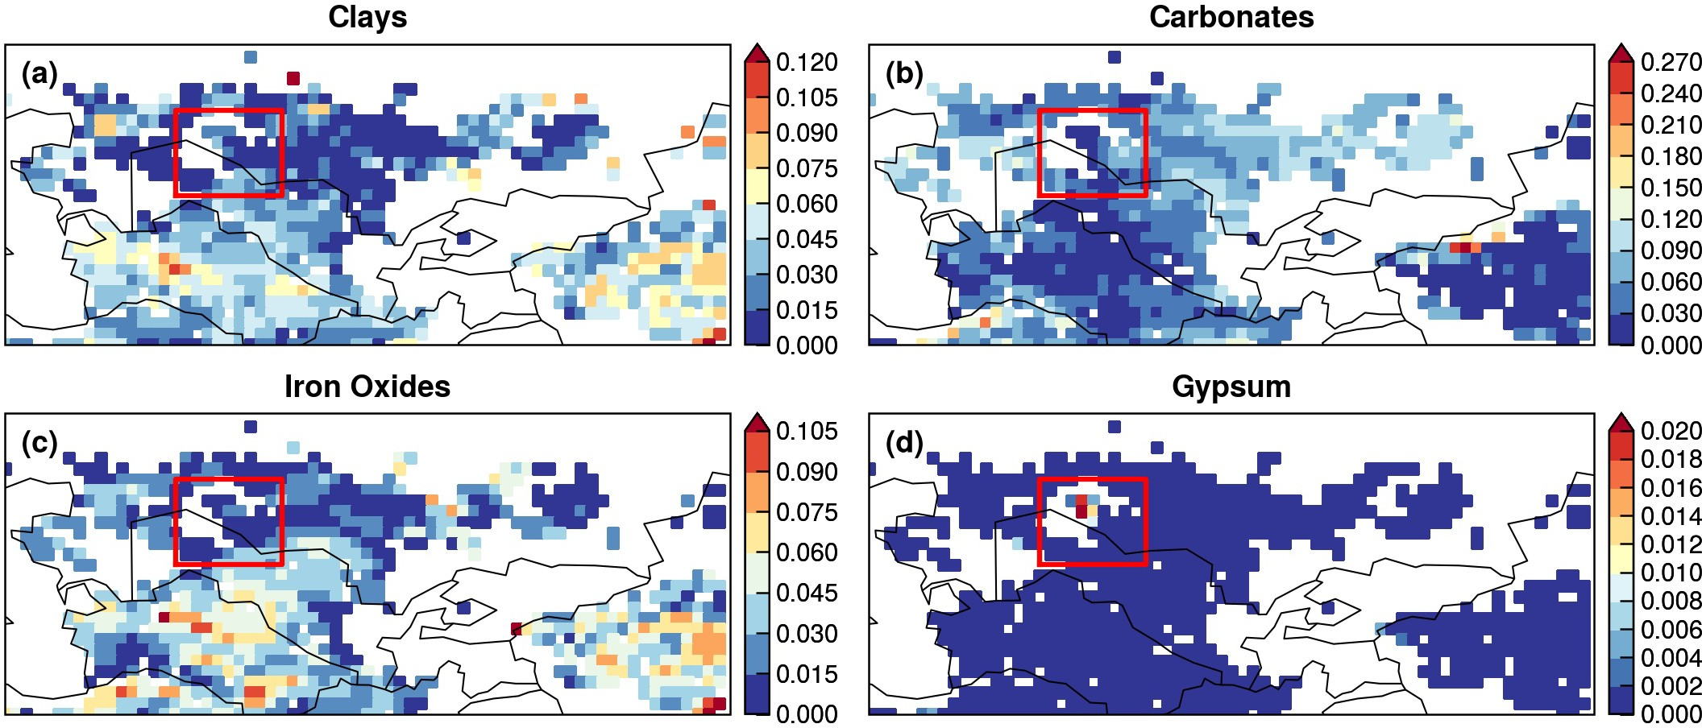

Figure 1. Aggregated spectral abundance of four mineral groups based on the Earth Surface Mineral Dust Source Investigation (EMIT) L3 product: (a) Clays (including chlorite, illite, muscovite, kaolinite, montmorillonite and vermiculite); (b) Carbonates (calcite and dolomite);
(c) Iron Oxides (goethite and hematite); and (d) Gypsum. Boxed regions indicate the Aralkum Desert. Note that panel (d) uses a different color scale from others.

lar, the global network of ground-based sun/sky photometers, AERosol RObotic NETwork (AERONET), has no operating sites
50 near Aralkum, presumably because of the region’s remoteness. The two operational AERONET sites in Central Asia—Issyk-Kul and Dushanbe—are located too far away to provide representative measurements of the saline dust from Aralkum (Semenov et al., 2005; Rupakheti et al., 2020). AERONET serves two important purposes. First, it provides the climatological aerosol information needed to specify season- and region-dependent aerosol optical models used in many satellite retrieval algorithms (Dubovik et al., 2002). Second, AERONET data are used as benchmark for validating satellite
55 retrievals. Consequently, the a priori assumptions about aerosol microphysical properties in satellite algorithms may not ac- curately capture the unique dust properties over Aralkum. The lack of ground truth also prevents an evaluation of satellite products’ performance in characterizing the saline dust from Aralkum. In general, satellite algorithms are optimized for global performance, but they may exhibit significant local biases when the local prevailing aerosol conditions deviate substantially from satellite algorithm assumptions on aerosol properties.
60 Large-scale dust monitoring has relied on satellite retrievals over ocean basins frequently affected by continental dust out- flow. For dust sources located deep within continental interiors such as Central Asia, observing airborne dust from space is more challenging due to difficulty in separating the surface contribution from the top-of-the-atmosphere (TOA) radiance mea- surements. Central Asia comprises a range of dust sources with varying sediment abundance and erodibility, including sandy and hilly deserts, desert steppes, salt flats, and ephemeral or dry lakes (Xi and Sokolik, 2015a, b). These regions feature het-

65 erogeneous and dynamic surface properties (e.g., reflectivity, emissivity), posing a major challenge to isolate the aerosol signal from surface contributions. Currently, a number of techniques have been developed to facilitate dust monitoring over desert surfaces. However, data users may struggle with the product choice, not knowing the strengths and limitations of each product for their specific area of interest. To date, the performance of satellite aerosol products for characterizing the Aralkum dust re- mains unknown. It is also unclear whether these products are consistent with each other. In this regard, a multisensor approach
70 is preferred over the use of a single product, and may provide potential insights about satellite product performance through the synergy of different observation techniques.
During 27–29 May 2018, a saline dust storm was triggered from the Aralkum Desert by cold air outbreak, causing persistent haze, record-high particulate concentrations, and salt deposition on agricultural fields (Xi, 2023). This manuscript documents the first part of detailed investigation of this event, focusing on the consistency and synergy of multisensor aerosol products. A
75 companion paper will focus on the large-scale dynamics and model simulations of the event.
This manuscript is organized as follows. We first conduct a survey of current satellite techniques and algorithms capable of detecting the presence, column burden, and vertical height of airborne dust over Central Asia (Section 2). The survey focuses on the theoretical basis and a priori assumptions about aerosol and surface properties associated with satellite retrievals of Ultraviolet Aerosol Index (UVAI), Aerosol Optical Depth (AOD), and Aerosol Layer Height (ALH). Then, we compare mul-
80 tiple UVAI, AOD (at both 0.55 and 10 µm), and ALH products to investigate the cross-sensor and cross-algorithm consistency in observing the saline dust from Aralkum on 27–29 May 2018. To avoid confusion, we will refer to the midvisible (0.55 µm) AOD simply as AOD, while specifying the wavelength as a subscript for other cases, e.g., AOD₁₀ for 10 µm AOD and AOD_{0.68} for 0.68 µm AOD. Due to lack of validation data, we focus on assessing the consistency (or lack thereof) between different sensors and algorithms rather than evaluating the product accuracy. Through a synergistic analysis of multisensor
85 satellite products, we aim to highlight the complementary strengths of various techniques, uncover their limitations and biases, and offer recommendations for their proper use and future refinements over Central Asia. Section 4 summarizes the findings of this study.

- Overview of Satellite Aerosol Retrievals over Desert Surfaces

UVAI

90 UVAI was first discovered as a spectral residual quantity in near-UV wavelengths (330–380 nm) which measures the departure of observed spectral contrast from that of a pure molecular atmosphere (Herman et al., 1997). Significant changes in the spectral dependence of backscattered UV radiances were frequently associated with the presence of absorbing aerosols, such as dust, carbonaceous aerosols, and volcanic ash. This phenomenon provides a physical basis for UVAI, which yields large positive values for absorbing aerosols over ocean and land (including deserts and snow/ice-covered surfaces), as well as above clouds.
95 This makes UVAI an excellent tracer for airborne dust (Prospero et al., 2002). Compared to a pure molecular atmosphere, dust particles reduce the spectral contrast of backscattered UV radiances by absorbing the Rayleigh scattered radiation from beneath the dust layer (Torres et al., 1998; de Graaf et al., 2005).

100

105

110
UVAI depends on multiple factors—including AOD, ALH, absorption properties, and surface reflectivity—with higher ALH or more absorbing particles leading to larger UVAI (de Graaf et al., 2005). UVAI is defined using pairs of wavelengths, and there is some dependence on the wavelength pair chosen.
In addition to absorbing aerosols, large positive UVAI values may also result from non-aerosol geophysical effects such as sun glint, ocean color, and strong wavelength dependence of surface reflectivity (Herman et al., 1997). These effects, if misinterpreted as aerosol signals, can introduce significant errors in dust detection.
In the original UVAI definition, water clouds were treated as part of a spectrally independent Lambertian Equivalent Reflector (LER), resulting in small negative UVAI values. Torres et al. (2018) introduced a new approach that explicitly accounts for the Mie scattering effects of water clouds. This Mie-based approach yields near-zero UVAI over cloudy scenes, and exhibits a weaker angular dependence compared to the original LER-based definition. Multidecadal UVAI records have been generated from spaceborne UV-visible spectrometers. In this study, we compare the UVAI products from Ozone Mapping and Profiler Suite (OMPS), TROPOspheric Monitoring Instrument (TROPOMI), and Earth Polychromatic Imaging Camera (EPIC), as described below.

OMPS

115

120

125
The OMPS Nadir Mapper is an imaging spectrometer onboard the Suomi National Polar-orbiting Partnership (SNPP) space- craft in a sun-synchronous orbit with an ascending node equatorial crossing time of 13:30. OMPS has
a nadir footprint of 50×50 km² and 110° across-track field of view, equivalent to a ground swath of 2800 km. The OMPS Nadir Mapper aerosol algorithm (NMMIEAI) reports the Mie-based UVAI at the 340/378.5 nm wavelengths (Torres, 2019a).

TROPOMI

TROPOMI is a nadir-viewing, push-broom-type grating spectrometer onboard the Copernicus Sentinel 5 Precursor (S5P) mission, which flies in close formation with SNPP (less than 5 min apart) in a sun-synchronous orbit with an ascending node equatorial crossing time of 13:30 (Veefkind et al., 2012). TROPOMI has a nadir footprint size of 3.5×7 km² and a 2,600 km swath width.
There are two separate UVAI products from TROPOMI, one developed by ESA (European Space Agency), and the other developed by NASA. The NASA version uses the TropOMAER algorithm which reports both LER- and Mie-based UVAI at 354/388 nm (Torres, 2021). The ESA version reports LER-based UVAI at three wavelength pairs: 354/388, 340/380, and 335/367 nm (Stein Zweers, 2022). The first two pairs were selected to continue the multidecadal heritage UVAI records, while the 335/367 nm pair was added to ensure compatibility with the future UVAI algorithm planned for the Sentinel-5 mission.

EPIC

130

135

140

145

150

155
EPIC is an imaging spectroradiometer onboard the Deep Space Climate Observatory (DSCOVR) spacecraft, which operates in a Lissajous orbit about Lagrange-1 point in the Earth-Sun system. This allows EPIC to view the sunlit disk of Earth every 60–100 minutes. The EPIC EPICAERUV algorithm reports both LER- and Mie-based UVAI at the 340/388 nm wavelengths (Torres, 2019b) with a pixel size of 16 km.

Midvisible AOD

Inferring column-integrated aerosol properties from reflected visible-NIR observations is an ill-posed inverse problem due to limited information content to fully characterize the atmosphere-surface system. Midvisible AOD is generally the most readily-available parameter from such sensors, and consequently algorithms must rely on a priori knowledge or assumptions of the aerosol size distribution, shape, and refractive index (known as aerosol optical models). A common strategy involves creating look-up tables (LUTs) of TOA reflectances for a set of predefined aerosol optical models, surface types, and solar/viewing geometries (e.g. Remer et al., 2013a), based on radiative transfer codes. These LUTs are then used to match with measured TOA reflectances to derive optimal estimates of AOD and, in some cases, additional aerosol properties related to particle size and absorption. Aerosol retrieval using this strategy is highly sensitive to the aerosol optical models that are predefined in the algorithm and selected during the retrieval. Although these aerosol models are designed to represent season- and location-specific aerosol conditions as realistically as possible, satellite algorithms may still incorporate inconsistent or even contradictory models, especially for regions like Central Asia due to lack of observational constraints. In addition, satellite algorithms may fail to select the appropriate model during the retrieval, leading to mismatch between the assumed aerosol properties and the actual aerosol conditions. These factors can contribute to inconsistencies between retrieved AODs, including those from the same instrument.
We compare multiple AOD products from three polar-orbiting instruments onboard NASA’s EOS and NOAA’s
JPSS satellites, including the Moderate Resolution Imaging Spectroradiometer (MODIS), Multi-angle Imaging Spectrora- diometer (MISR), and Visible Infrared Imaging Radiometer Suite (VIIRS). MODIS and VIIRS employ three single-view aerosol algorithms—Dark Target (DT), Deep Blue (DB), and Enterprise Processing System (EPS)—and the time series-based Multi-Angle Implementation of Atmospheric Correction (MAIAC) algorithm. MISR utilizes two algorithms: an operational standard algorithm for generating routine global aerosol records, and a research algorithm designed to explore alternative retrieval methods and additional aerosol properties on a case-by-case basis.

160

165

170

175
Below, we briefly describe the MODIS, VIIRS, and MISR aerosol algorithms, focusing on the a priori assumptions about aerosol optical models and surface reflectances. Other algorithm components (e.g., screening of clouds/sun glint/snow) are not discussed.

MODIS and VIIRS DT over-water algorithms

The DT algorithm exploits the contrast of reflective aerosol layers against a dark background in the visible spectrum. Over water, the algorithm searches the LUT for the best fit of measured TOA reflectances at seven window bands from visible to SWIR, and obtains solutions for both AOD and fine mode fraction (FMF) (Tanré et al., 1997). The ambient aerosol scene is represented as a linear combination of one fine and one coarse mode weighted by FMF. DT considers nine aerosol optical models over water: four fine aerosol models, three sea salt models, and two coarse dust models, which are derived from long-term AERONET measurements near water bodies (Remer et al., 2005). Due to lack of non-spherical dust models, the algorithm was known to yield biased retrievals over dusty oceanic scenes (Zhou et al., 2020b). A spheroidal dust model has been introduced and will be implemented in the MODIS Collection 7 (Zhou et al., 2020a).
In the MODIS product suite, the DT aerosol retrieval is performed at a nominal resolution of 10×10 km². A higher-resolution product (DT3K) was later introduced at 3×3 km² to capture small-scale aerosol features (Remer et al., 2013b). DT3K employs the same technique as DT, but using different pixel aggregation and quality assurance (QA) rules. The DT algorithm has been ported to VIIRS, which retrieves AOD at a nominal resolution of 6×6 km² (Sawyer et al., 2020).

MODIS and VIIRS DB algorithms

180

185
Inspired by the aerosol detection capability in the near-UV, the DB algorithm employs the 0.41 µm or “deep blue” band, which has lower and more homogeneous surface reflectivity than the longer visible wavelengths (Hsu et al., 2004). Aerosols are represented by a spheroidal dust model and a spherical fine-dominated anthropogenic model, which employ various SSA values depending on locations and seasons. The surface reflectances are determined based on a pre-calculated database over bright surfaces (e.g., deserts, urban areas), and empirical relationships between visible and SWIR bands over vegetated surfaces (Hsu et al., 2013).
DB was initially implemented to fill the data gap over bright surfaces in the MODIS aerosol product. In the VIIRS product suite, DB has been expanded to all cloud-, snow- and ice-free land surfaces, and also performs retrieval over water using the Satellite Ocean Aerosol Retrieval (SOAR) algorithm (Hsu et al., 2019; Lee et al., 2024). SOAR considers four aerosol optical models: maritime, dust, fine-dominated, and mixed, each represented by a bi-modal distribution consisting of one fine and one coarse mode (Sayer et al., 2018). The dust model consists of one spherical fine mode and one spheroidal coarse mode, derived from AERONET measurements at Cape Verde (Lee et al., 2017).

VIIRS EPS algorithm

190

195

200

205
The EPS algorithm was developed for NOAA’s next-generation polar-orbiting and geostationary environmental satellites. Here we focus on the VIIRS EPS aerosol product described in Laszlo (2018) and more recently Laszlo and Liu (2022). Over water, EPS is based on the MODIS heritage and represents the aerosol column as a linear combination of one fine and one coarse mode weighted by FMF, selected from four fine-mode and five coarse-mode aerosol models same as the MODIS DT algorithm (Remer et al., 2006). The algorithm searches for the AOD and FMF that give the best match between observed and pre-calculated TOA reflectances at seven VIIRS channels (Jackson et al., 2013; Laszlo and Liu, 2022).
Over land, EPS simultaneously retrieves AOD, aerosol optical model, and Lambertian surface reflectances in selected bands, by matching the observed and calculated TOA reflectance over both dark and bright (snow-free) surfaces. EPS considers four candidate aerosol optical models, of which three are spherical, fine-mode dominated aerosols (labeled as generic, urban, and smoke), and one is non-spherical, coarse-mode dominated aerosol (labeled as dust). The dust model is forcibly used for North Africa and the Arabian Peninsula to account for the dominant dust presence in these regions. The candidate aerosol models are adopted from the MODIS Collection 5 DT algorithm (Remer et al., 2006). Over bright desert surfaces, the surface reflectance is estimated from a static database of spectral reflectance ratios between VIIRS channels (Zhang et al., 2016).

MODIS MAIAC algorithm

210

215
Unlike the single-view approach adopted by DT, DB and EPS algorithms, MAIAC uses a sliding window to accu- mulate up to 16 days of multi-angle observations from different orbits for the same location to retrieve bidirectional surface reflectance over land (including deserts) simultaneously with aerosol properties (Lyapustin et al., 2018). MAIAC uses a dynamic minimum reflectance method to define the surface reflectance spectral ratios for each 1 km grid cell, which allows AOD retrieval over dark and bright surfaces. The MODIS Collection 6 MAIAC algorithm uses nine aerosol optical models derived from AERONET climatology to represent the regional background aerosol conditions. For Central Asia, the background aerosol model (“Model 2”) is derived from AERONET measurements over the western U.S., which represents a mixture of dust and fine mode aerosols. During the retrieval, a smoke/dust test is first applied to determine whether the background or dust model should be used. If dust is detected, the algorithm uses a spheroidal dust model (“Model 6”) derived from AERONET measurements from the Solar Village site in Saudi Arabia (Dubovik et al., 2006).

MISR aerosol algorithms

MISR measures reflected sunlight using nine push-broom cameras with view angles of ±70.5°, ±60.0°, ±45.6°, ±26.1°, and 0° along-track, each in four spectral bands (446, 558, 672, and 866 nm) across a 380 km swath at pixel-resolution between 275 m and 1.1 km, depending on the channel (Diner et al., 1998). The MISR Standard Aerosol retrieval algorithm produces
220 AOD and constraints on column-effective particle type operationally (Garay et al., 2020). The aerosol column is represented

225

230

235

240

245

250
by 74 aerosol optical models as mixtures of single-composition components, including 50 mixtures of spherical components, 20 mixtures of spherical and dust components, and 4 mixtures of dust components. The algorithm accounts for the contribution of surface bidirectional reflectance factor (BRF) based on a principal component analysis of TOA MISR radiance data.
The MISR Research Aerosol retrieval algorithm is optimized to provide constraints on particle size, sphericity, and light- absorption under favorable observing conditions on a case-by-case basis (Limbacher et al., 2022). The algorithm considers a broader range of aerosol mixtures to allow more subtle particle property distinction. For the surface reflectance, two different approaches are considered: retrieved surface BRF self-consistently using only MISR data (similar to the standard algorithm), and prescribed surface BRF from MODIS MAIAC product to separate the surface contribution. In addition, an AI/ML (artificial intelligence/machine learning) approach has been developed based in part on a global aerosol microphysical property dataset developed by (Anstett et al.).
In addition to the radiometrically derived AOD, ALH can be derived geometrically from the parallax in the hyper-stereo im- agery. The MISR Interactive Explorer (MINX) software performs this task interactively, on a case-by-case basis, and retrieves plume heights at 1.1 km horizontal resolution, and between 250 and 500 m vertical resolution (Nelson et al., 2013). The MISR ALH retrievals identify the layer of maximum spatial contrast in the plume imagery, so the results are often skewed lower than CALIPSO, which also measures thin, less distinct aerosol layers above dense plume features (Flower and Kahn, 2017). Results for the MISR AOD and ALH retrievals will be presented for the current study.

Thermal Infrared AOD (AOD₁₀)

Compared to visible and NIR-based techniques, aerosol retrieval in thermal-infrared (TIR) wavelengths offers several advan- tages, such as nighttime observation and enhanced contrast of dust signals over deserts. In addition, the infrared spectrum is primarily sensitive to coarse particles (diameter>1 µm), providing better dust detection. Split-window techniques have been used to detect dust from passive radiometers by exploiting the distinct negative brightness temperature difference between two neighboring atmospheric window channels (e.g., 10.8 and 12 µm) (Legrand et al., 2001; Lensky and Rosenfeld, 2008). Based on this approach, the Dust RGB composite derived from the Spinning Enhanced Visible and InfraRed Imager (SEVIRI) is capable of tracking dust plumes qualitatively every 15 minutes and mapping the source locations over Central Asia, as demonstrated in Xi (2023).
Hyperspectral infrared spectrometers have offered new potential to infer dust properties, including AOD₁₀ and dust layer height. A major challenge in TIR-based retrieval is isolating the aerosol signal from the infrared emissions of the atmosphere and the underlying surface. Hence, TIR-based algorithms rely on forward model simulations of TOA radiances or brightness temperatures for a range of atmospheric profiles (e.g., temperature, water vapor), surface properties (e.g., emissivity, tempera- ture), and dust aerosol properties (e.g., AOD₁₀, vertical distribution, size, and refractive index). Below we describe four AOD₁₀ products derived from the Infrared Atmospheric Sounding Interferometer (IASI), a Fourier transform spectrometer onboard the European MetOp satellite series that observes the Earth’s radiation spectra from 645 to 2760 cm⁻¹ (3.6–15.5 µm) at a spec- tral resolution of 0.5 cm⁻¹ and a nadir ground resolution of 12 km. The four algorithms differ in the retrieval methods, the atmosphere and surface input data, and the dust optical models assumed in forward model calculations, among other factors.

255 2.3.1 LMD algorithm

260

265

270

275

280

285
The Laboratoire de Météorologie Dynamique (LMD) algorithm employs a two-step, LUT-based approach (Capelle et al., 2018). In the first step, the atmospheric state is determined using 18 IASI channels that are insensitive to the surface or aerosols. In the second step, AOD₁₀, mean altitude, and surface temperature are retrieved by fitting observed brightness tem- peratures against simulations at 8 aerosol-sensitive channels. These simulations incorporate a range of atmospheric profiles, surface properties (emissivity, temperature, and pressure), AOD₁₀ values, altitudes, and dust microphysical properties. Dust is represented by a spherical, lognormal size distribution (R_{eff} =2.3 µm, σ_{g}=0.65) and two refractive indices from (Balkanski et al., 2007) and (Volz, 1973), corresponding to strongly and weakly absorbing dust types, respectively. Surface emissivity is based on the monthly mean IASI retrievals by (Capelle et al., 2012).

MAPIR algorithm

The Mineral Aerosol Profiling from Infrared Radiances (MAPIR) algorithm retrieves the vertical profiles of dust concentrations using the Rodgers optimal estimation method (Callewaert et al., 2019). The dust concentration profiles are converted to AOD₁₀ using Mie-calculated extinction cross section, based on an assumed size distribution and refractive index. A forward model (RTTOV) is used to simulate the IASI radiances, based on a priori of the state vector (i.e., dust concentration profiles at seven 1-km-thick layers centered at 0.5 to 6.5 km), along with temperature and water vapor profiles derived from IASI. The dust optical model assumes a lognormal size distribution (r_{g}=0.6 µm, σ_{g}=2), and the refractive index from (Volz, 1973). Surface emissivity is based on a monthly climatology derived from IASI clear sky spectra by (Zhou et al., 2011).

ULB algorithm

The Université libre de Bruxelles (ULB) algorithm estimates dust AOD₁₀ using a neural network approach (Clarisse et al., 2019). The algorithm first performs dust detection by computing a dust index from the linear discrimination analysis of the IASI-observed spectra. The dust index is then converted to dust AOD₁₀ via a neural network trained with synthetic spectra generated by a forward model. The forward model incorporates a representative set of atmospheric states from IASI Level-2 data, surface emissivity from (Zhou et al., 2011), and a range of dust layer altitudes from 0 to 7 km. Dust aerosol is represented by a lognormal size distribution (r_{g}=0.5 µm, σ_{g}=2), and the refractive index from (Volz, 1973).

IMARS algorithm

The Infrared Mineral Aerosol Retrieval Scheme (IMARS) algorithm performs probabilistic estimates of dust AOD₁₀, compo- sition, effective radius, and mean layer temperature (a proxy for layer height), based on forward model simulations of the IASI-observed radiances under various dust and ice cloud conditions (Offenwanger et al., 2024). The algorithm considers 12 possible combinations of four dust mineralogical mixtures (China, Central Sahara, Niger, Iowa Loess) and three size distribu- tions. Each dust mixture is associated with predefined mineral fractions (and hence refractive indices) and particle effective radius. Surface emissivity is based on the MODIS UCSB Emissivity Library.

ALH

290

295

300

305

310
Aerosol vertical distribution can be retrieved from both active and passive sensors. Active sensors, such as the Cloud-Aerosol Lidar with Orthogonal Polarization (CALIOP) lidar, provide vertically-resolved retrievals of aerosol volume extinction at high vertical resolutions. However, they are limited by narrow swaths and poor spatial coverage. In recent years, substantial progress has been made in retrieving ALH from passive sensors using various techniques, such as stereoscopic retrieval from polar-orbiting multiangle or geostationary imagers (Nelson et al., 2013; Carr et al., 2020), polarimetric observations in the near UV (Wu et al., 2016), differential optical absorption spectroscopic or DOAS ratios in NIR wavelengths (Xu et al., 2017, 2019), and hyperspectral infrared measurements (Capelle et al., 2018; Callewaert et al., 2019; Clarisse et al., 2019; Offenwanger et al., 2024). Although passive techniques do not achieve the same level of accuracy as lidars and only estimate an effective height with limited information on the aerosol layer thickness, they provide much better spatial coverage and revisit frequency (Lu et al., 2021, 2023).
The ALH definition varies by retrieval techniques, and may refer to the top of aerosol layers such as from stereoscopic techniques, or an effective central height corresponding to peak aerosol extinction (Xu et al., 2017). Like AOD, ALH is an optical quantity and varies with the retrieval wavelength. Except for stereoscopic techniques, passive ALH retrievals depend on assumptions about the aerosol vertical profile and layer thickness. In this study, we compare four ALH products, including the CALIOP aerosol extinction-weighted height, EPIC aerosol optical centroid height (AOCH) product, IASI LMD mean dust layer altitude, and MISR plume height. The MISR plume height is described in Section 2.2.5. Other products are described below.

CALIOP aerosol extinction-weighted height
CALIOP was a nadir-viewing elastic backscatter lidar onboard the Cloud-Aerosol Lidar and Infrared Pathfinder Satellite Obser- vations (CALIPSO), and measured polarized backscatter at 532 nm and total attenuated backscatter at 532 nm and 1032 nm, with a vertical resolution of 30 m below 8.2 km and 60 m between 8.2 and 20.2 km (Winker et al., 2009). In the CALIOP data processing, calibrated attenuated backscatter coefficient profiles are used to detect the top and base altitudes of atmospheric features. A set of scene classification algorithms (SCA) then classifies these features as either aerosol or cloud, and determine the aerosol type and cloud phase. During this process, aerosol extinction-to-backscatter ratios (or lidar ratios) are selected to derive the aerosol extinction and backscatter coefficient profiles (Young et al., 2018). The selection of lidar ratios is based on the aerosol typing algorithm which considers six tropospheric aerosol types—clean marine, dusty marine, dust, polluted continental/smoke, polluted dust, and elevated smoke (Kim et al., 2018). Based on the aerosol extinction profile, the ALH
L

with respect to the mean sea level can be calculated as
n i=1
n
L
βext,iZi βext,i
, where β_{ext,i} is the 532 or 1064 nm aerosol extinction

i=1
315 coefficient (km⁻¹) at level i, and Z_{i} is the altitude (km) at level i (Koffi et al., 2012).

EPIC AOCH product

320

325

330

335

340
The EPIC AOCH product is derived from the spectral contrast in TOA reflectances between the oxygen (O₂) absorption and continuum bands. The physical principle is that ALH affects the path length of backscattered light and the amount of light absorbed by well-mixed O₂ molecules, thereby producing a spectral contrast between the O₂ absorption bands relative to the continuum bands (Xu et al., 2019). The EPIC AOCH algorithm employs pre-computed TOA reflectances for a range of AOD, AOCH, surface reflectivity, and surface pressure and retrieves AOD and AOCH. Three aerosol optical models are considered: smoke, Saharan dust, and Asian dust. The dust models are derived from AERONET measurements at Cape Verde and over East Asia, respectively (Xu et al., 2017). Aerosol vertical distribution assumes a quasi-Gaussian profile characterized by a centroid altitude and a fixed half-width at half maxima of 1 km. Hence, the EPIC-retrieved AOCH represents the altitude of peak volume extinction.

IASI LMD mean dust layer altitude

TIR-based retrieval employs the sensitivity of infrared radiation to the temperature of the aerosol layer, which is intrinsically linked to its mean altitude. The IASI LMD algorithm estimates the dust AOD and mean altitude by matching IASI observations to forward model simulations assuming eight mean layer altitudes from 750 to 5795 m (Capelle et al., 2018). Dust is assumed to be uniformly distributed within a single atmospheric layer, of which the thickness varies from 500 to 800 m. The retrieved mean altitude represents the height at which half of the AOD is below and half of the AOD is above, and considered as an infrared optical equivalent to the centroid of the aerosol vertical profiles.

Evaluation of Cross-Sensor and Cross-Algorithm Consistency

Table 1 summarizes the satellite products and parameters used in this study. These products were chosen based on the data availability and similar overpass times over Central Asia, ensuring direct comparisons with minimal scene differences. While some products have duplicated parameters (e.g., AOD is also reported in the UVAI products), we focus on the primary and most widely used aerosol parameters from each product. The UVAI and midvisible AOD products also include Angström exponent and single scattering albedo (SSA) over land; however, they are subject to larger uncertainties than AOD retrievals, and generally not recommended for scientific studies.

Horizontal and Vertical Dust Distributions

This section describes the horizontal and vertical dust distributions based on coincident passive and active satellite observations. On 27 May 2018, MODIS/Aqua observed an extensive whitish dust plume originating from the Aralkum Desert and moving southeastward towards Iran and Afghanistan (Fig. 2(a)). While CALIOP missed the Aralkum plume, it detected a shallow dust
345 layer at an altitude of 0–1 km at the southeast coast of Caspian Sea (Fig. 2(d)). This dust likely originated from the dry channel

Table 1. List of satellite aerosol products considered in this study.

Sensor | Algorithm/Product | Resolution | Data Reference
OMPS/SNPP | UV Aerosol  NMMIEAI v2 | Index (UVAI)  50×50 km² | Torres (2019a)
EPIC/DSCOVR | AER v3 | 12×12 km² | Torres (2019b)
TROPOMI/S5P | TROPOMAER v1 | 7.5×3 km² | Torres (2021)
 | AER_AI v2 | 7.5×3 km² | ESA (2021)
Midvisible Aerosol Optical Depth (AOD)
MODIS/Terra, Aqua | DT C6.1 | 10×10 km² | Levy and Hsu (2015a)
 | DT3K C6.1 | 3×3 km² | Levy and Hsu (2015b)
 | DB C6.1 | 10×10 km² | Levy and Hsu (2015a)
 | MAIAC C6.1 | 1×1 km² | Lyapustin and Wang (2022)
VIIRS/SNPP, NOAA20 | DT v2 | 6×6 km² | Levy et al. (2023)
 | DB v2 | 6×6 km² | Hsu (2022)
 | EPS v3r0 | 0.75×0.75 km² | Kondragunta et al. (2023)
MISR/Terra | v23 (operational) | 4.4×3 km² | ASDC (1999)
 | Research Algorithm | 1.1×1.1 km² | This Study
Thermal Infrared AOD (AOD10)
IASI/METOP-A | LMD v2.2 | 1°×1° | C3S CDS (2019)
 | MAPIR v5.1 | 1°×1° | C3S CDS (2019)
 | ULB v9 | 1°×1° | C3S CDS (2019)
 | IMARS v7 | 1°×1° | C3S CDS (2019)
Aerosol Layer Height (ALH)
CALIOP/CALIPSO | 05kmAPro v4.51 | 5 km | ASDC (2023)
EPIC/DSCOVR | AOCH v1 | 30×30 km² | ASDC (2018)
IASI/METOP-A | LMD v2.2 | 12 km | C3S CDS (2019)
MISR/Terra | Plume Height | 1.1 km | This Study

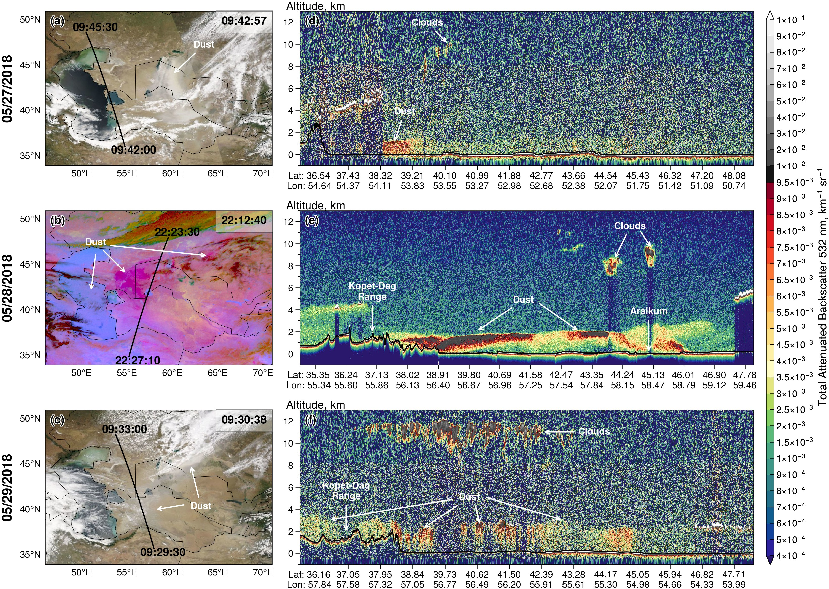

Figure 2. (a–c) CALIPSO ground tracks superimposed on coincident MODIS/Aqua true color (27 and 29 May 2018) and SEVIRI Dust RGB composite (28 May 2018) imagery. The ground track start and end times are labeled. MODIS and SEVIRI scan times over Aralkum (45°N, 60°E) are shown at the top right corner. (d–f) Corresponding CALIOP 532 nm total attenuated backscatter profile. Black lines indicate the ground surface.

of the ancient River Uzboy in western Turkmenistan, which has been identified as a highly active dust source in Central Asia (Nobakht et al., 2021).
On 28 May 2018, a high pressure system developed just south of the Aralkum Desert. As shown in the nighttime SEVIRI Dust RGB composite (Fig. 2(b)), the anticyclonic flow carried the lofted dust across Ustyurt Plateau toward the Caspian Sea,
350 while simultaneously producing new dust emissions from Aralkum that dispersed eastward. CALIOP detected an extensive dust layer stretching from Aralkum to the Kopet-Dag Range along the Turkmenistan border (Fig. 2(e)). The Kopet-Dag Range acted as a physical barrier, causing dust to concentrate along its foothills. The lofted dust was concentrated within an elevated layer at altitudes of 1–2 km near the Aralkum but extended to the ground level toward the gently sloping foothills. The

355

360
relatively low dust layer height likely resulted from the large-scale subsidence and a shallow nighttime boundary layer. The spatial variation in dust layer height may explain the contrasting color signatures observed in the SEVIRI imagery: the elevated dust near Aralkum displays a rich magenta hue, whereas the lower-lying dust near the Kopet-Dag foothills is less discernible, potentially due to reduced temperature contrast between the surface and dust aloft.
On 29 May 2018, remnants of the Aralkum dust plume continued to affect western Uzbekistan and Turkmenistan. The suspended dust was partially detected by CALIOP due to extensive cloud cover. The dust layer extended to an altitude of 3.5 km, likely resulting from daytime convective mixing and increased vertical motion ahead of an approaching cold front.

Comparison of UVAI Products

365

370

375

380

385
Figure 3 compares multiple UVAI products in detecting the fresh dust plume on 27 May 2018, including the Mie-based UVAI from OMPS, TROPOMI, and EPIC, all developed by NASA, and the TROPOMI LER- based UVAI developed by ESA. The sensor scan times over Aralkum (45°N, 60°E), as shown in each panel, are less than 20 minutes apart. The UVAI products display similar spatial patterns, but with significant differences in the dynamic range and statistical distribution. Among the three NASA products (Fig. 3(b–d)), OMPS yields markedly lower UVAI (mean 0.5, maximum 3.2) compared to EPIC (1.1 and 11.4) and TROPOMI (0.6 and 5.2), likely due to its coarser spatial resolution. EPIC exhibits significantly higher values over dusty scenes, partly because the 340/388 nm pair is more sensitive to absorbing aerosols. Nonetheless, the cloudy scenes in EPIC appear more noisy, most likely due to EPIC L1 calibration issues (personal communications with Karin Blank). Statistically, both OMPS and TROPOMI (NASA) reveal a bimodal distribution with a prominent peak near zero and a secondary peak near 1; EPIC displays a unimodal distribution with a larger spread, as indicated by the standard deviation and interquartile range.
Comparing the TROPOMI 354/388 nm UVAI from NASA and ESA (Fig. 3(d, f)) reveals that the ESA LER-based method produces more negative values over cloudy, dust-free scenes (e.g., Caspian Sea) than the NASA Mie-based method. Con- sequently, the ESA product exhibits greater dispersion—indicated by a trimodal distribution—although their regional mean and median differ by less than 0.05. The choice of 354/388 nm versus 340/380 nm wavelength pair in the ESA TROPOMI product has a minor effect on the UVAI statistics, with small differences in the regional averages, extremes, and dispersion. However, the 335/367 nm pair produces significantly lower UVAI and less dispersion, indicating reduced sensitivity to aerosol absorption.
Dust detection using UVAI products often used fixed thresholds to isolate the dust signal. For example, Prospero et al. (2002) used a UVAI threshold of 1 for North Africa and 0.7 elsewhere; Schepanski et al. (2012) used a threshold of 2 to detect major dust plumes over the Sahara. As shown in Fig. 3(g), EPIC yields more than 18% pixels exceeding a threshold of 2—over three times the proportions observed in OMPS and TROPOMI. This disparity suggests that using a fixed UVAI threshold may lead to significant inconsistencies in dust detection. In contrast, adopting a percentile-based threshold can more effectively capture the dynamic range of each product, resulting in more coherent dust plume detection. As demonstrated in Fig. 3, using the 95th percentile produces a consistent delineation of the dust plume, and captured three clusters of elevated UVAI values separated by clouds (see Fig. 3(a)).

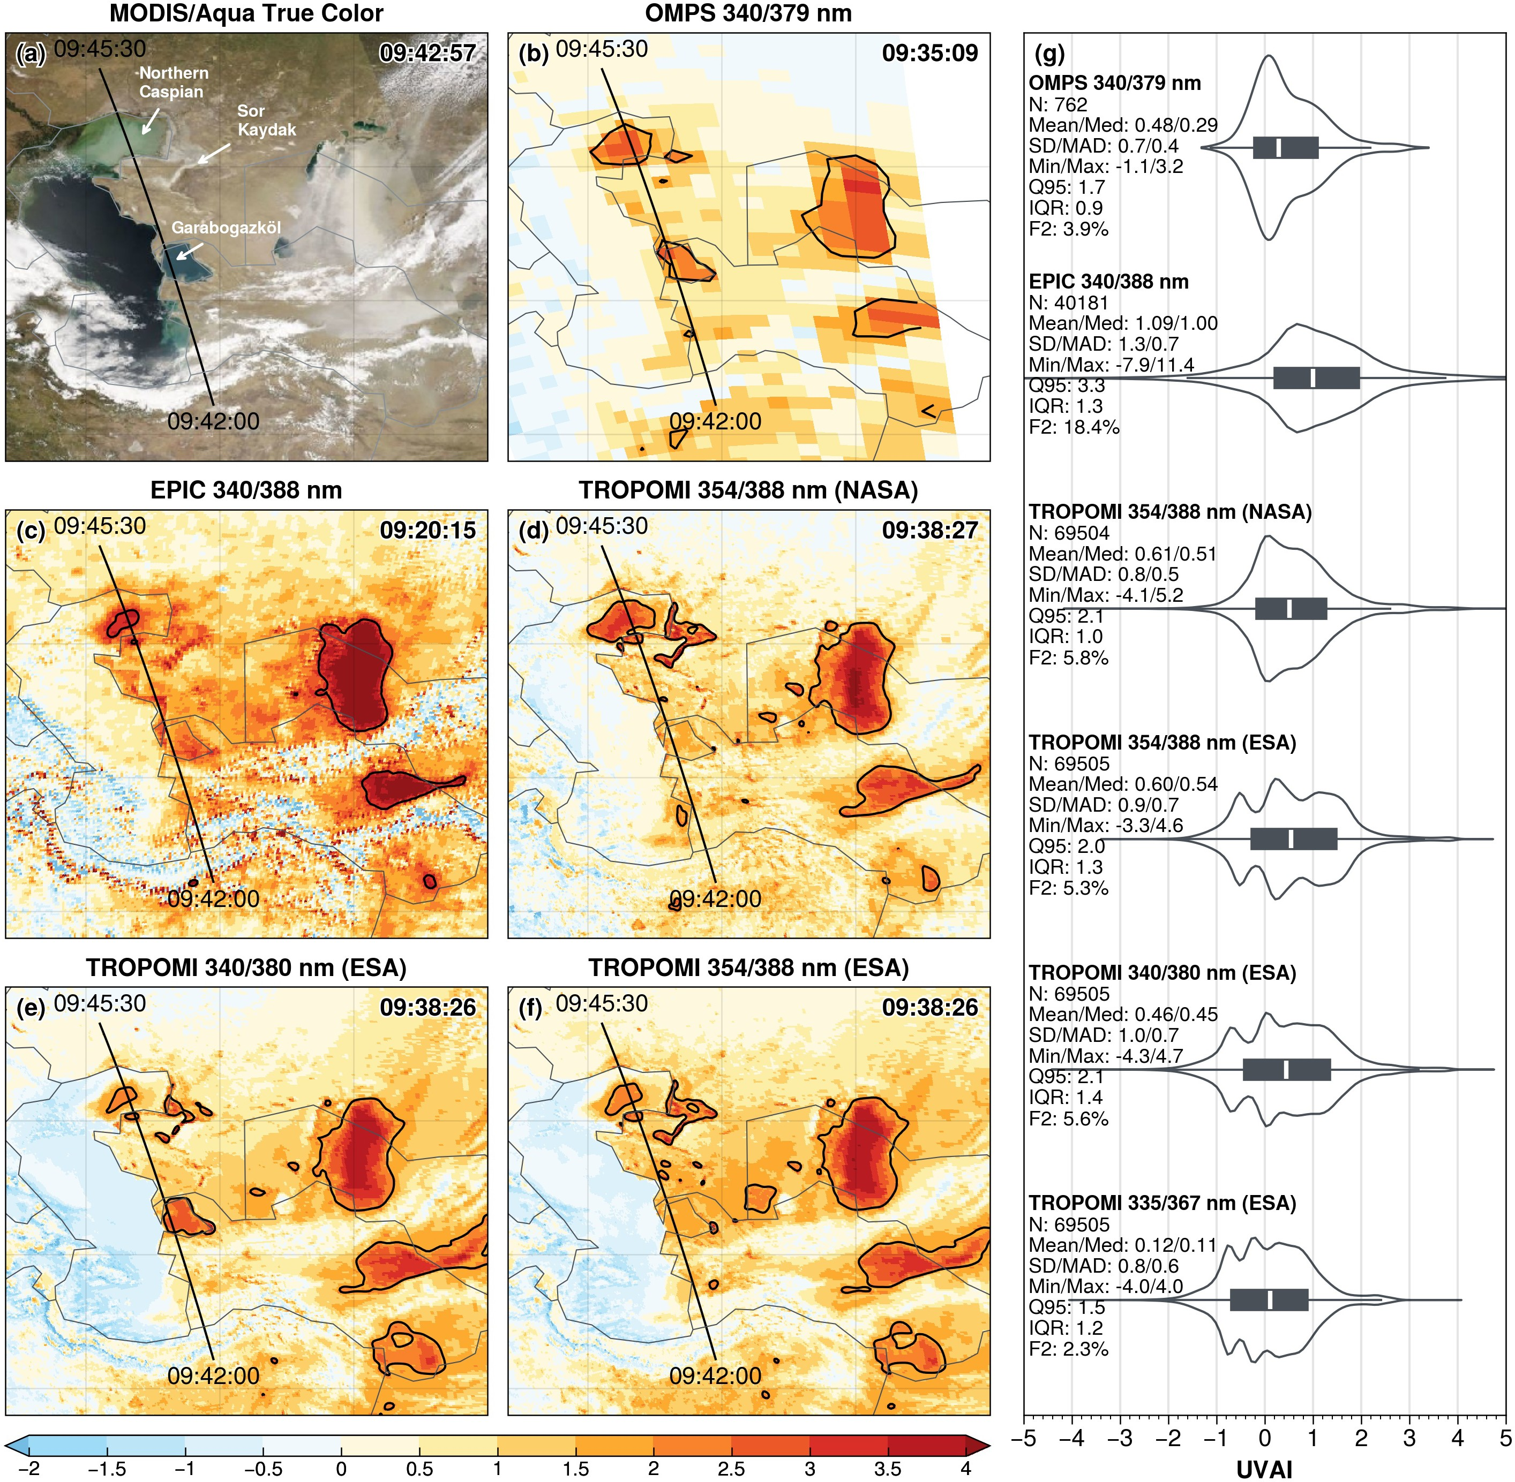

Figure 3. Comparison of UVAI products on 27 May 2018: (a) MODIS/Aqua true color image; (b–f) Five UVAI products from OMPS, EPIC, and TROPOMI; (g) Violin plots and summary statistics of six UVAI products. The sensor scan time over the Aralkum and CALIPSO ground track are indicated on panel (a–f). Black contours in (b–f) indicate the 95% percentile of UVAI values. The summary statistics in panel (g) are pixel count (N), mean, median (Med), standard deviation (SD), median absolute deviation (MAD), minimum (Min), maximum (Max), 95% percentile (Q95), interquartile range (IQR), and proportion of UVAI≥2 pixels (F2).

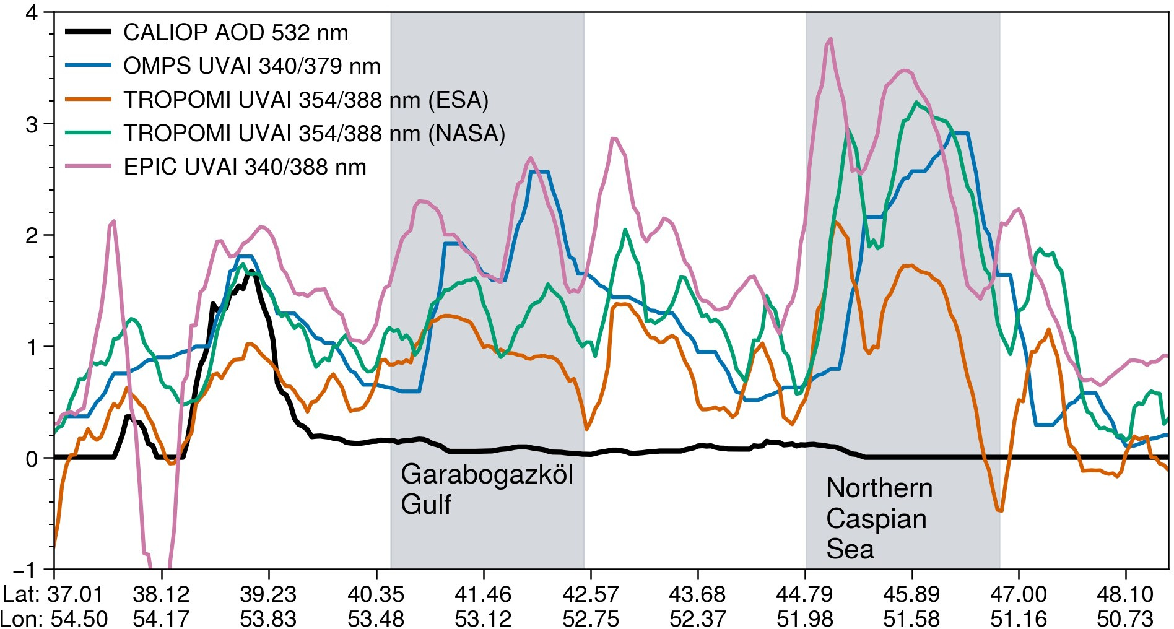

Figure 4. Coincident measurements of CALIOP 532 nm AOD and UVAI products along the eastern coast of Caspian Sea on 27 May 2018. The CALIPSO ground track is shown in Fig. 3. The Garabogazköl Gulf and northern Caspian Sea are shaded.

390

395

400
A persistent feature in all UVAI products is the occurrence of large positive values along the eastern coast of Caspian Sea, particularly over the northern Caspian Sea and Garabogazköl Gulf (i.e., above 2). To determine if airborne dust was responsible for these anomalies, we conduct a comparison between UVAI and coincident CALIOP 532 nm AOD measurements. The CALIPSO ground track is displayed in Fig. 3. To account for the along-track scan time differences (<30 min apart) between the sensors, we shifted the UVAI products to match the AOD and UVAI maxima observed at the southeastern coast of Caspian Sea (see Fig. 2(d)). Next, we applied a 5-second moving averaging to smooth the co-located AOD and UVAI measurements.
Figure 4 shows that CALIOP detected only a very thin aerosol layer (i.e., 532 nm AOD<0.1) over the northern Caspian Sea and Garabogazköl Gulf. The large positive UVAI in these regions also remained stationary and persisted on dust-free days, indicating that the elevated UVAI was unlikely caused by dust and was most likely related to time-invariant surface features. Due to the influx of sediment-rich water from the Volga and Ural rivers (Modabberi et al., 2019; Moradi, 2022), the northern Caspian Sea displays persistent discoloration, as seen in Fig. 3(a). This shallow, sediment-rich water strongly absorbs in the near-UV, producing a spectral signature with enhanced absorption at shorter wavelengths that resembles the signature of airborne dust (He et al., 2012; Lee et al., 2013). Similarly, the shallow, saline waters of Garabogazköl Gulf (with a salinity of about 35%) cause strong UV absorption and yield a dust-like UVAI signal, in contrast to the main body of the Caspian

Table 2. Summary statistics of eight AOD products in observing the Aralkum dust aerosol during 27–29 May 2018, based on best-quality, over-land retrievals. SD, standard deviation. MAD, median absolute deviation. IQR, interquartile range. Sk, skewness. 90th, 90th percentile.

Product | N | Mean | SD | Median | MAD | IQR | Sk | 90th | Max
MODIS/Terra DB | 21,338 | 0.49 | 0.73 | 0.25 | 0.17 | 0.38 | 3.0 | 1.0 | 3.5
MODIS/Aqua DB | 21,659 | 0.46 | 0.55 | 0.31 | 0.18 | 0.37 | 3.4 | 0.9 | 3.5
MODIS/Terra MAIAC | 5,223,130 | 0.35 | 0.54 | 0.18 | 0.11 | 0.26 | 4.7 | 0.7 | 6
MODIS/Aqua MAIAC | 5,070,926 | 0.37 | 0.69 | 0.17 | 0.10 | 0.24 | 4.3 | 0.7 | 6
VIIRS/SNPP DB | 110,726 | 0.44 | 0.76 | 0.15 | 0.10 | 0.39 | 3.6 | 1.0 | 5
VIIRS/NOAA20 DB | 110,286 | 0.56 | 0.85 | 0.26 | 0.19 | 0.55 | 3.2 | 1.2 | 5
VIIRS/SNPP EPS | 5,295,908 | 0.49 | 0.62 | 0.26 | 0.19 | 0.54 | 2.3 | 1.2 | 5
VIIRS/NOAA20 EPS | 3,996,574 | 0.37 | 0.53 | 0.19 | 0.16 | 0.39 | 2.8 | 1.0 | 5

405

410

415

420
Sea, which has a much lower salinity (1.3%) and yields near zero UVAI. In addition, the Sor Kaydak salt marsh to the east of northern Caspian produces large positive UVAI due to enhanced UV absorption by salt minerals and organisms (Fig. 3). Therefore, enhanced UV absorption by turbid and saline waters and salt flats causes the water-leaving UV radiances to deviate from those for a pure scattering atmosphere, thereby generating large positive UVAI that resembles the effects of airborne dust. This surface-related UVAI signal is likely common over ephemeral and dried lakes, and constitutes a potential source of error in using UVAI products for dust plume detection and source mapping.

Comparison of Midvisible AOD Products

    - AOD retrieval over desert surfaces

Table 2 shows the summary statistics of eight 550 nm AOD products, based on the best-quality, over-land retrievals of the Aralkum dust event between 27 and 29 May 2018. The number of pixels differs greatly among the products, indicating in- consistent sampling due to different spatial resolutions, screening of irretrievable scenes (e.g., clouds, snow/ice, sun glint, ocean color), and/or QA definitions. The inconsistent sampling, along with algorithm differences as discussed in Section 2.2, contribute to the disparities in the AOD statistics. In addition, the NOAA EPS product uses L1b data from the NOAA VIIRS Calibration/Validation group, whereas the NASA DT and DB products use the L1b data from the NASA VIIRS Calibration Support Team, which may further explain the inconsistent retrievals.
Based on the MODIS products, the AOD statistics appear more consistent between the Terra and Aqua platforms than between the DB and MAIAC algorithms. In particular, the mean AOD differs by less than 10% between Terra and Aqua, but exceeds 20% between DB and MAIAC. Compared to MAIAC, DB produces a larger upper tail, as indicated by a higher 90th percentile, and consequently a broader distribution (higher SD, MAD and IQR). MAIAC produces a narrower distribution (lower MAD and IQR) despite more extreme high values (upper limit of 6 versus 3.5 for DB).

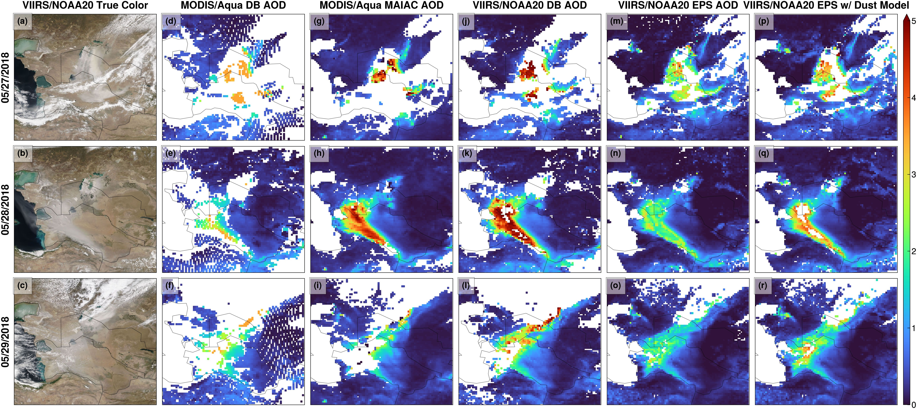

Figure 5. Over-land AOD retrievals on 27–29 May 2018. (a–c) VIIRS/NOAA20 true color images, (d–f) MODIS/Aqua DB product, (g–i) MODIS/Aqua MAIAC product, (j–l) VIIRS/NOAA20 DB product, (m–o) VIIRS/NOAA20 EPS product, and (p–r) VIIRS/NOAA20 EPS product using the dust optical model as a test case.

425

430

435
The VIIRS DB and EPS algorithms employ the same upper limit (5), but display more complex AOD statistics compared to MODIS. For VIIRS/SNPP, EPS yields a higher mean and median as well as more extreme values, as indicated by a slightly higher 90th percentile. In contrast, DB produces a larger standard deviation and skewness, indicating a broader upper tail. For VIIRS/NOAA20, DB yields a larger spread (higher SD and IQR), and a larger upper tail (higher 90th percentile), suggesting that DB captures more frequent high AOD values than EPS.
Next, we examined the MODIS/Aqua DB and MAIAC products, and the VIIRS/NOAA20 DB and EPS products. By com- paring AOD retrievals from the same sensor, we can attribute the disparity to the choice of algorithms. The instruments are hereafter referred to simply as MODIS and VIIRS unless otherwise noted. Due to the different spatial resolutions, all products are regridded onto a uniform 0.2°×0.2° grid by computing the mean value within each grid cell. Only the best-quality retrievals are used, based on the QA rules recommended in each product.
Figure 5 displays the daily gridded AOD products, together with VIIRS true color images to help attribute missing retrievals to either clouds or incorrect cloud screening. None of the algorithms captured the full extent of the fresh dust plume on 27 May 2018, while the retrieved AOD for the dust scene reached the upper limit of each algorithm. There are several possible reasons. First, the AOD retrieval from reflected sunlight relies on the scene brightening by aerosol scattering (primarily the forward scattering of surface reflection) against a relatively dark background. At high aerosol loadings, the TOA reflectance becomes less sensitive to additional AOD increases. Second, AOD retrieval is performed by matching observed TOA reflectances against

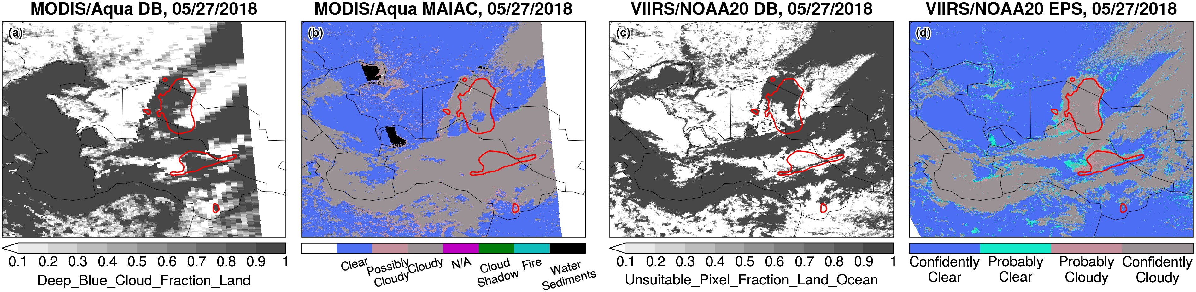

Figure 6. Misclassification of the fresh dust plume as clouds on 27 May 2018. (a) Cloud fraction from MODIS/Aqua DB product; (b) Cloud mask from MODIS/Aqua MAIAC product; (c) Unsuitable pixel fraction from VIIRS/NOAA20 DB product; and (d) Cloud mask from VIIRS/NOAA20 EPS product. Red contours indicate the 95th percentile (2.1) of TROPOMI TropOMAER UVAI product.

440

445

450

455
pre-computed values within a specific AOD range, which may be a poor fit if the aerosol burden is high or exceeds the predefined AOD limit. These retrievals are often flagged as marginal quality, and consequently excluded from the QA screening for best-quality data. Setting an upper AOD limit is necessary to minimize the impact of residual cloud contamination. Heavy dust scenes may be either retrieved but with low confidence in clear sky, or classified as clouds and not retrieved.
To check whether the fresh dust plume was erroneously classified as clouds, Fig. 6 displays the cloud fraction and cloud masks reported in selected granules from each product, as well as the TROPOMI UVAI on 27 May 2018. Given the small overpass time differences between S5P and Aqua (5 minute) and between S5P and NOAA20 (1 hour), TROPOMI UVAI provides a nearly coincident view of the dust plume. Fig. 6 reveals that the thick dust plume is mostly flagged as clouds in all products. For MODIS, the DB algorithm detected parts of the plume fringes, where the AODs reached the algorithm limit (3.5). MAIAC classified the majority of dust scene as “cloudy”. For VIIRS, the DB algorithm does not report cloud masking or fraction; instead it reports an Unsuitable_Pixel_Fraction_Land_Ocean parameter, which indicates that the dust pixels near Aralkum were not retrieved. Similarly, the dust scene was flagged as “confidently cloudy” in the EPS algorithm.
On 28 May 2018, a high pressure system produced cloud-free conditions over Central Asia, providing an optimal sky condi- tion for aerosol observation (Fig. 5(b)). All products successfully captured the extensive dust layer over western Turkmenistan; however, there are large differences in the AOD magnitudes. Notably, VIIRS EPS yields significantly lower (by more than 50%) AOD than other products over dust-affected areas. As described in Section 2, all the algorithms use predefined aerosol optical models (including a coarse-mode dust models) to represent location- and season-dependent aerosol microphysical prop- erties. To examine whether the dust optical model was successfully selected, Fig. 7 displays the aerosol optical model reported in selected granules. MODIS DB does not report this information and thus is not shown. Both MODIS MAIAC and VIIRS DB successfully selected their respective dust models for the dust scene over western Turkmenistan. VIIRS EPS

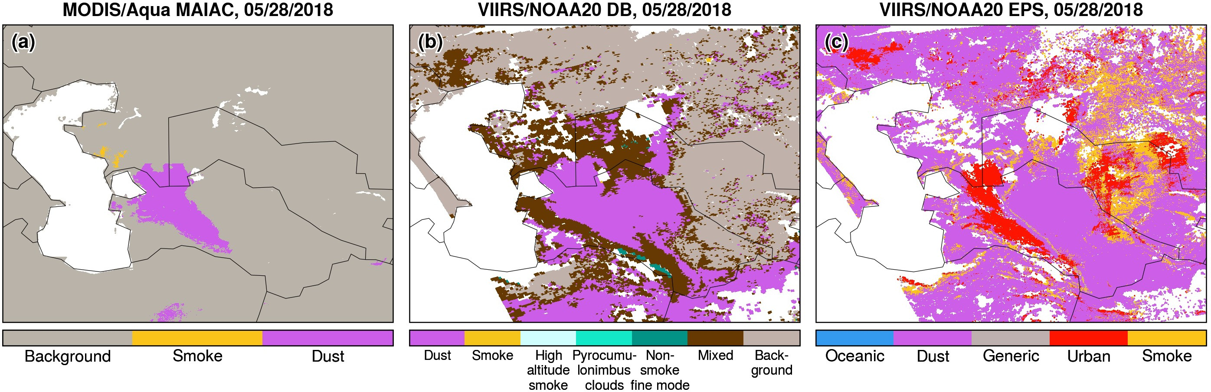

Figure 7. Aerosol optical model used for over-land retrievals on 28 May 2018 in the (a) MODIS/Aqua MAIAC, (b) VIIRS/NOAA20 DB, and (c) VIIRS/NOAA20 EPS products.

460

465

470

475

480
selected the urban aerosol model for the dust scene, presumably because the urban model produced a closer match between the observed and simulated TOA reflectances.
According to Laszlo and Liu (2022), EPS first retrieves AOD in the blue channel (0.41 µm) and then scales it to longer wavelengths using the normalized spectral extinction coefficients from the aerosol optical model. The normalized extinction coefficient exhibits much stronger wavelength dependence in the urban model than the dust model (see Figure 3-4 in Laszlo and Liu (2022)). For the same AOD at 0.41 µm, the dust model would yield more than 40% higher AOD at 0.55 µm compared to the urban model. We therefore hypothesize that had the dust model be selected as intended, EPS would have retrieved higher AOD that align more closely with DB and MAIAC. Indeed, when we forced EPS to use the dust model, as shown in Fig. 5(p–r), the deviations from DB and MAIAC were reduced, although the retrieved AODs remained lower and produced more marginal retrievals that were subsequently excluded in the regridded products.
Using the gridded AOD products, we conducted a regression analysis to further investigate the inconsistencies among aerosol algorithms (Fig. 8). The choice of algorithms for both MODIS and VIIRS introduces a non-linear response in the retrieved AOD. For MODIS, MAIAC produces lower AOD than DB under low aerosol loadings (e.g., 36% lower for AOD<1), but higher AOD under heavy loadings (22% higher for 2<AOD<3). This nonlinearity may be partly explained by MAIAC’s higher spatial resolution, which yields more extreme retrievals (either very clean or heavily polluted). The higher AOD limit in MAIAC (6 vs. 3.5 for DB) may further exacerbate the discrepancies at heavy aerosol loadings, as shown in Fig. 8(a). For VIIRS, EPS retrievals are generally lower than DB across all aerosol loadings, with the EPS–DB difference increasing from 37% for AOD<1 to 51% for 4<AOD<5 (Fig. 8(b)). Indeed, Fig. 5(m–o) confirm that EPS yields approximately 50% lower AODs than other algorithms in areas affected by thick dust.
Figure 9 displays the MISR AOD retrievals on 28 May 2018 (orbit 98092) based on the standard operational product and three different version of the MISR research algorithms. The standard algorithm exhibits several limitations. First, the algorithm

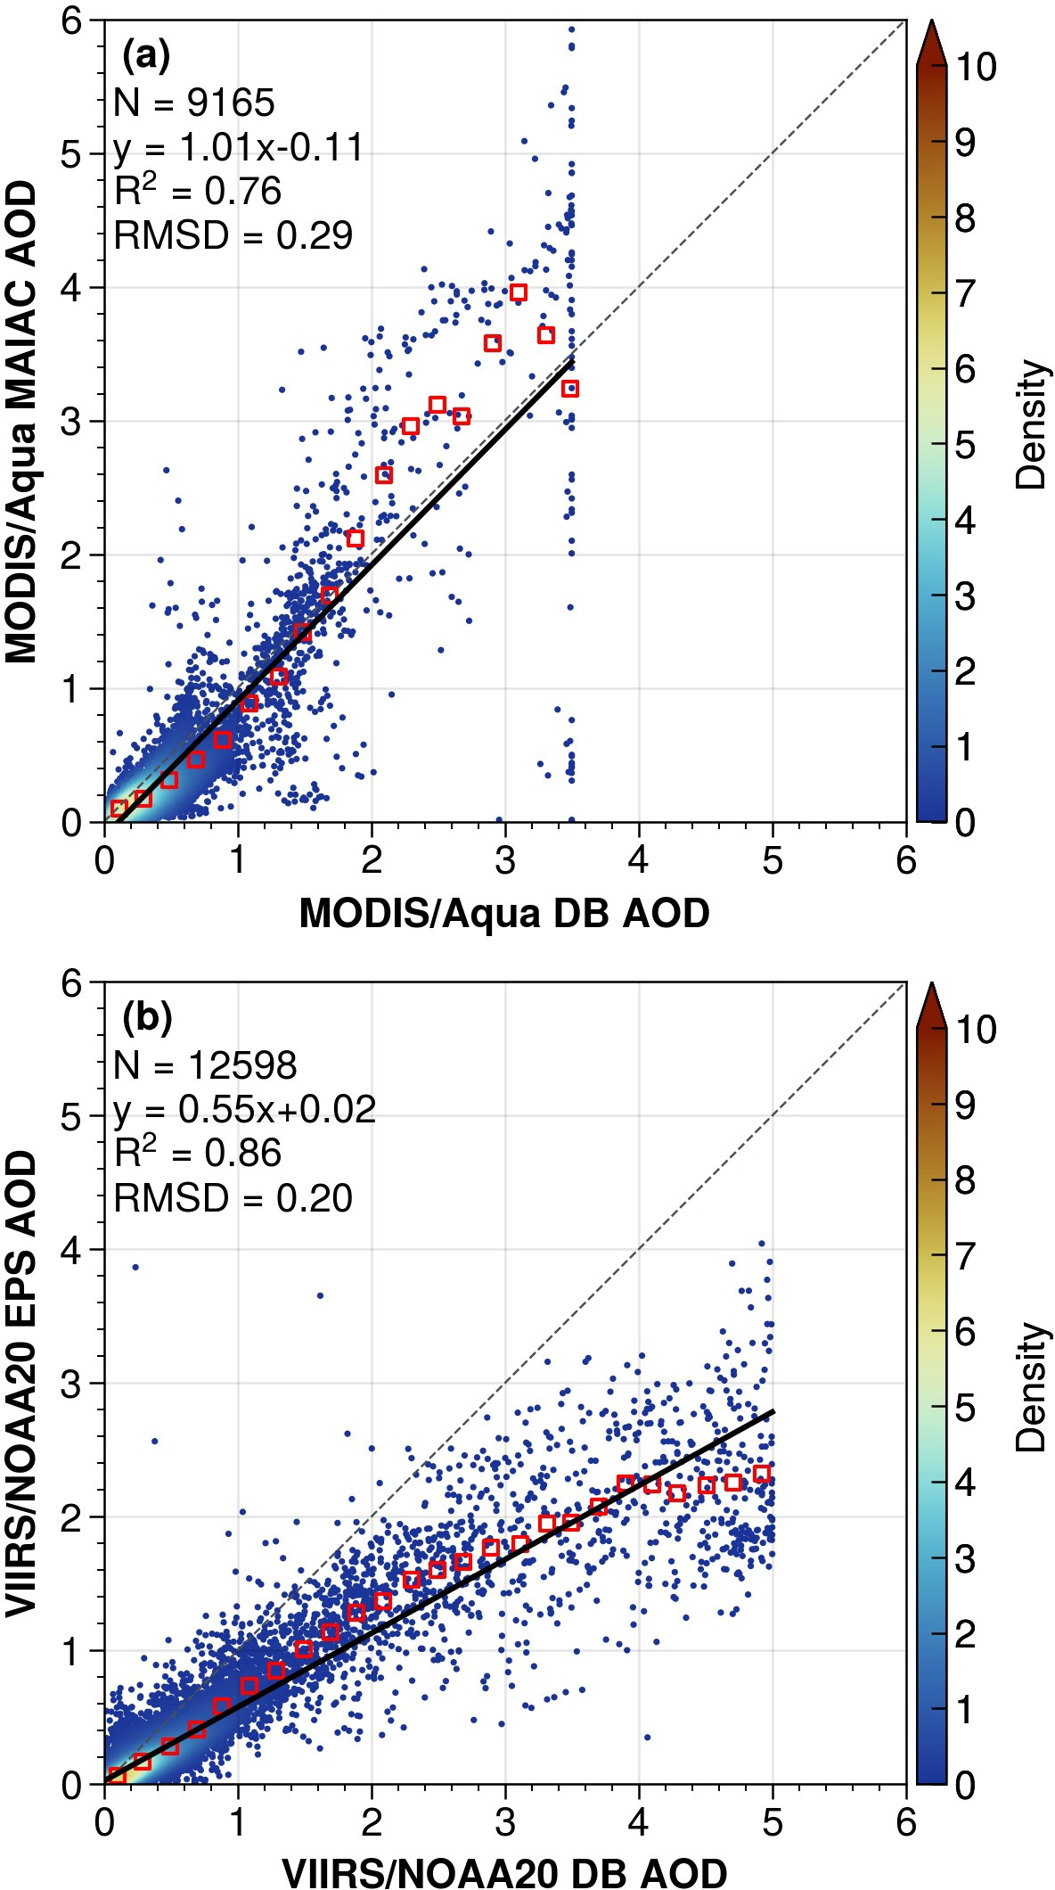

Figure 8. Comparison of over-land AOD retrievals during 27–29 May 2018: (a) MODIS/Aqua MAIAC vs. DB; (b) VIIRS/NOAA20 EPS vs. DB. Black lines indicate the linear model fits. Red squares indicate bin-averaged AODs every 0.1 increments. RMSD, root mean square difference.

uses an outdated land/water mask and marked the Aral Sea as “shallow water”; as a result, no retrieval was performed over the Aralkum Desert. Second, the thick dust over the foothills of Kopet-Dag Range was misclassified as clouds. Lastly, the retrieved AOD is substantially lower than those from single-view sensors (i.e., MODIS and VIIRS, Fig. 5). (Kahn et al., 2010) noted that MISR tends to underestimate AOD under heavy aerosol loadings, since the weak surface reflection signal leads

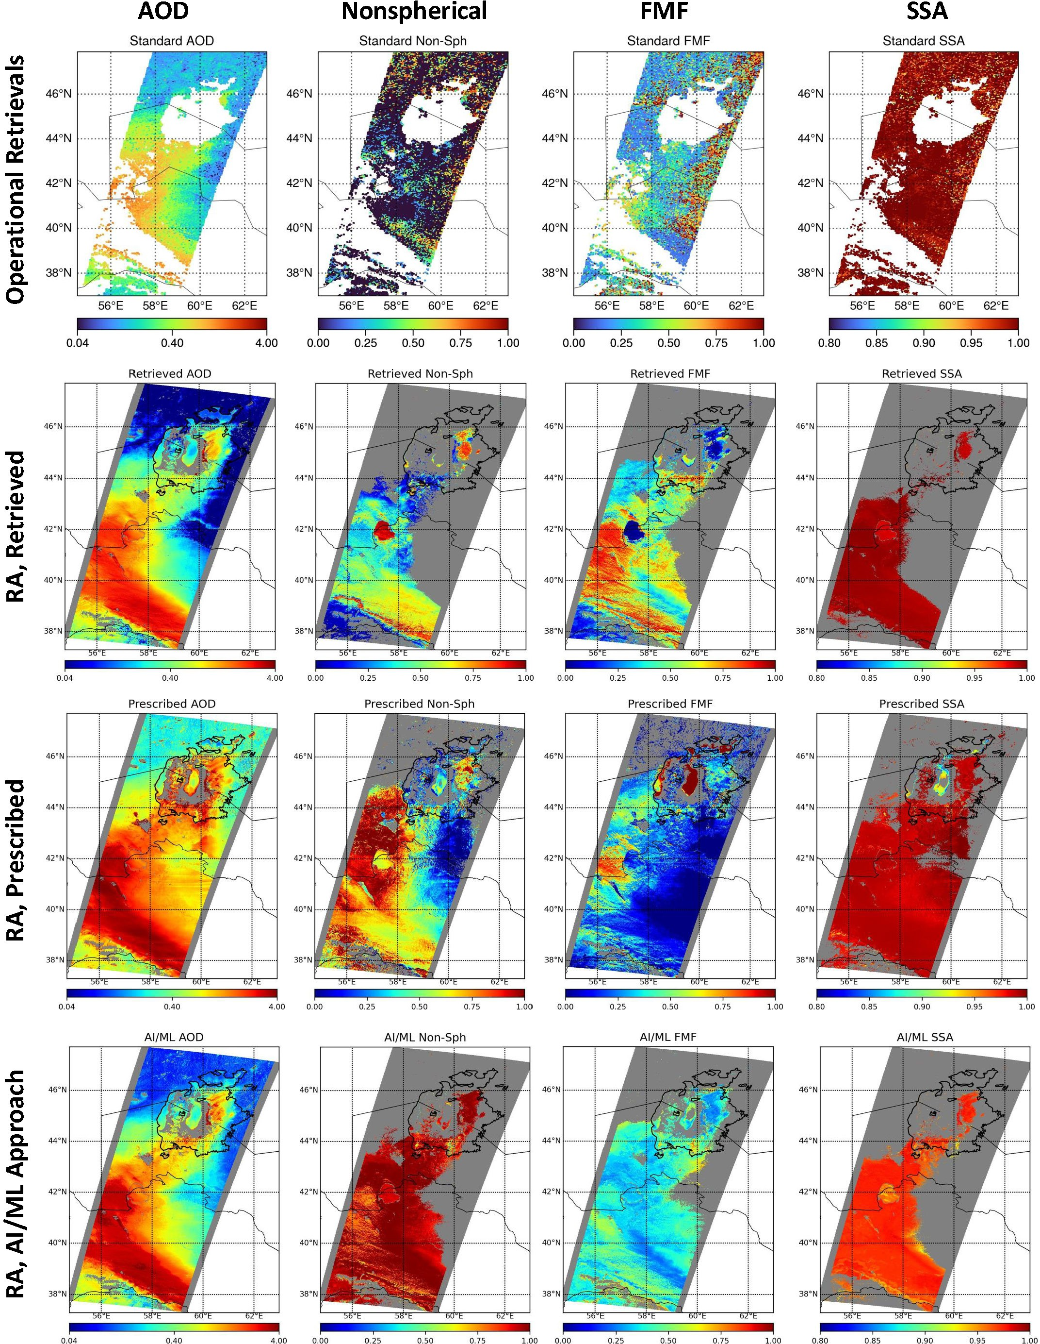

Figure 9. MISR aerosol retrievals on 28 May 2018 based on: (top row) Operational standard product; (2nd row) Research algorithm with retrieved surface reflectances from MISR data; (3rd row) Research algorithm with prescribed surface reflectances from MODIS MAIAC product; and (bottom row) Research algorithm using an AI/ML approach.

485 to poor surface-atmosphere separation and overestimation of the surface contribution to TOA radiances. Another cause of biased AOD retrieval is the use of inappropriate aerosol optical models. Currently, the MISR standard algorithm does not have suitable optical models for saline dust, and consequently does not provide confident constraints on the particle microphysical

490

495

500
properties. We find that the standard algorithm selected spherical non-absorbing aerosol mixtures for the dust scene, resulting in underestimation of the nonspherical fraction and overestimation of FMF and SSA.
To explore the particle-property information content of MISR observations, we ran the MISR research algorithm in three modes: (a) with the surface retrieved self-consistently with the atmosphere using only MISR data, (b) with the surface re- flectance prescribed from the MODIS MAIAC product (Limbacher et al., 2022), and (c) with a modified algorithm based on an AI/ML approach. Initial statistics indicate that these models do well in the regional means. AOD is retrieved fairly consistently with all three approaches, except in the highest and lowest AOD regions. The prescribed surface results appear to perform bet- ter for extremely high AOD conditions and capture the increasing AOD gradient towards the Kopet-Dag Range. The retrieved nonspherical fraction and FMF show large discrepancies. The AI/ML approach performs closest to expectation in this case (i.e., NonSph>0.8), whereas the retrieved- and prescribed-surface results may have underestimated the nonspherical fraction. Results for SSA are generally consistent, with SSA>0.95 for the dust scenes, except for low AOD regions where the AI/ML SSA results are probably too low (<0.95).

AOD retrieval over the Caspian Sea

505

510

515

520
In this section, we compare six AOD products in observing the dust outflow to the Caspian Sea on 28 May 2018, based on the best quality, over-water retrievals from MODIS/Aqua (DT, DT3K, and MAIAC) and VIIRS/NOAA20 (DT, DB, and EPS). All products are gridded to a 0.1°×0.1° resolution. Bilinear interpolation is applied to the MODIS DT product in order to fill the data gaps due to reduced pixel resolutions near sensor swath edges.
Figure 10 shows that all six products capture the enhanced aerosol burden associated with dust outflow to the Garabogazköl Gulf and Caspian Sea. Among the MODIS products, DT3K and MAIAC produce more extreme AOD over Garabogazköl Gulf than DT, resulting in higher means and greater spread (indicated by higher SD and MAD). These spurious high AODs create unnatural discontinuities along coastal regions, likely due to inaccurate surface reflectance characterization of the shallow, saline waters. In the VIIRS products, DT exhibits extremely high AOD over the shallow waters and salt flats of northern Caspian Sea, and to a lesser extent over the coastal region of Garabogazköl Gulf. The non-negligible surface signal (different from the dark surface characteristic of deep water assumed by these algorithms) from these areas was misinterpreted as aerosol signal, leading to spurious high AODs. As a result, VIIRS DT produced a higher mean, more extreme upper tail values (indicated by the 90th percentile and maximum), and a larger spread (higher SD and IQR) than the DB and EPS products.
We further examined the aerosol optical models selected during the over-water retrieval (Fig. 11). The MAIAC spheroidal dust model (“Model 6”) was applied to only small parts of the dust scene, resulting in discontinuous AOD patterns. VIIRS DT reports retrieval results from each combination of the four fine and five coarse models which fits successfully, from which we computed the relative fractions of three groups: fine aerosol, sea salt, and coarse dust. We find that the sea salt group dominates the retrieved AOD, indicating that the spherical dust model was not selected as intended in the DT algorithm. VIIRS DB successfully applied the spheroidal dust model for the full extent of the dust scene, and the maritime model for dust-free regions, while VIIRS EPS selected its oceanic aerosol model for the full scene, again failing to select the dust model as intended. In summary, the aerosol algorithms demonstrate

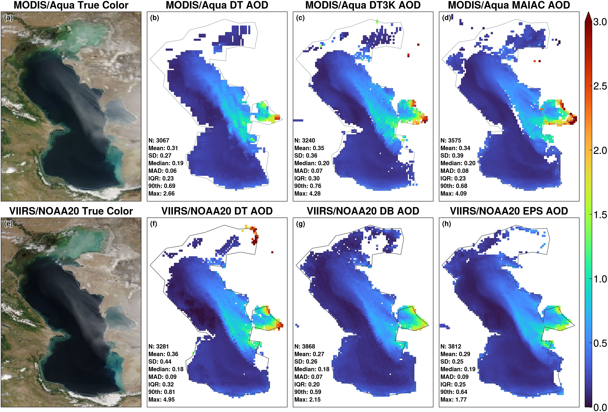

Figure 10. Over-water AOD retrievals over the Caspian Sea on 28 May 2018. Top row panels are MODIS/Aqua (a) true color image, (b) DT AOD, (c) DT3K AOD, and (d) MAIAC AOD. Bottom row panels are VIIRS/NOAA20 (e) true color image, (f) DT AOD, (g) DB AOD, and
(h) EPS AOD. All products are gridded to a 0.1°×0.1° resolution.

525

530
varied performance in detecting the dust aerosol over Caspian Sea and selecting the appropriate aerosol optical model during AOD retrievals.
Figure 12 compares the gridded AOD products via linear regression to assess the cross-algorithm consistency. Overall, over- water retrievals exhibit stronger linear relationships and better agreement than over-land products (Fig. 8), with R² above 0.9 and RMSD below 0.1 in all cases. In particular, MODIS DT and DT3K products show excellent agreement with a regression slope of 0.98 and an R² of 0.91, while other products show slightly weaker slopes of approximately 0.8. Notably, DT yields lower AOD under clean marine conditions (AOD<0.15), but higher AOD in dusty conditions than the MAIAC, DB and EPS algorithms.
Compared to over-land retrievals, over-water retrievals benefit from using more spectral bands, which provide greater in- formation content to constrain aerosol particle size over the dark, homogeneous water surfaces. As described in Section 2.2.1,

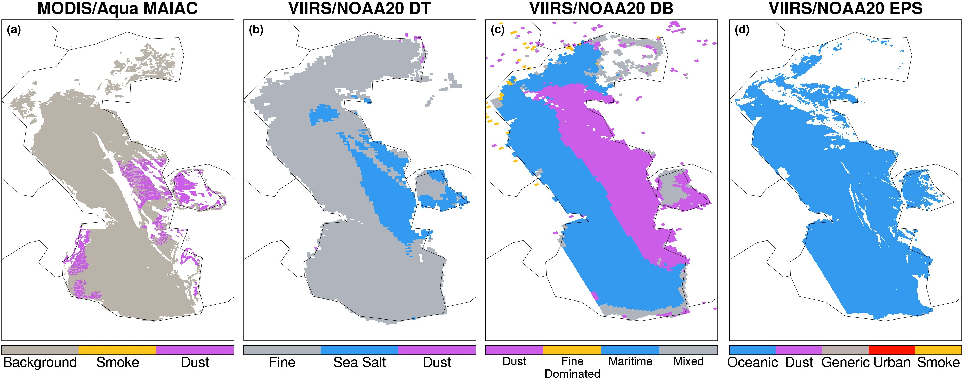

Figure 11. Aerosol optical models used for AOD retrieval over the Caspian Sea on 28 May 2018 in the (a) MODIS/Aqua MAIAC, (b) VIIRS/NOAA20 DT, (c) VIIRS/NOAA20 DB, and (d) VIIRS/NOAA20 EPS products.
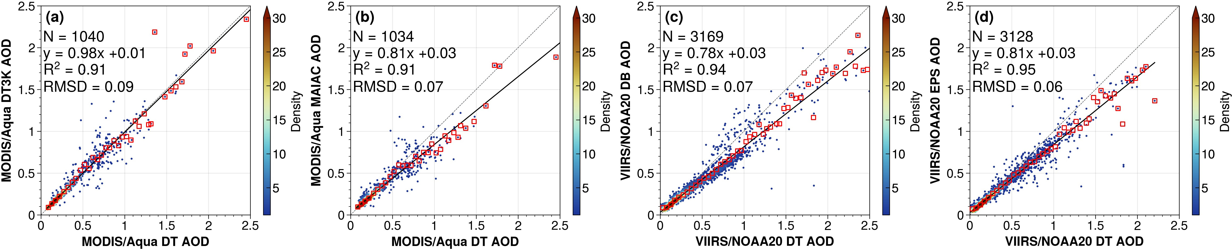

Figure 12. Comparison of AOD retrievals over the Caspian Sea on 28 May 2018: (a) MODIS/Aqua DT3K vs. DT; (b) MODIS/Aqua MAIAC vs. DT, (c) VIIRS/NOAA20 DB vs. DT, (d) VIIRS/NOAA20 EPS vs. DT. Black lines indicate the linear regression fits. Red squares indicate bin-averaged AODs at 0.05 increments. RMSD, root mean square difference.

over-water algorithms represent the aerosol column as a sum of a fine and a coarse mode, and retrieve the total AOD and FMF. Here, we use the total AOD and FMF to compute the coarse-mode AOD from each product, and perform a similar comparison to that in Fig. 12. Figure 13 shows that the derived coarse-mode AODs exhibit strong linear relationships between the considered products, with R² above 0.8 and RMSD below 0.1, although the agreement is some-
535 what weaker than for the total AOD. In general, the DT algorithm tends to yield higher coarse-mode AOD under dust-laden conditions compared to DT3K, MAIAC, DB and EPS.

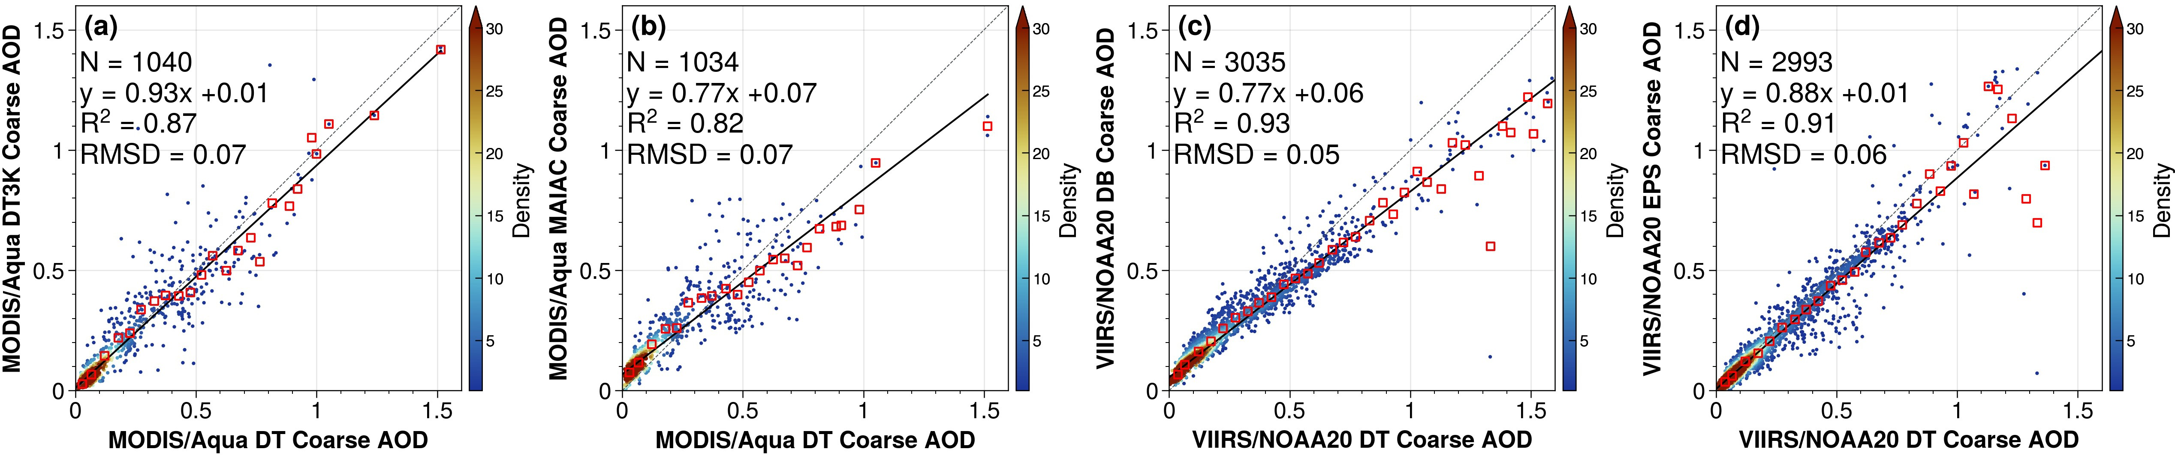

Figure 13. Same as Fig. 12 but for coarse-mode AOD.
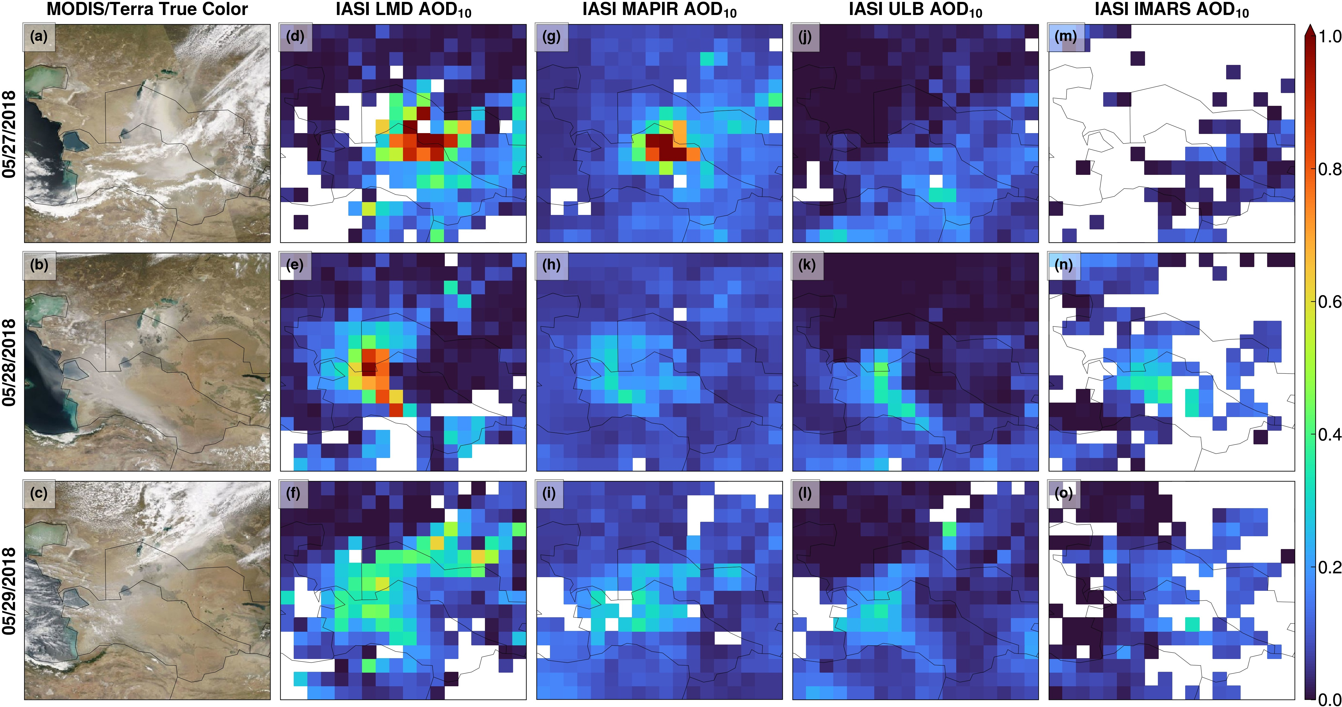

Figure 14. AOD10 retrievals from four IASI aerosol products on 27–29 May 2018. (a–c) MODIS/Terra true color images, (d–f) LMD, (g–i) MAPIR, (j–l) ULB, and (m–o) IMARS.

Comparison of Infrared AOD (AOD₁₀) Products

In this section, we compare the IASI AOD₁₀ products from four algorithms: LMD, MAPIR, ULB and IMARS, based on Level-3 daily gridded (1°×1°) products from the Aerosol_cci project. Table 3 summarizes the AOD₁₀ statistics based on
540 separate daytime (descending node) and nighttime (ascending node) retrievals on 27–29 May 2018. Figure 14 displays the daily combined AOD₁₀ by merging the daytime and nighttime observations. The inclusion of both daytime and nighttime

Table 3. Summary statistics of four IASI AOD10 algorithms in observing the Aralkum dust aerosol during 27–29 May 2018, based on Level- 3 products from both daytime and nighttime retrievals. SD, standard deviation. MAD, median absolute deviation. QR, interquartile range. Sk, skewness.

Algorithm | N | Mean | SD | Median | MAD | IQR | Sk | Max
LMD | 1122 | 0.13 | 0.20 | 0.05 | 0.05 | 0.17 | 2.5 | 1.2
MAPIR | 1380 | 0.11 | 0.11 | 0.08 | 0.03 | 0.07 | 6.0 | 1.7
ULB | 1486 | 0.06 | 0.09 | 0.03 | 0.04 | 0.09 | 2.0 | 0.6
IMARS | 365 | 0.08 | 0.07 | 0.07 | 0.05 | 0.10 | 1.4 | 0.4

545

550

555

560

565
data substantially improved the data coverage compared to midvisible AOD products (Fig. 5), which rely solely on daytime observations and are more susceptible to cloud interference.
Among the four algorithms, LMD has the best performance in detecting the dust plume features on all three days, over both deserts and the Caspian Sea. On 27 May, LMD captured the extensive plume stretching from the Aralkum Desert to the southern borders of Turkmenistan (Fig. 14(d)), outperforming midvisible techniques in detecting the freshly emitted dust over bright desert surfaces. The highest AOD₁₀ (1.2) was observed downwind over Uzbekistan rather than near the Aralkum Desert, due to difficulty in detecting the heavy dust near the source. Additionally, the retrieved AOD₁₀ reached the upper limit of the predefined range (0–1.4), indicating possible underestimation. Unlike midvisible AOD, which includes fine aerosol contributions, AOD₁₀ is sensitive to coarse particles only. The AOD₁₀-to-AOD ratio depends on the particle size distribution, particularly the relative fraction of fine and coarse modes. Using a AOD₁₀-to-AOD ratio of 0.6 for coarse-dominated dust would imply an AOD₁₀ of around 3—more than twice the upper limit set in the LMD algorithm—corresponding to the maximum observed VIIRS DB AOD on 27 May (Fig. 5(j)). On 28 May, LMD successfully retrieved the dust accumulated by the Kopet- Dag Range and outflow to the Caspian Sea (Fig. 14(e)), resulting in a spatially continuous AOD₁₀ pattern, in contrast to midvisible retrievals which exhibited unnatural discontinuities near coastal areas due to inconsistent treatment of water and land surface reflectances. The AOD₁₀ retrieval on 29 May captured the remnant dust from the previous emission event and the newly emitted dust from Aralkum, consistent with the midvisible AOD patterns.
Compared to LMD, MAPIR generally yields higher background AOD₁₀ over aerosol-free areas but lower AOD₁₀ over dust scenes, resulting in less distinct plume features (Fig. 5(g–i)). The two products exhibit moderate correlations, with R² of
0.6 for daytime retrievals, and 0.4 for nighttime retrievals. MAPIR successfully retrieved the thick dust on 27 May, although with a smaller spatial extent than LMD. However, MAPIR struggled to detect dust over the complex terrains of the Ustyurt Plateau and Kopet-Dag foothills on 28–29 May, likely due to increased uncertainty in characterizing the heterogeneous surface properties (e.g., emissivity, temperature), to which infrared retrievals are particularly sensitive over elevated terrains (Capelle et al., 2014).
Overall, ULB and IMARS exhibit poorer performance compared to LMD and MAPIR. Specifically, ULB misclassified the entire dust plume as clouds on 27 May, and significantly underestimated AOD₁₀ on 28–29 May, similar to MAPIR. IMARS

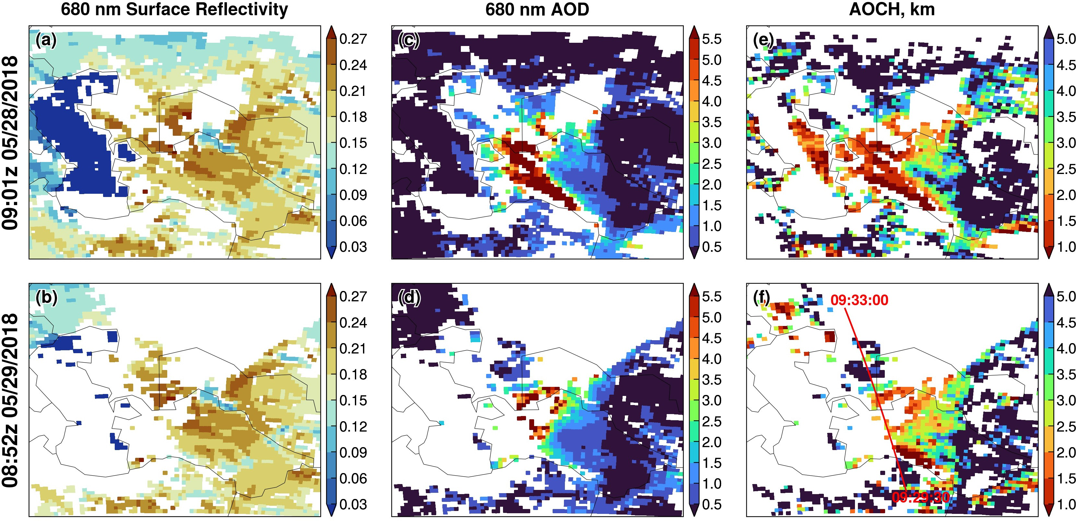

Figure 15. EPIC AOCH retrievals at 09:01z 28 May 2018 (top row) and 08:47z 29 May 2018 (bottom row): (a, b) 680 nm surface reflectivity; (c, d) 680 nm AOD; (e, f) AOCH. The coincident CALIPSO ground track is shown in panel (f).

reported substantial missing data for dust-affected areas on all three days, likely due to overly restrictive cloud masking and/or low confidence associated with its probabilistic retrievals.

Comparison of ALH Products

570

575

580
In this section, we compare four ALH products: CALIOP aerosol extinction-weighted height, EPIC-retrieved AOCH, IASI LMD mean dust layer altitude, and the MISR stereo-height retrieval. The CALIOP ALH is calculated from the aerosol ex- tinction vertical profiles at 532 and 1064 nm, whereas the EPIC and IASI products retrieve an effective ALH using passive techniques that rely on a priori assumptions about aerosol vertical distributions (Section 2.4). Among the IASI products, we focus on the LMD algorithm due to its superior performance in detecting dust plume features (Fig. 14). Below, we first examine the EPIC retrievals at around 09:00z on 28 and 29 May 2018, and use co-located CALIOP measurements for validation. The dust plume on 27 May is misclassified as clouds in the EPIC AOCH product and thus not discussed. Next, we compare the coincident retrievals from EPIC and IASI to assess the consistency between these passive techniques for retrieving ALH over desert surfaces. Finally, we present results on MISR plume height retrieval on 28 May 2018.
Figure 15 displays the 0.68 µm surface reflectivity, AOD_{0.68}, and AOCH retrieved from EPIC. On 28 May, the low surface reflectivity and elevated dust loading (i.e., AOD_{0.68} >0.5) over Caspian Sea provided optimal conditions for inferring AOCH from DOAS measurements in the NIR spectra. Figure 15(e) shows that the dust outflow to Garabogazköl Gulf and Caspian Sea

585

590

595

600

605

610

615
was elevated to an altitude of 1.5–2.5 km, likely enhanced by orographic lifting as the dust was transported across the Ustyurt Plateau.
In contrast, the bright desert surfaces of Central Asia pose significant challenges in isolating aerosol scattering contributions to the EPIC measurements. Radiative transfer simulations indicate that the sensitivity to ALH in the O₂ band contrast diminishes over bright surfaces, requiring high aerosol loadings to generate reliable AOCH retrieval (Xu et al., 2019). As shown in Fig. 15, the EPIC-retrieved AOD_{0.68} and AOCH exhibits inverse spatial patterns: AOCH displays unrealistically high values over low AOD_{0.68} areas, and reasonably low values over high AOD_{0.68} (up to 6) areas that form a continuous pattern with the Caspian Sea retrievals. Thus, AOD_{0.68} provides a practical method for screening marginal-quality AOCH retrievals. Focusing on dust scenes where AOD_{0.68} exceeds 2, the retrieved AOCH over Turkmenistan’s desert plains increased from 1–1.5 km on 28 May to 2–3 km on 29 May. This temporal evolution can be explained by the meteorological conditions: a prevailing high pressure system suppressed vertical aerosol mixing on 28 May, whereas enhanced upward motion ahead of a deepening cold front promoted convective mixing on 29 May.
The EPIC AOCH retrievals are evaluated against the extinction-weighted ALH derived from CALIOP observations along the CALIPSO track on 29 May, shown in Fig. 16. Generally, the CALIOP 532 nm channel is more prone to signal attenuation in the presence of dense absorbing aerosols, resulting in lower ALH than the 1064 nm channel (Torres et al., 2013). Our analysis reveals that the wavelength choice has minor effects on the CALIOP-derived ALH, with a mean difference of 0.05 km between the two channels. EPIC AOCH retrievals exhibit substantial positive biases in regions with low aerosol loadings. Using the CALIOP 532 nm ALH as a benchmark, the EPIC AOCH product has a mean bias of 3.6 km and an RMSE of 4.3 km, with only 17% (21%) of the co-located retrievals within 0.5 (1.0) km agreement. However, after applying a AOD_{0.68} threshold of
1.5 to isolate dust-dominated scenes, the AOCH accuracy improved, with significantly lower mean bias (0.4 km) and RMSE (0.8 km), as well as 61% (72%) of co-located retrievals within 0.5 (1.0) km agreement. In general, the higher the AOD_{0.68} threshold, the better the agreement between EPIC and CALIOP.
To compare the EPIC AOCH and IASI mean dust layer altitude retrievals, we selected the EPIC scans closest in time (06:50z 28 May and 06:41z 29 May) to the daytime IASI overpasses to minimize scene differences. We applied an AOD_{0.68} threshold of 1.5 to EPIC AOCH data over land to exclude marginal-quality retrievals and enhance clarity. As illustrated in Fig. 17, the AOD_{0.68} threshold removes the majority of unrealistic AOCH values over land. However, EPIC displays unrealistic retrievals over the northern Caspian Sea and coastal regions. This bias resembles the surface-related UVAI signal shown in Fig. 3, suggesting that the water-leaving radiances from turbid coastal waters may have been misinterpreted as aerosol signals in the EPIC AOCH algorithm. Comparing EPIC retrievals on both days reveals no significant AOCH changes between 06:50z and 09:01z on 28 May, likely due to a prevailing cold anticyclone that trapped dust within a shallow boundary layer. In contrast, the mean AOCH increased by about 0.4 km between 06:41z and 08:52z on 29 May, likely due to the gradual lifting by an approaching cold front.
Figure 17 (c–d) suggests that IASI generally retrieves higher ALH than EPIC in dust-affected areas, both over deserts and the Caspian Sea. To further assess the ALH differences, we regridded the Level-2 data from both sensors onto a 1°×1° resolution and analyzed the co-located retrievals, which are shown in 18. EPIC and IASI have the poorest agreement at low aerosol

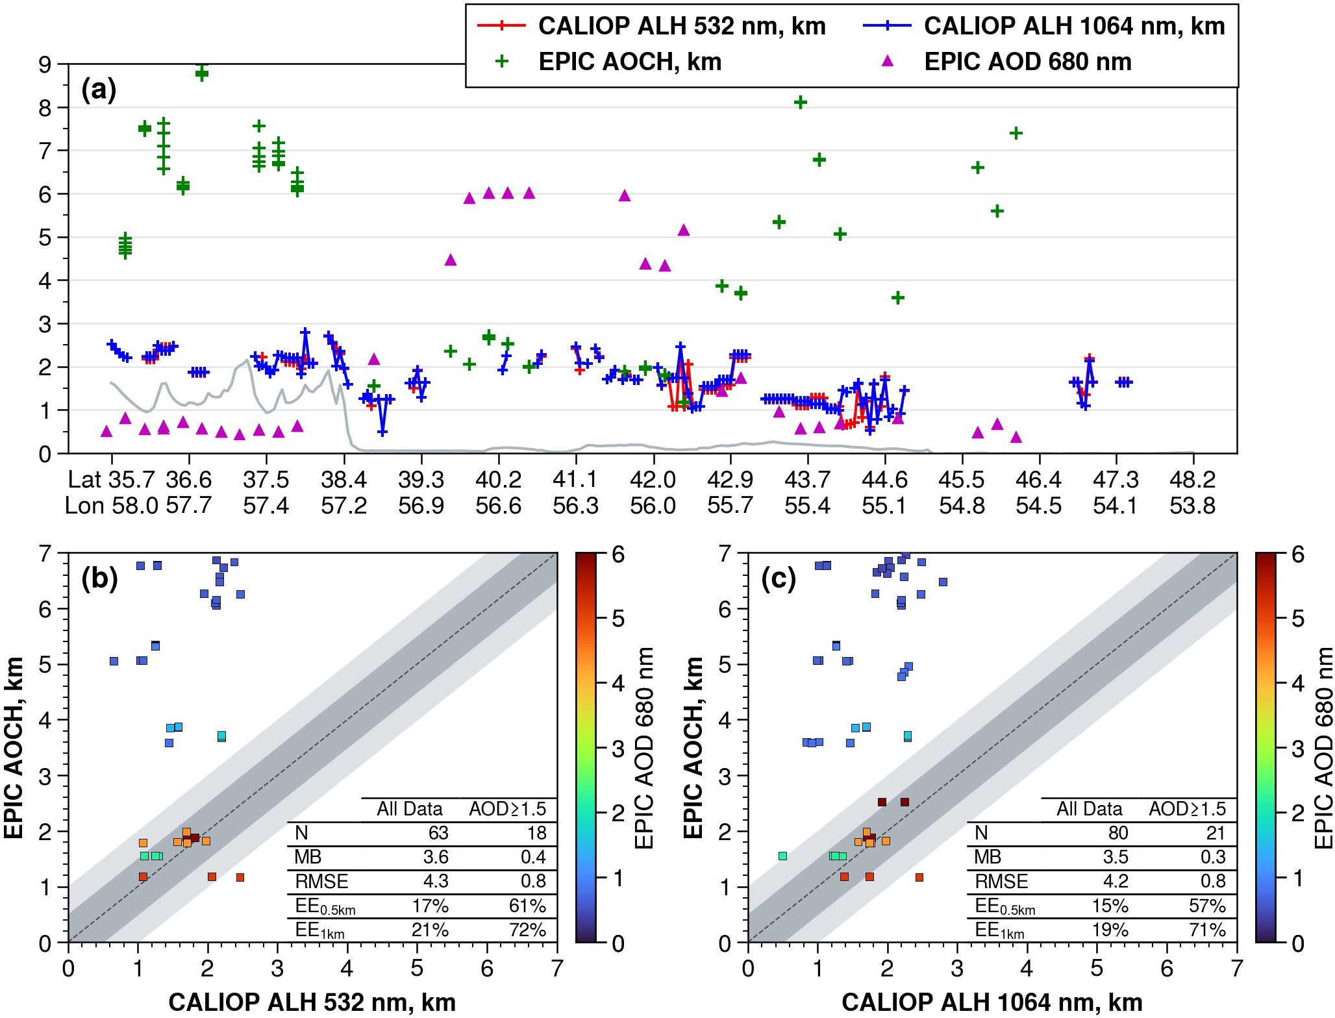

Figure 16. (a) Coincident retrievals of CALIOP extinction-weighted ALH and EPIC AOCH along the CALIPSO overpass on 29 May 2018 (ground track shown in Fig. 15f). Magenta triangles are EPIC-retrieved AOD0.68. Gray line indicates the ground surface. (b) Comparison between CALIOP 532 nm ALH and EPIC AOCH. (c) Comparison between CALIOP 1064 nm ALH and EPIC AOCH. N, number of coincident retrievals. MB, mean bias. RMSE, root mean square error. EE, percentage of co-located retrievals within expected errors of 0.5 and 1 km (shaded).

loadings, exhibiting large dispersions in the ALH differences. EPIC tends to produce much higher ALH under such low conditions. The EPIC-IASI agreement improves as the aerosol loading increases. For example, retrievals with AOD₁₀ ≥0.3 show a mean ALH difference of -0.4 km and an RMSD of 1.4 km, with 79% (85%) of co-located retrievals falling within
620 0.5 (1.0) km differences. Moreover, the dispersion of ALH differences decreases progressively at higher aerosol loadings, indicating generally higher ALH retrievals from IASI than EPIC (Fig. 18(b)).

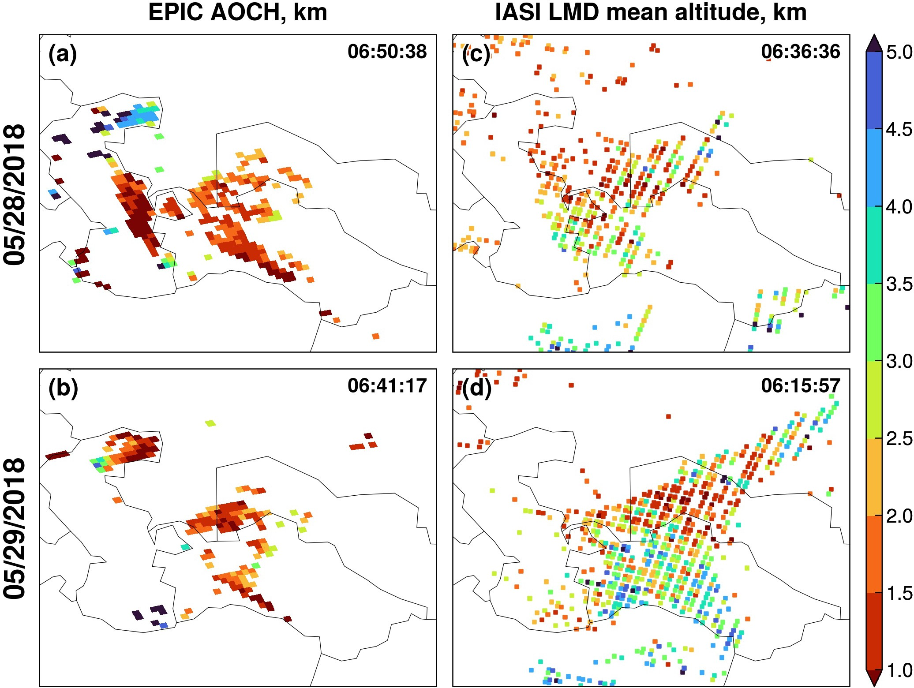

Figure 17. ALH retrievals in the (a, b) EPIC AOCH and (c, d) IASI LMD products on 28–29 May 2018. Only the EPIC AOCH retrievals with AOD0.68>1.5 are shown. The sensor scan times over Aralkum (45°N, 60°E) are shown at the top right corner of each panel.

Finally, we used MINX to perform stereo height retrieval from MISR multi-angle images for two polygon regions located at the Kopet-Dag Range foothills (Fig. 19). The retrieved dust ALH ranges from 1 to 1.5 km for most pixels in both regions. The MISR ALH is approximately 0.5 km lower than the CALIOP-detected dust layer top (Fig. 2(f)), but aligns with
625 the CALIOP extinction-weighted ALH and EPIC AOCH products (Fig. 16(a)).

Conclusions

The Aralkum Desert has emerged as a prominent source of wind-blown saline dust in Central Asia. While satellite-based aerosol observations remain the most practical means for monitoring the region’s dust activity, they face considerable chal-

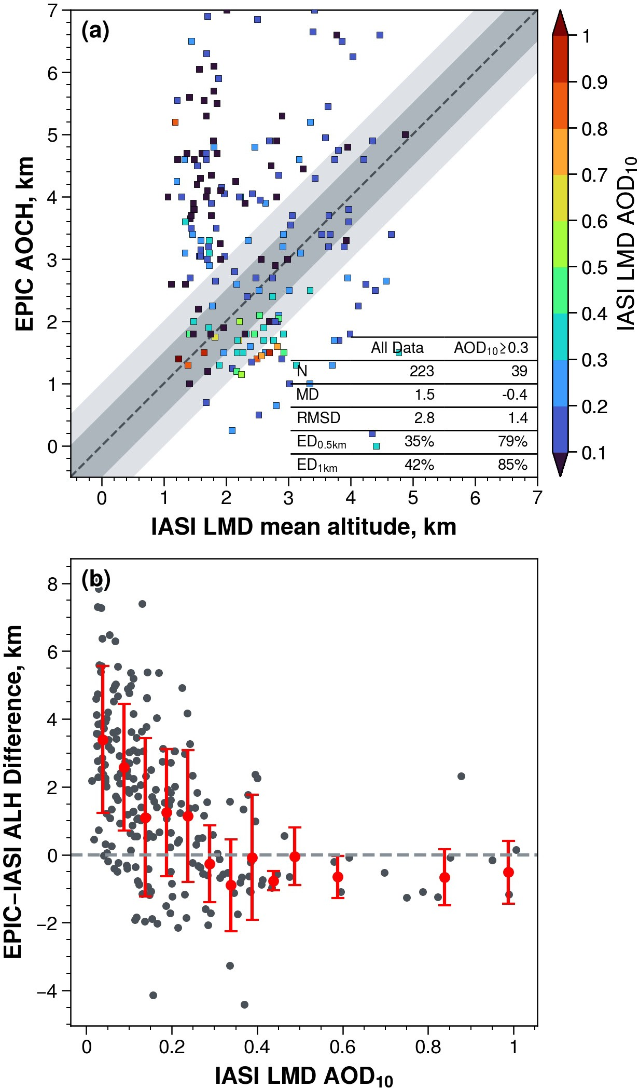

Figure 18. (a) Comparison of co-located ALH retrievals by EPIC and IASI. N, number of coincident retrievals. MD, mean difference. RMSD, root mean square difference. ED, percentage of co-located retrievals within expected differences of 0.5 and 1 km (shaded). (b) The EPIC−IASI difference as a function of IASI-retrieved AOD10.

lenges due to the absence of in situ aerosol measurements near Aralkum and the area’s heterogeneous and highly variable 630 surface characteristics. Although satellite algorithms are optimized for global performance, they may exhibit greater inconsis- tency and biases in Central Asia, where the region-specific aerosol and surface properties are inaccurately represented in the algorithms. To date, the performance and consistency of various observation techniques in characterizing the saline aerosol
from Aralkum remain poorly understood. We address this knowledge gap through two key efforts.

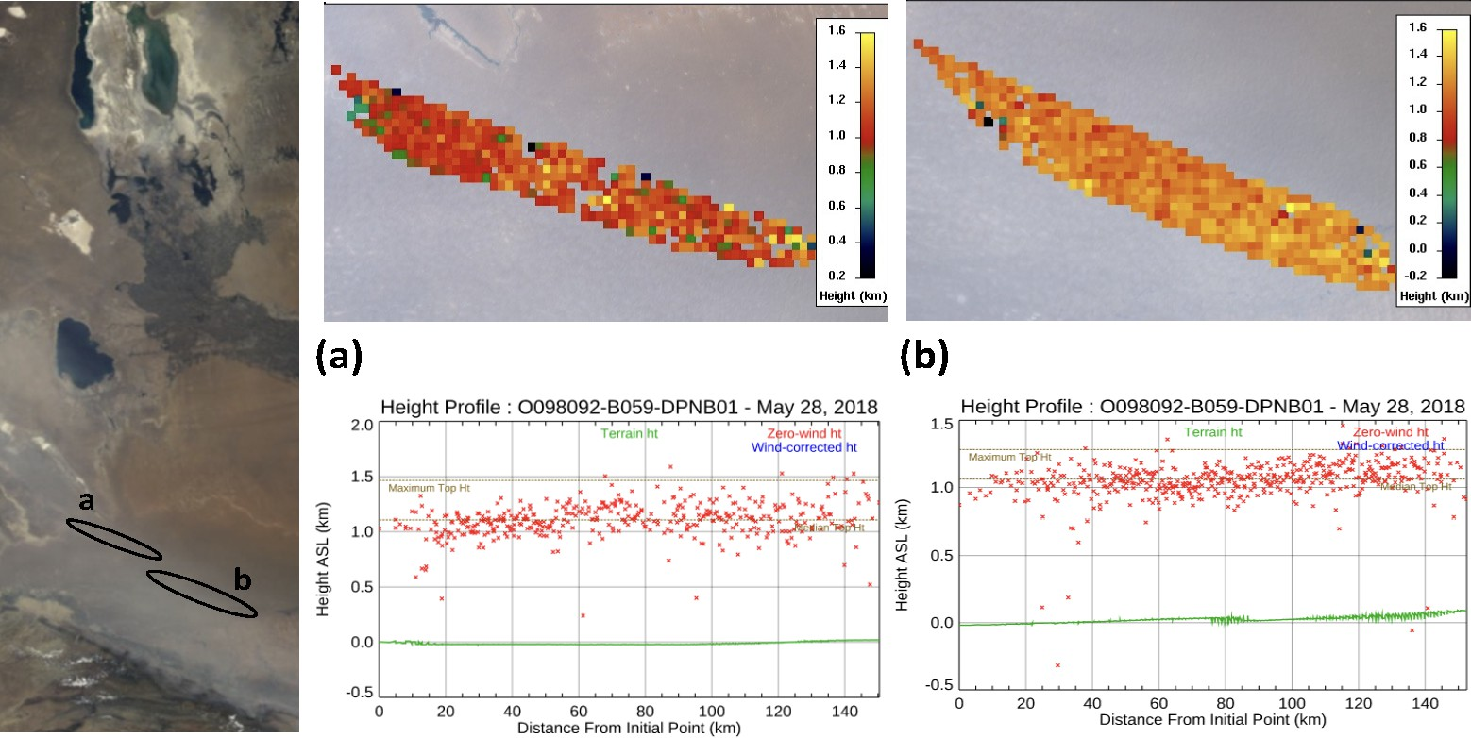

Figure 19. MINX-retrieved plume height profiles (middle and right panels) based on MISR multi-angle images on 28 May 2018 (orbit 98092), for two polygon areas denoted in the nadir-view RGB image (left panel). Surface elevation is represented in green, and retrieved plume heights in red.

635

640

645
First, we conducted a survey of current satellite techniques and algorithms capable of detecting the presence, column burden, and vertical height of airborne dust over Central Asia, focusing on four families of satellite aerosol products: UVAI, midvisible AOD, thermal-infrared AOD, and ALH. The survey identifies the diverse methodologies employed by various algorithms and the differing a priori assumptions regarding surface properties and aerosol optical models (e.g., refractive index, particle shape, particle size distribution). In particular, the dust optical models predefined in these algorithms are primarily derived from AERONET measurements from West Africa and the Middle East. These models may deviate substantially from the microphysical properties of Aralkum-derived aerosols, which has been found to contain distinct chemical and mineralogical compositions (e.g., sulfate- and carbonate-rich minerals, low iron oxide content).
Currently, due to lack of in situ aerosol measurements (e.g., AERONET), the extent to which these dust optical models deviate from actual conditions in Central Asia has yet to be determined. The impact of inaccurate algorithm assumptions on the aerosol product performance is also not well understood. Addressing these knowledge gaps requires establishing in situ aerosol measurement capabilities near Aralkum, e.g., in the downwind Karakalpakstan region. Such measurements are essential not only for validating satellite products but also for developing new or refining existing aerosol optical models for Central Asia or similar environments.
Second, we performed a case study to assess the cross-sensor and cross-algorithm consistency in observing a saline dust storm originating from the Aralkum Desert during 27–29 May 2018. We analyzed a broad range of aerosol products, including

650

655

660

665

670

675

680
UVAI from OMPS, TROPOMI and EPIC, midvisible AOD from MODIS, MISR, and VIIRS, thermal-infrared AOD from IASI using four different algorithms, and ALH from EPIC, CALIOP, IASI, and MISR. This synergistic, multisensor analysis allowed us to identify the complementary strengths of different techniques and uncover the potential limitations and biases of each product. The main findings are as follows.
The UVAI products show similar spatial patterns associated with the heavy dust plume on 27 May, but exhibit notable differences in magnitude and dynamic range. These discrepancies can be attributed, at least in part, to the choice of wavelength pair and the treatment of cloud scattering effect. Using the 95th percentile of each product as a threshold for dust detection, we find overall agreement in delineating the dust plume extent. However, all UVAI products show large positive values over the northern Caspian Sea, Garabogazköl Gulf, and Sor Kaydak salt marsh. These dust-like signals are primarily caused by enhanced UV absorption by turbid and saline waters, which causes the water-leaving UV radiances to deviate from a pure Rayleigh scattering atmosphere, similar to the effect of absorbing aerosols. Consequently, this presents a significant limitation for using UVAI for dust detection and source mapping over Central Asia, due to interferences of turbid/salty waters, salt marshes, and saline deserts. Therefore, caution must be used to avoid misinterpreting surface effects as dust signals over ephemeral or dry lakes such as Aralkum.
Midvisible AOD retrievals over desert surfaces exhibit considerable inconsistencies across different sensors and algorithms. The choice of retrieval algorithms causes nonlinear relationships between the retrieved AOD from MODIS and VIIRS. Specif- ically, the MAIAC algorithm retrieves lower AOD than the DB algorithm under low aerosol loadings but higher AOD under high aerosol loadings. The EPS algorithm generally produces lower AOD than DB, with their divergence increasing as aerosol loading increases. In the operational EPS product, an urban aerosol optical model was selected for dust retrieval, leading to significantly lower AOD compared to other algorithms. A test retrieval using the dust optical model, however, shows significant improvement in the EPS agreement with other algorithms. The MISR operational product exhibits reduced data coverage and significant AOD underestimation compared to MODIS and VIIRS. In contrast, the MISR research algorithm produces higher, more consistent AOD retrievals as well as improved constraints on particle microphysical properties. Over the Caspian Sea, midvisible AOD retrievals show better overall agreement between algorithms, despite the DT and EPS algorithms failing to select the dust optical model during retrieval. Generally, the DT algorithm retrieves lower AOD under clean marine conditions but higher AOD under dust-laden conditions compared to MAIAC, DB, and EPS algorithms.
The high surface reflectivity and shallow and turbid coastal waters of Central Asia poses a great challenge for passive ALH retrieval from EPIC. The EPIC AOCH product significantly overestimates aerosol heights under low aerosol loading or background conditions. However, over dust-laden scenes, EPIC shows good agreement with the CALIOP extinction-weighted height, with a mean bias of 0.4 km, an RMSE of 0.8 km, and 61% (72%) of co-located retrievals falling within 0.5 km (1.0 km) differences. At low aerosol loadings, EPIC AOCH and IASI infrared-based mean dust height retrievals show considerable discrepancies, but their differences stabilize as aerosol loading increases. On average, IASI retrievals over dust-laden scenes are 0.4 km higher than those from EPIC. The MISR plume height retrieval, derived from parallax of multi-angle images, aligns well with EPIC and CALIOP in detecting dust height over the foothills of the Kopet-Dag Range.

685

690
Data availability. Most of the data analyzed in the study are publicly available. The data repository links are provided in Table 1. The MISR research algorithm and plume height results will be available upon request. The regridded data products are available at https://doi.org/10. 5281/zenodo.13994593.

Author contributions. XX performed conceptualization, data curation, formal analysis, visualization, and writing of the initial draft. HL performed VIIRS EPS retrieval using dust model. JL and RK performed MISR research algorithm aerosol and plume height retrievals. All authors contributed to the result interpretation and edited the manuscript.

Competing interests. The authors declare no competing interests.

Acknowledgements. X. Xi acknowledges support from the NASA Land-Cover and Land-Use Change (LCLUC) Program (grant no. 80NSSC20K1480). The work of R. Kahn is supported in part by the NASA Terra-Aqua-NPP program, and the NASA Earth Observing System MISR project.
The satellite data teams acknowledge funding support from multiple NASA and NOAA funding sources supporting the multi-decadal devel- opment and evaluation of these data records. The authors gratefully acknowledge the Copernicus Data Space Ecosystem and NASA ASDC,
695 LAADS DAAC, and GES DISC for maintaining/distributing the data products used in this study.

References

700

705

710

715

720

725

730
Anstett, M., Limbacher, J., and Kahn, R.: A global aerosol microphysical property record from the Multi-angle Imaging SpectroRadiometer (MISR) research aerosol retrieval algorithm, In prep.
Argaman, E., Singer, A., and Tsoar, H.: Erodibility of some crust forming soils/sediments from the Southern Aral Sea Basin as determined in a wind tunnel, Earth Surface Processes and Landforms, 31, 47–63, https://doi.org/10.1002/esp.1230, 2006.
ASDC: MISR Level 2 Aerosol parameters V003 [Dataset], https://doi.org/10.5067/TERRA/MISR/MIL2ASAE_L2.003, 1999.
ASDC: DSCOVR EPIC Aerosol Optical Centroid Height Version 1 [Dataset], https://doi.org/10.5067/EPIC/DSCOVR/L2_AOCH.001, 2018. ASDC: CALIPSO Lidar Level 2 Aerosol Profile, V4-51 [Dataset], https://doi.org/10.5067/CALIOP/CALIPSO/CAL_LID_L2_05kmAPro-
Standard-V4-51, 2023.
Balkanski, Y., Schulz, M., Claquin, T., and Guibert, S.: Reevaluation of Mineral aerosol radiative forcings suggests a better agreement with satellite and AERONET data, Atmospheric Chemistry and Physics, 7, 81–95, https://doi.org/10.5194/acp-7-81-2007, 2007.
C3S CDS: Aerosol properties gridded data from 1995 to present derived from satellite observation [Dataset], https://doi.org/10.24381/cds.239d815c, 2019.
Callewaert, S., Vandenbussche, S., Kumps, N., Kylling, A., Shang, X., Komppula, M., Goloub, P., and De Mazière, M.: The mineral aerosol profiling from infrared radiances (MAPIR) algorithm: Version 4.1 description and evaluation, Atmospheric Measurement Techniques, 12, 3673–3698, https://doi.org/10.5194/amt-12-3673-2019, 2019.
Capelle, V., Chédin, A., Péquignot, E., Schlüssel, P., Newman, S. M., and Scott, N. A.: Infrared continental surface emissivity spectra and skin temperature retrieved from IASI observations over the tropics, Journal of Applied Meteorology and Climatology, 51, 1164–1179, https://doi.org/10.1175/JAMC-D-11-0145.1, 2012.
Capelle, V., Chédin, A., Siméon, M., Tsamalis, C., Pierangelo, C., Pondrom, M., Crevoisier, C., Crepeau, L., and Scott, N. A.: Eval- uation of IASI-derived dust aerosol characteristics over the tropical belt, Atmospheric Chemistry and Physics, 14, 9343–9362, https://doi.org/10.5194/acp-14-9343-2014, 2014.
Capelle, V., Chédin, A., Pondrom, M., Crevoisier, C., Armante, R., Crepeau, L., and Scott, N. A.: Infrared dust aerosol optical depth re- trieved daily from IASI and comparison with AERONET over the period 2007–2016, Remote Sensing of Environment, 206, 15–32, https://doi.org/10.1016/j.rse.2017.12.008, 2018.
Carr, J. L., Wu, D. L., Daniels, J., Friberg, M. D., Bresky, W., and Madani, H.: Geo–geo stereo-tracking of atmospheric motion vectors (AMVS) from the geostationary ring, Remote Sensing, 12, 1–47, https://doi.org/10.3390/rs12223779, 2020.
Clarisse, L., Clerbaux, C., Franco, B., Hadji-Lazaro, J., Whitburn, S., Kopp, A. K., Hurtmans, D., and Coheur, P. F.: A Decadal Data Set of Global Atmospheric Dust Retrieved From IASI Satellite Measurements, Journal of Geophysical Research: Atmospheres, 124, 1618–1647, https://doi.org/10.1029/2018JD029701, 2019.
de Graaf, M., Stammes, P., Torres, O., and Koelemeijer, R. B.: Absorbing Aerosol Index: Sensitivity analysis, application to GOME and comparison with TOMS, Journal of Geophysical Research D: Atmospheres, 110, 1–19, https://doi.org/10.1029/2004JD005178, 2005.
Diner, D. J., Beckert, J. C., Reilly, T. H., Bruegge, C. J., Conel, J. E., Kahn, R. A., Martonchik, J. V., Ackerman, T. P., Davies, R., Gerstl,
S. A., Gordon, H. R., Muller, J. P., Myneni, R. B., Sellers, P. J., Pinty, B., and Verstraete, M. M.: Multi-angle imaging spectroradiome- ter (MISR) instrument description and experiment overview, IEEE Transactions on Geoscience and Remote Sensing, 36, 1072–1087, https://doi.org/10.1109/36.700992, 1998.

735

740

745

750

755

760

765
Dubovik, O., Holben, B., Eck, T. F., Smirnov, A., Kaufman, Y. J., King, M. D., Tanré, D., and Slutsker, I.: Variability of Absorption and Optical Properties of Key Aerosol Types Observed in Worldwide Locations, Journal of the Atmospheric Sciences, 59, 590–608, https://doi.org/10.1175/1520-0469(2002)059<0590:voaaop>2.0.co;2, 2002.
Dubovik, O., Sinyuk, A., Lapyonok, T., Holben, B. N., Mishchenko, M., Yang, P., Eck, T. F., Volten, H., Muñoz, O., Veihelmann, B., van der Zande, W. J., Leon, J. F., Sorokin, M., and Slutsker, I.: Application of spheroid models to account for aerosol particle nonsphericity in remote sensing of desert dust, Journal of Geophysical Research Atmospheres, 111, https://doi.org/10.1029/2005JD006619, 2006.
ESA: TROPOMI Level 2 Ultraviolet Aerosol Index products Version 02 [Data set], https://doi.org/10.5270/S5P-3dgz66p, 2021.
Flower, V. J. and Kahn, R. A.: Assessing the altitude and dispersion of volcanic plumes using MISR multi-angle imaging from space: Sixteen years of volcanic activity in the Kamchatka Peninsula, Russia, Journal of Volcanology and Geothermal Research, 337, 1–15, https://doi.org/10.1016/j.jvolgeores.2017.03.010, 2017.
Garay, M. J., Witek, M. L., Kahn, R. A., Seidel, F. C., Limbacher, J. A., Bull, M. A., Diner, D. J., Hansen, E. G. G., Kalashnikova, O. V., Lee, H., Nastan, A. M., and Yu, Y.: Introducing the 4.4km spatial resolution Multi-Angle Imaging SpectroRadiometer (MISR) aerosol product, Atmospheric Measurement Techniques, 13, 593–628, https://doi.org/10.5194/amt-13-593-2020, 2020.
Gaston, C. J., Pratt, K. A., Suski, K. J., May, N. W., Gill, T. E., and Prather, K. A.: Laboratory Studies of the Cloud Droplet Ac- tivation Properties and Corresponding Chemistry of Saline Playa Dust, Environmental Science and Technology, 51, 1348–1356, https://doi.org/10.1021/acs.est.6b04487, 2017.
Groll, M., Opp, C., Issanova, G., Vereshagina, N., and Semenov, O.: Physical and chemical characterization of dust deposited in the Turan Lowland (Central Asia), in: E3S Web of Conferences, vol. 99, ISSN 22671242, https://doi.org/10.1051/e3sconf/20199903005, 2019.
He, X., Bai, Y., Pan, D., Tang, J., and Wang, D.: Atmospheric correction of satellite ocean color imagery using the ultraviolet wavelength for highly turbid waters, Optics Express, 20, 20 754, https://doi.org/10.1364/oe.20.020754, 2012.
Herman, J. R., Bhartia, P. K., Torres, O., Hsu, C., Seftor, C., and Celarier, E.: Global distribution of UV-absorbing aerosols from Nimbus 7/TOMS data, Journal of Geophysical Research Atmospheres, 102, 16 911–16 922, https://doi.org/10.1029/96jd03680, 1997.
Hofer, J., Althausen, D., Abdullaev, S. F., Makhmudov, A. N., Nazarov, B. I., Schettler, G., Engelmann, R., Baars, H., Fomba, K. W., Müller, K., Heinold, B., Kandler, K., and Ansmann, A.: Long-term profiling of mineral dust and pollution aerosol with multiwavelength polarization Raman lidar at the Central Asian site of Dushanbe, Tajikistan: Case studies, Atmospheric Chemistry and Physics, 17, 14 559– 14 577, https://doi.org/10.5194/acp-17-14559-2017, 2017.
Hsu, C.: VIIRS/NOAA20 Deep Blue Aerosol L2 6-Min Swath 6 km [Data set], https://doi.org/doi.org/10.5067/VIIRS/AERDB_L2_VIIRS_NOAA20.002, 2022.
Hsu, N. C., Tsay, S. C., King, M. D., and Herman, J. R.: Aerosol properties over bright-reflecting source regions, IEEE Transactions on Geoscience and Remote Sensing, 42, 557–569, https://doi.org/10.1109/TGRS.2004.824067, 2004.
Hsu, N. C., Jeong, M. J., Bettenhausen, C., Sayer, A. M., Hansell, R., Seftor, C. S., Huang, J., and Tsay, S. C.: Enhanced Deep Blue aerosol retrieval algorithm: The second generation, Journal of Geophysical Research Atmospheres, 118, 9296–9315, https://doi.org/10.1002/jgrd.50712, 2013.
Hsu, N. C., Lee, J., Sayer, A. M., Kim, W., Bettenhausen, C., and Tsay, S. C.: VIIRS Deep Blue Aerosol Products Over Land: Extending the EOS Long-Term Aerosol Data Records, Journal of Geophysical Research: Atmospheres, 124, 4026–4053, https://doi.org/10.1029/2018JD029688, 2019.
Jackson, J. M., Liu, H., Laszlo, I., Kondragunta, S., Remer, L. A., Huang, J., and Huang, H. C.: Suomi-NPP VIIRS aerosol algorithms and data products, Journal of Geophysical Research Atmospheres, 118, 673–12, https://doi.org/10.1002/2013JD020449, 2013.

770

775

780

785

790

795

800

805
Jiang, H., Huang, J., Li, L., Huang, L., Manzoor, M., Yang, J., Wu, G., Sun, X., Wang, B., Egamberdieva, D., Panosyan, H., Birkeland, N. K., Zhu, Z., and Li, W.: Onshore soil microbes and endophytes respond differently to geochemical and mineralogical changes in the Aral Sea, Science of the Total Environment, 765, https://doi.org/10.1016/j.scitotenv.2020.142675, 2021.
Kahn, R. A., Gaitley, B. J., Garay, M. J., Diner, D. J., Eck, T. F., Smirnov, A., and Holben, B. N.: Multiangle Imaging SpectroRadiometer global aerosol product assessment by comparison with the Aerosol Robotic Network, Journal of Geophysical Research Atmospheres, 115, https://doi.org/10.1029/2010JD014601, 2010.
Kim, M. H., Omar, A. H., Tackett, J. L., Vaughan, M. A., Winker, D. M., Trepte, C. R., Hu, Y., Liu, Z., Poole, L. R., Pitts, M. C., Kar, J., and Magill, B. E.: The CALIPSO version 4 automated aerosol classification and lidar ratio selection algorithm, Atmospheric Measurement Techniques, 11, 6107–6135, https://doi.org/10.5194/amt-11-6107-2018, 2018.
Koffi, B., Schulz, M., Bréon, F. M., Griesfeller, J., Winker, D., Balkanski, Y., Bauer, S., Berntsen, T., Chin, M., Collins, W. D., Dentener, F., Diehl, T., Easter, R., Ghan, S., Ginoux, P., Gong, S., Horowitz, L. W., Iversen, T., Kirkevg, A., Koch, D., Krol, M., Myhre, G., Stier, P., and Takemura, T.: Application of the CALIOP layer product to evaluate the vertical distribution of aerosols estimated by global models: AeroCom phase i results, https://doi.org/10.1029/2011JD016858, 2012.
Kondragunta, S., Laszlo, I., and Ma, L.: NOAA JPSS Visible Infrared Imaging Radiometer Suite (VIIRS) Aerosol Optical Depth and Aerosol Particle Size Distribution Environmental Data Record (EDR) from NDE, https://doi.org/10.7289/V5319T4H, 2023.
Laszlo, I.: Remote Sensing of Tropospheric Aerosol Optical Depth From Multispectral Monodirectional Space-Based Observations, in: Comprehensive Remote Sensing, edited by Liang, S. B. T. C. R. S., pp. 137–196, Elsevier, Oxford, ISBN 978-0-12-803221-3, https://doi.org/https://doi.org/10.1016/B978-0-12-409548-9.10389-6, 2018.
Laszlo, I. and Liu, H.: EPS Aerosol Optical Depth (AOD) Algorithm Theoretical Basis Document Version 3.4, Tech. rep., NOAA NESDIS CENTER for SATELLITE APPLICATIONS and RESEARCH, https://www.star.nesdis.noaa.gov/jpss/documents/ATBD/ATBD_EPS_ Aerosol_AOD_v3.4.pdf, 2022.
Lee, J., Hsu, N. C., Sayer, A. M., Bettenhausen, C., and Yang, P.: AERONET-Based Nonspherical Dust Optical Models and Effects on the VIIRS Deep Blue/SOAR Over Water Aerosol Product, Journal of Geophysical Research: Atmospheres, 122, 10 384–10 401, https://doi.org/10.1002/2017JD027258, 2017.
Lee, J., Hsu, N. C., Kim, W. V., Sayer, A. M., and Tsay, S.-C.: VIIRS Version 2 Deep Blue Aerosol Products, Journal of Geophysical Research: Atmospheres, 129, e2023JD040 082, https://doi.org/https://doi.org/10.1029/2023JD040082, 2024.
Lee, Z., Hu, C., Shang, S., Du, K., Lewis, M., Arnone, R., and Brewin, R.: Penetration of UV-visible solar radiation in the global oceans: Insights from ocean color remote sensing, Journal of Geophysical Research: Oceans, 118, 4241–4255, https://doi.org/10.1002/jgrc.20308, 2013.
Legrand, M., Plana-Fattori, A., and N’Doumé, C.: Satellite detection of dust using the IR imagery of Meteosat 1. Infrared difference dust index, Journal of Geophysical Research Atmospheres, 106, 18 251–18 274, https://doi.org/10.1029/2000JD900749, 2001.
Lensky, I. M. and Rosenfeld, D.: Clouds-Aerosols-Precipitation Satellite Analysis Tool (CAPSAT), Atmospheric Chemistry and Physics, 8, 6739–6753, https://doi.org/10.5194/acp-8-6739-2008, 2008.
Levy, R. C. and Hsu, N. C.: MODIS Atmosphere L2 Aerosol Product [Data set], https://doi.org/10.5067/MODIS/MYD04_L2.006, 2015a. Levy, R. C. and Hsu, N. C.: MODIS Atmosphere L2 Aerosol Product [Dataset], https://doi.org/10.5067/MODIS/MOD04_3K.061, 2015b. Levy, R. C., Mattoo, S., Sawyer, V., and Munchak, L.: VIIRS/NOAA20 Dark Target Aerosol 6-Min L2 Swath 6 km [Dataset],
https://doi.org/10.5067/VIIRS/AERDT_L2_VIIRS_NOAA20.002, 2023.

810

815

820

825

830

835

840
Limbacher, J. A., Kahn, R. A., and Lee, J.: The new MISR research aerosol retrieval algorithm: A multi-Angle, multi-spectral, bounded- variable least squares retrieval of aerosol particle properties over both land and water, Atmospheric Measurement Techniques, 15, 6865– 6887, https://doi.org/10.5194/amt-15-6865-2022, 2022.
Lu, Z., Wang, J., Xu, X., Chen, X., Kondragunta, S., Torres, O., Wilcox, E. M., and Zeng, J.: Hourly Mapping of the Layer Height of Thick Smoke Plumes Over the Western U.S. in 2020 Severe Fire Season, Frontiers in Remote Sensing, 2, https://doi.org/10.3389/frsen.2021.766628, 2021.
Lu, Z., Wang, J., Chen, X., Zeng, J., Wang, Y., Xu, X., Christian, K. E., Yorks, J. E., Nowottnick, E. P., Reid, J. S., and Xian, P.: First Mapping of Monthly and Diurnal Climatology of Saharan Dust Layer Height Over the Atlantic Ocean From EPIC/DSCOVR in Deep Space, Geophysical Research Letters, 50, https://doi.org/10.1029/2022GL102552, 2023.
Lyapustin, A. and Wang, Y.: MODIS/Terra+Aqua Land Aerosol Optical Depth Daily L2G Global 1km SIN Grid V061 [Data set], https://doi.org/10.5067/MODIS/MCD19A2.061, 2022.
Lyapustin, A., Wang, Y., Korkin, S., and Huang, D.: MODIS Collection 6 MAIAC algorithm, Atmospheric Measurement Techniques, 11, 5741–5765, https://doi.org/10.5194/amt-11-5741-2018, 2018.
Modabberi, A., Noori, R., Madani, K., Ehsani, A. H., Danandeh Mehr, A., Hooshyaripor, F., and Kløve, B.: Caspian Sea is eutrophying: The alarming message of satellite data, Environmental Research Letters, 15, https://doi.org/10.1088/1748-9326/abc6d3, 2019.
Moradi, M.: Interannual and intra-annual cycles of satellite-derived chlorophyll-a concentrations in the Caspian Sea, Journal of Great Lakes Research, 48, 143–158, https://doi.org/10.1016/j.jglr.2021.10.021, 2022.
Nelson, D. L., Garay, M. J., Kahn, R. A., and Dunst, B. A.: Stereoscopic height and wind retrievals for aerosol plumes with the MISR INteractive eXplorer (MINX), Remote Sensing, 5, 4593–4628, https://doi.org/10.3390/rs5094593, 2013.
Nobakht, M., Shahgedanova, M., and White, K.: New Inventory of Dust Emission Sources in Central Asia and Northwestern China Derived From MODIS Imagery Using Dust Enhancement Technique, Journal of Geophysical Research: Atmospheres, 126, https://doi.org/10.1029/2020JD033382, 2021.
Offenwanger, T., Samaras, S., and Klüser, L.: Algorithm Theoretical Basis Document Annex D Infrared Mineral Aerosol Retrieval Scheme (IMARS) Algorithm version v7.1, Tech. rep., Copernicus Climate Change Service, 2024.
Orlovsky, L. and Orlovsky, N.: White sand storms in Central Asia, in: Global Alarm: Dust and Sand Storms from the World’s Dry lands, edited by Yang, Y., Squires, V., and Lu, Q., chap. 8, pp. 169–201, United Nations, 2001.
Prospero, J. M., Ginoux, P., Torres, O., Nicholson, S. E., and Gill, T. E.: Environmental characterization of global sources of atmospheric soil dust identified with the Nimbus 7 Total Ozone Mapping Spectrometer (TOMS) absorbing aerosol product, Reviews of Geophysics, 40, 2–1, https://doi.org/10.1029/2000RG000095, 2002.
Remer, L. A., Kaufman, Y. J., Tanré, D., Mattoo, S., Chu, D. A., Martins, J. V., Li, R. R., Ichoku, C., Levy, R. C., Kleidman, R. G., Eck,
T. F., Vermote, E., and Holben, B. N.: The MODIS aerosol algorithm, products, and validation, Journal of the Atmospheric Sciences, 62, 947–973, https://doi.org/10.1175/JAS3385.1, 2005.
Remer, L. A., Didier, T. ., Kaufman, Y. J., Levy, R., and Mattoo, S.: Algorithm for remote sensing of tropospheric aerosol from MODIS: Collection 5 ATBD, Tech. rep., NASA, Greenbelt, MD, 2006.
Remer, L. A., Brogniez, C., Cairns, B., Hsu, N. C., Kahn, R., Stammes, P., Tanré, D., and Torres, O.: Recent instruments and algorithms for passive shortwave remote sensing, in: Aerosol Remote Sensing, edited by Lenoble, J., Remer, L., and Tanre, D., vol. 9783642177,
pp. 185–222, Springer Berlin Heidelberg, Berlin, Heidelberg, ISBN 978-3-642-17725-5, https://doi.org/10.1007/978-3-642-17725-5_8, 2013a.

845

850

855

860

865

870

875

880
Remer, L. A., Mattoo, S., Levy, R. C., and Munchak, L. A.: MODIS 3 km aerosol product: Algorithm and global perspective, Atmospheric Measurement Techniques, 6, 1829–1844, https://doi.org/10.5194/amt-6-1829-2013, 2013b.
Rudich, Y., Khersonsky, O., and Rosenfeld, D.: Treating clouds with a grain of salt, Geophysical Research Letters, 29, 17–1, https://doi.org/10.1029/2002gl016055, 2002.
Rupakheti, D., Rupakheti, M., Abdullaev, S. F., Yin, X., and Kang, S.: Columnar aerosol properties and radiative effects over Dushanbe, Tajikistan in Central Asia, Environmental Pollution, 265, https://doi.org/10.1016/j.envpol.2020.114872, 2020.
Sawyer, V., Levy, R. C., Mattoo, S., Cureton, G., Shi, Y., and Remer, L. A.: Continuing the MODIS dark target aerosol time series with VIIRS, Remote Sensing, 12, https://doi.org/10.3390/rs12020308, 2020.
Sayer, A. M., Hsu, N. C., Lee, J., Bettenhausen, C., Kim, W. V., and Smirnov, A.: Satellite Ocean Aerosol Retrieval (SOAR) Algorithm Extension to S-NPP VIIRS as Part of the “Deep Blue” Aerosol Project, Journal of Geophysical Research: Atmospheres, 123, 380–400, https://doi.org/10.1002/2017JD027412, 2018.
Schepanski, K., Tegen, I., and Macke, A.: Comparison of satellite based observations of Saharan dust source areas, Remote Sensing of Environment, 123, 90–97, https://doi.org/10.1016/j.rse.2012.03.019, 2012.
Semenov, V. K., Smirnov, A., Aref’ev, V. N., Sinyakov, V. P., Sorokina, L. I., and Ignatova, N. I.: Aerosol optical depth over the mountainous region in central Asia (Issyk-Kul Lake, Kyrgyzstan), Geophysical Research Letters, 32, 1–5, https://doi.org/10.1029/2004GL021746, 2005.
Sokolik, I. N. and Toon, O. B.: Incorporation of mineralogical composition into models of the radiative properties of mineral aerosol from UV to IR wavelengths, Journal of Geophysical Research Atmospheres, 104, 9423–9444, https://doi.org/10.1029/1998JD200048, 1999. Stein Zweers, D. C.: TROPOMI ATBD of the UV aerosol index document number - S5P-KNMI-L2-0008-RP, Tech. Rep. 2.1.0,
Royal Netherlands Meteorological Institute, De Bilt, 3731 GA, the Netherlands, https://sentinel.esa.int/documents/247904/2476257/ Sentinel-5P-TROPOMI-ATBD-UV-Aerosol-Index.pdf, 2022.
Tanré, D., Kaufman, Y. J., Herman, M., and Mattoo, S.: Remote sensing of aerosol properties over oceans using the MODIS/EOS spectral radiances, Journal of Geophysical Research Atmospheres, 102, 16 971–16 988, https://doi.org/10.1029/96jd03437, 1997.
Torres, O.: OMPS-NPP L2 NM Aerosol Index swath orbital V2 [Data set], https://doi.org/10.5067/40L92G8144IV, 2019a.
Torres, O.: DSCOVR EPIC Level 2 UV Aerosol Version 3 [Data set], https://doi.org/10.5067/EPIC/DSCOVR/L2_AER_03, 2019b.
Torres, O.: TROPOMI/Sentinel-5P Near UV Aerosol Optical Depth and Single Scattering Albedo L2 1-Orbit Snapshot 7.5 km x 3 km [Data set], https://doi.org/10.5067/MEASURES/AER/DATA204, 2021.
Torres, O., Bhartia, P. K., Herman, J. R., Ahmad, Z., and Gleason, J.: Derivation of aerosol properties from satellite measure- ments of backscattered ultraviolet radiation: Theoretical basis, Journal of Geophysical Research Atmospheres, 103, 17 099–17 110, https://doi.org/10.1029/98JD00900, 1998.
Torres, O., Ahn, C., and Chen, Z.: Improvements to the OMI near-UV aerosol algorithm using A-train CALIOP and AIRS observations, Atmospheric Measurement Techniques, 6, 3257–3270, https://doi.org/10.5194/amt-6-3257-2013, 2013.
Torres, O., Bhartia, P. K., Jethva, H., and Ahn, C.: Impact of the ozone monitoring instrument row anomaly on the long-term record of aerosol products, Atmospheric Measurement Techniques, 11, 2701–2715, https://doi.org/10.5194/amt-11-2701-2018, 2018.
Veefkind, J. P., Aben, I., McMullan, K., Förster, H., de Vries, J., Otter, G., Claas, J., Eskes, H. J., de Haan, J. F., Kleipool, Q., van Weele, M., Hasekamp, O., Hoogeveen, R., Landgraf, J., Snel, R., Tol, P., Ingmann, P., Voors, R., Kruizinga, B., Vink, R., Visser, H., and Levelt,
P. F.: TROPOMI on the ESA Sentinel-5 Precursor: A GMES mission for global observations of the atmospheric composition for climate, air quality and ozone layer applications, Remote Sensing of Environment, 120, 70–83, https://doi.org/10.1016/j.rse.2011.09.027, 2012.

885

890

895

900

905

910

915
Volz, F. E.: Infrared Optical Constants of Ammonium Sulfate, Sahara Dust, Volcanic Pumice, and Flyash, Applied Optics, 12, 564, https://doi.org/10.1364/ao.12.000564, 1973.
Winker, D. M., Vaughan, M. A., Omar, A., Hu, Y., Powell, K. A., Liu, Z., Hunt, W. H., and Young, S. A.: Overview of the CALIPSO mission and CALIOP data processing algorithms, Journal of Atmospheric and Oceanic Technology, 26, 2310–2323, https://doi.org/10.1175/2009JTECHA1281.1, 2009.
Wu, L., Hasekamp, O., van Diedenhoven, B., Cairns, B., Yorks, J. E., and Chowdhary, J.: Passive remote sensing of aerosol layer height using near-UV multiangle polarization measurements, Geophysical Research Letters, 43, 8783–8790, https://doi.org/10.1002/2016GL069848, 2016.
Xi, X.: On the Geomorphic, Meteorological, and Hydroclimatic Drivers of the Unusual 2018 Early Summer Salt Dust Storms in Central Asia, Journal of Geophysical Research: Atmospheres, 128, https://doi.org/10.1029/2022JD038089, 2023.
Xi, X. and Sokolik, I. N.: Seasonal dynamics of threshold friction velocity and dust emission in Central Asia, Journal of Geophysical Research: Atmospheres, 120, 1536–1564, https://doi.org/10.1002/2014JD022471, 2015a.
Xi, X. and Sokolik, I. N.: Dust interannual variability and trend in Central Asia from 2000 to 2014 and their climatic linkages, Journal of Geophysical Research: Atmospheres, 120, 12 175–12 197, https://doi.org/10.1002/2015JD024092, 2015b.
Xi, X. and Sokolik, I. N.: Quantifying the anthropogenic dust emission from agricultural land use and desiccation of the Aral Sea in Central Asia, Journal of Geophysical Research: Atmospheres, 121, 270–12, https://doi.org/10.1002/2016JD025556, 2016.
Xu, X., Wang, J., Wang, Y., Zeng, J., Torres, O., Yang, Y., Marshak, A., Reid, J., and Miller, S.: Passive remote sensing of altitude and optical depth of dust plumes using the oxygen A and B bands: First results from EPIC/DSCOVR at Lagrange-1 point, Geophysical Research Letters, 44, 7544–7554, https://doi.org/10.1002/2017GL073939, 2017.
Xu, X., Wang, J., Wang, Y., Zeng, J., Torres, O., Reid, J. S., Miller, S. D., Vanderlei Martins, J., and Remer, L. A.: Detecting layer height of smoke aerosols over vegetated land and water surfaces via oxygen absorption bands: Hourly results from EPIC/DSCOVR in deep space, Atmospheric Measurement Techniques, 12, 3269–3288, https://doi.org/10.5194/amt-12-3269-2019, 2019.
Young, S. A., Vaughan, M. A., Garnier, A., Tackett, J. L., Lambeth, J. D., and Powell, K. A.: Extinction and optical depth retrievals for CALIPSO’s Version 4 data release, Atmospheric Measurement Techniques, 11, 5701–5727, https://doi.org/10.5194/amt-11-5701-2018, 2018.
Zhang, H., Kondragunta, S., Laszlo, I., Liu, H., Remer, L. A., Huang, J., Superczynski, S., and Ciren, P.: An enhanced VIIRS aerosol optical thickness (AOT) retrieval algorithm over land using a global surface reflectance ratio database, Journal of Geophysical Research, 121, 717–10, https://doi.org/10.1002/2016JD024859, 2016.
Zhou, D. K., Larar, A. M., Liu, X., Smith, W. L., Strow, L. L., Yang, P., Schlüssel, P., and Calbet, X.: Global land surface emissiv- ity retrieved from satellite ultraspectral IR measurements, IEEE Transactions on Geoscience and Remote Sensing, 49, 1277–1290, https://doi.org/10.1109/TGRS.2010.2051036, 2011.
Zhou, Y., Levy, R. C., Remer, L. A., Mattoo, S., and Espinosa, W. R.: Dust Aerosol Retrieval Over the Oceans With the MODIS/VIIRS Dark Target Algorithm: 2. Nonspherical Dust Model, Earth and Space Science, 7, https://doi.org/10.1029/2020EA001222, 2020a.
Zhou, Y., Levy, R. C., Remer, L. A., Mattoo, S., Shi, Y., and Wang, C.: Dust Aerosol Retrieval Over the Oceans With the MODIS/VIIRS Dark-Target Algorithm: 1. Dust Detection, Earth and Space Science, 7, https://doi.org/10.1029/2020EA001221, 2020b.

